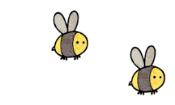
Curriculum - Term 2 November 2026
BADGERS Y6
Topic for the Term | VICTORIAN BRITAIN


English
Reading | Children will:  - recap comprehension skills including inference, vocabulary and comparing themes, using shorter texts each week, focussing on particular skills  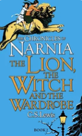
Whole class book | The Lion The Witch and The Wardrobe
Writing | - Genres for writing – linked to our topic where appropriate - will include a narrative, poetry, a non-chronological report and instructions.
Grammar, Spelling & Punctuation | Children will:  - recap subordinating and co-ordinating conjunctions  - varying verb forms  - punctuation and presentation devices (bullet points)  - learn words with the /oa/ sound spelt ow or ou, words with a soft c spelt ce, words with the f sound spelt ph and challenge words from the Y5/6 statutory spelling list.
How you can help at home | Encourage regular reading and discuss what your child has read, asking questions about characters’ feelings, motives and actions. Encourage them to use evidence from the text.  Explore vocabulary together, identifying unfamiliar words and discussing their meanings. Look for similarities and differences between characters, settings and themes in different books.  Encourage writing for real purposes, such as instructions for a game, a persuasive letter or a factual report about a topic that interests them.  Practise spelling patterns and statutory spellings through short, regular activities.


Maths
Fractions | Children will:  - simplify fractions  - compare and order  - add and subtract  - multiply by whole numbers and fractions  - divide fractions by whole numbers  - find fractions of an amount.
Comparing Units | Children will:  - compare metric and imperial units
How you can help at home | Practise times tables and division facts regularly to support simplifying fractions and finding equivalent fractions.  Use everyday situations to explore fractions, such as sharing food, dividing quantities or calculating fractions of amounts when shopping.  Compare metric and imperial measurements when cooking, shopping or travelling. Look at kilograms and pounds, litres and pints, and kilometres and miles.

  Science | ELECTRICITY  Children will:  - further their understanding of electricity  - develop their knowledge of various circuits and the impact of changed variables to those circuits  - use this knowledge to create a DT project.
  Art & Design Technology | Children will:  - observe the work of William Morris  - develop their own designs using his as inspiration  - enhance their DT skills and crafting ready for Christmas.
  Computing | Children will:  - continue their computing media learning  - design and develop a website, including a study of what makes a good website  - apply prior learning from previous years.
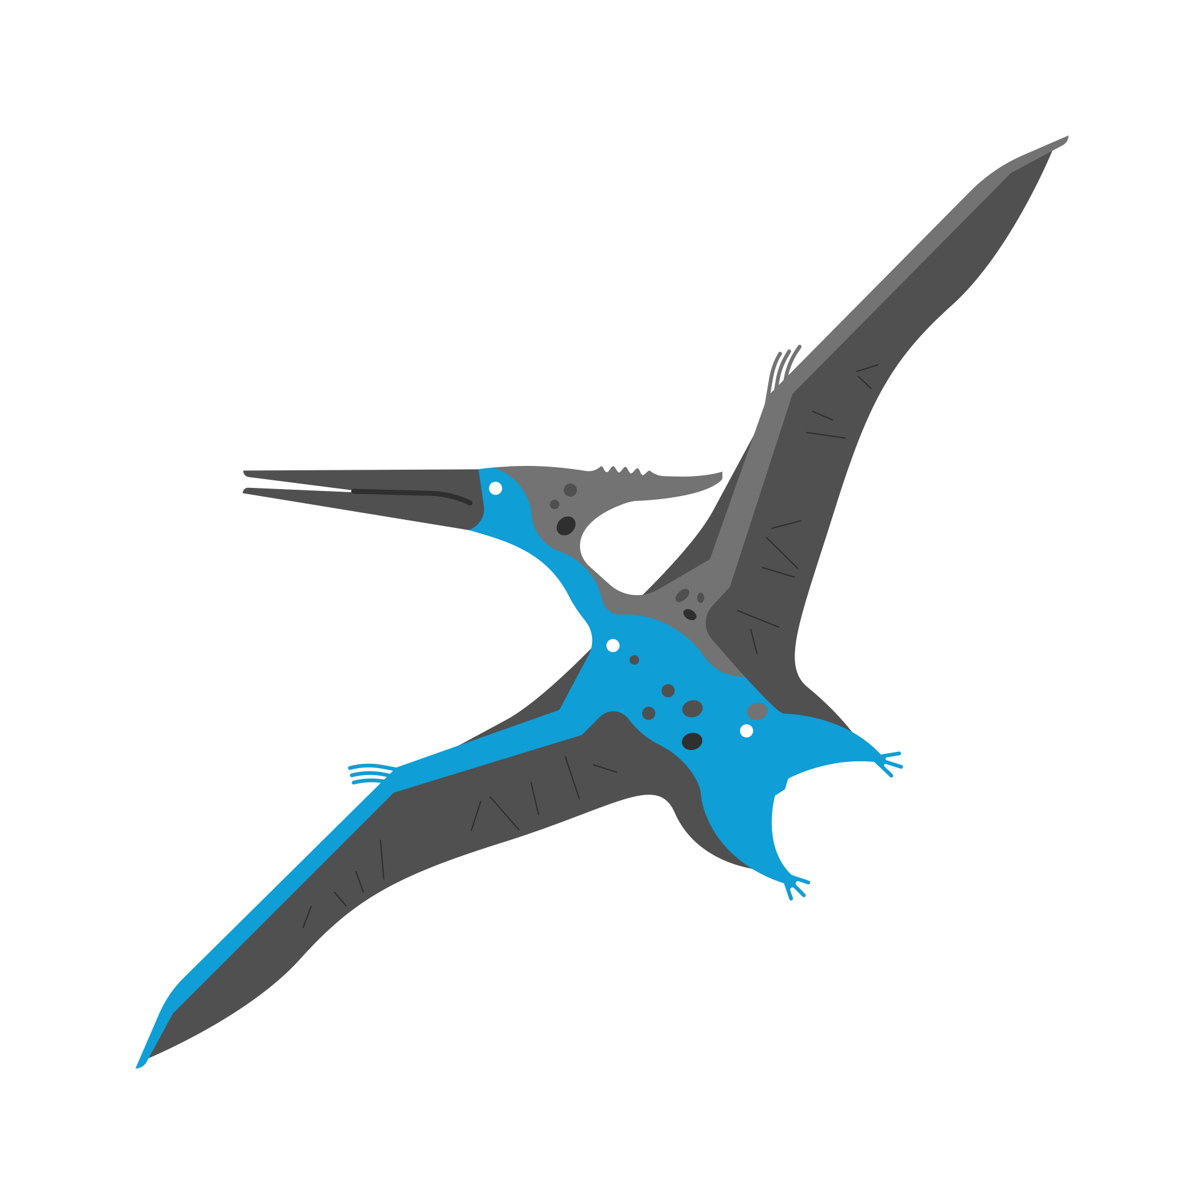  History | - Children will further their understanding of Victorian Britain with a focus on the development of the train system.
  Religious  Education | CREATION AND SCIENCE: CONFLICTING OR COMPLEMENTARY?  Through discussion, research art and music children will:  - expand their understanding of the Christian story of Genesis  - consider where it fits in the Big Story of Bible and its importance to Christians  - think about how Christians connect the account of creation in Genesis 1 with different scientific ideas such as cosmology and evolution.
  Physical  Education | Hockey – children will:  - develop attacking skills to beat a defender  - apply attacking skills with control under pressure  - select the appropriate skill, choosing when to pass and when to dribble  - move into and create space to support a teammate  - use the appropriate defensive technique for the situation  - apply rules, skills and principles to play in a tournament.  Strength, Flexibility and Co-ordination – children will:  - use flexibility and control when moving between poses  - use strength and control when moving between poses  - create their own sequence showing control, balance and technique  - work collaboratively to create a controlled paired sequence  - create, refine and perform a sequence with control and confidence.
  PSHE | VALUING DIFFERENCE  Children will learn:  - that it is OK to be different  - what we have in common  - how to respect differences  - about tolerance and respect for others  - about challenging gender stereotypes
  Music | World Unite  - through performance, singing and playing, children will explore beat, rhythm and syncopation for a united performance.
  French  with  Madame Hanna | - Children will have the opportunity to develop their language skills across the four attainment targets (speaking, listening, reading and writing) with primary focus on speaking and listening around the theme of weather.
Enrichment Ideas | - Visit the Spa Valley Railway in Tunbridge Wells to experience a heritage railway journey and discover how steam trains transformed travel during the Victorian era.  - Investigate electricity at home by identifying appliances that use mains electricity or batteries. Discuss how electricity has changed everyday life since Victorian times.  - Research a Victorian inventor, such as Thomas Edison or Joseph Swan, and find out how developments in electric lighting changed people's lives.  - Visit the Science Museum in London to explore the history of technology, electricity and inventions that transformed the Victorian world.
Suggested Reading | - Rivet Boy, Barbara Henderson  - Rose Campion and the Stolen Secret, Lyn Gardner  - Investigating Electricity, Jacqui Bailey  - The Boy Who Harnessed The Wind, Bryan Mealer & William Kamkwamba

