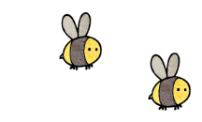
Curriculum - Term 2 November 2026
OTTERS Y5
Topic for the Term | North America
Topic for the Term | Children will learn about the continent of North America, its 23 countries and their biomes.


English
Reading | Children will:  - focus will be on applying the VIPERS skills and extending vocabulary to aid comprehension in reading and precision in our writing  - continue to look at inference and prediction.
Whole class book | The Miraculous Journey of Edward Tulane
Writing | 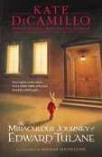  - Genres for writing – linked to our topic where appropriate - will include narrative, persuasive (travel brochure), instruction and poetry.  - We will continue our emphasis on presentation and neat handwriting in pen.
Grammar, Spelling & Punctuation | Children will:  - revise grammar and punctuation from previous years  - look at different sentences (simple, compound and complex) and modal verbs  - learn words ending in -ant, -ent, -ence, -ably, -ibly, -ance, -able and -ible  - learn words from the 5/6 words statutory spelling list.
How you can help at home | Continue to read with your child for 15 minutes at least 3 times each week, discussing vocabulary, characters. Practise spellings in a variety of ways, including on Spelling Shed.


Maths
Multiplication and division | Children will learn about:  - factors  - common factors  - prime, square and cube numbers  - multiplying and dividing by 10, 100 and 1000.
Fractions | Children will:  - find fractions equivalent to unit and non-unit fractions  - recognise equivalent fractions  - convert between improper fractions and mixed numbers  - order and compare fractions less and greater than 1  - add and subtract fractions  - add and subtract mixed numbers.
How you can help at home | Practise times tables regularly to help your child identify factors, common factors and multiples.  Use everyday objects such as pizza slices, chocolate bars or Lego, to explore equivalent fractions and compare fractions.  Practise fractions in real-life situations, such as doubling or halving recipes, including adding and subtracting fractions and mixed numbers.

  Science | Life cycles  Children will learn about:  - the life cycles of plants  - asexual plant reproduction (tubers, runners, bulbs, plantlets) and sexual reproduction (seeds)  - look at the differences between the lifecycles of mammals, amphibians, insects and birds.  Working scientifically, children will:  - plan different types of scientific enquiries to answer questions  - take measurements  - use a range of scientific equipment  - record data and results, use test results to make predictions to set up further comparative and fair tests  - report and present findings from enquiries
  Art & Design Technology | Children will:  - learn about Mexican artist, Frida Kahlo, and create self-portraits  - linked to computing, create drawings using shapes (vector drawings)  - design and make a range of products linked to Christmas including sewing (blanket stitch) and using tools (hammers).
  Computing | Children will:  - learn about vector drawing tools in Microsoft PowerPoint  - create vector drawings, learning about layers and objects and manipulating objects  For their end product, the children will make calendars from vector drawings.
Geography   | Children will:  - learn about the continent of North America, from the Arctic to the tropics.  - explore what makes North America a continent of extremes, in size, scale, climate and physical geography.  - consider and evaluate the impact of tourism, and the role of conservation in national parks.  Thinking geographically, children will:  - locate countries, regions and cities using atlases, globes, and lines of longitude and latitude.  - compare scale with real measurements  - interpret climate graphs  - analyse maps, photographs and data; reaching an evidence-based conclusion
  Religious  Education | INCARNATION - Was Jesus the Messiah?  Children will:  - investigate Christian beliefs around the Trinity and incarnation  - look at what the Bible says about the Messiah  - explore how Christians express their belief in Jesus as the Messiah and put these beliefs into practice.
  Physical  Education | - In addition to the daily mile, children will be doing PE on Tuesdays (swimming) and Wednesdays (dance). Please make sure that PE kit is always in school as there may be occasions when we will use it on other days. Earring should be taken out, not taped up.
  PSHE | VALUING DIFFERENCE  Children will look at:  - look at the quality of friendships  - learn how to have kind conversations  - look at stereotypes  - think about how they can celebrate and be happy being themselves!
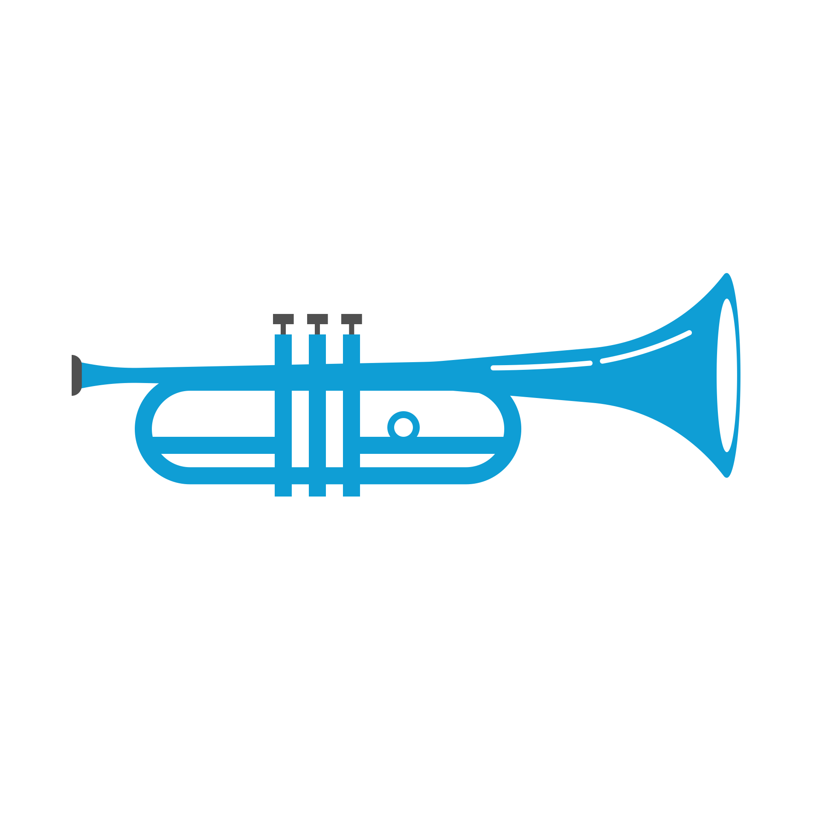  Music | The Music of North America  Children will:  - explore the rhythmic music of Indigenous North American peoples. They will learn how drumming, chanting and call-and-response are used to tell stories, then compose and perform their own rhythmic story pieces from simple rhythm notation.  - learn how the blues grew out of hardship and struggle. They will sing in a call-and-response style, play the 12-bar blues on tuned instruments and improvise their own short melodies.  - discover how country music tells stories through song. They will compare it with the blues, listen for instruments such as the fiddle and banjo, and write and sing their own verse.  - explore the lively, syncopated rhythms of Latin music, including the clave. They will layer parts to perform as a whole-class ensemble, then evaluate their performance using musical vocabulary such as tempo, dynamics, timbre and texture.
  French  with  Madame Hanna | Children will:  - develop their language skills across the four attainment targets (speaking, listening, reading and writing) with a primary focus on speaking and listening  - learn vocabulary linked to the weather and clothes  - learn about French traditions at Christmas time.
Enrichment Ideas | - Explore North America together using Google Earth. Visit famous landmarks such as the Grand Canyon, Niagara Falls and the Rocky Mountains and compare the landscapes with those in Kent.  - Visit a local nature reserve, such as Sevenoaks Wildlife Reserve, to observe plants, insects and birds at different stages of their life cycles.  - Go on a life cycle hunt in your garden, a local park or woodland. Take photographs to record changes over time.  - Explore North American food and culture by cooking a traditional dish from Canada, the USA or Mexico. Find out where the ingredients come from and locate the country on a map.
Suggested Reading | - Earth’s Incredible Places – Grand Canyon, Susan Lamb  - 50 Adventures in 50 States, Kate Siber & Lydia Hill  - City of Spies, Iszi Lawrence  - The Good Thieves, Katherine Rundell

