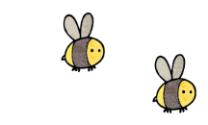
Curriculum - Term 2 November 2026
OWLS Y4
Topic for the Term | Romans in Britain
Topic for the Term | Our history learning this term is continues with the Roman invasion in Britain, specifically looking at the uprising of Boudicca and the Iceni Tribe.
What we’ll be learning | - Who Boudicca was and the uprising  - Why the Romans Left Britain  - What the Romans have left behind


English
Reading | - World’s Worst Gladiator  - Julius Zebra 2  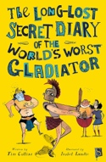  - Diary of a Roman Girl
Whole class book | World’s Worst Gladiator
Writing | Children will write:  - poetry  - a speech  - a diary entry.  Writing will be linked to history learning, where appropriate.
Grammar, Spelling & Punctuation | Children will learn:  - compound Words  - conjunctions  - possessive pronouns
How you can help at home | Hear your child read at home frequently and ask them questions about what they have read.  Check they understand the meaning of words.


Maths
Area | Children will learn:  - What is area?  - Making shapes and comparing the areas
Multiplication | - Multiplication and division up to 12 x 12
Reasoning and Fluency | - Reasoning questions  - Mathematical puzzles  - Problem solving  - Recap of column addition and subtraction
How you can help at home | Have your child do their TT Rockstars homework for 5 mins daily to increase their speed and accuracy.

  Science | Animals Including Humans  Children will investigate:  - why animals have different teeth  - food chains  - the digestive system
  Art & Design Technology | DT – children will:  - build, make and evaluate slingshot cars
  Computing | Photograph editing - children will:  - taking photographs and edit them  - put on a gallery display of their photographs
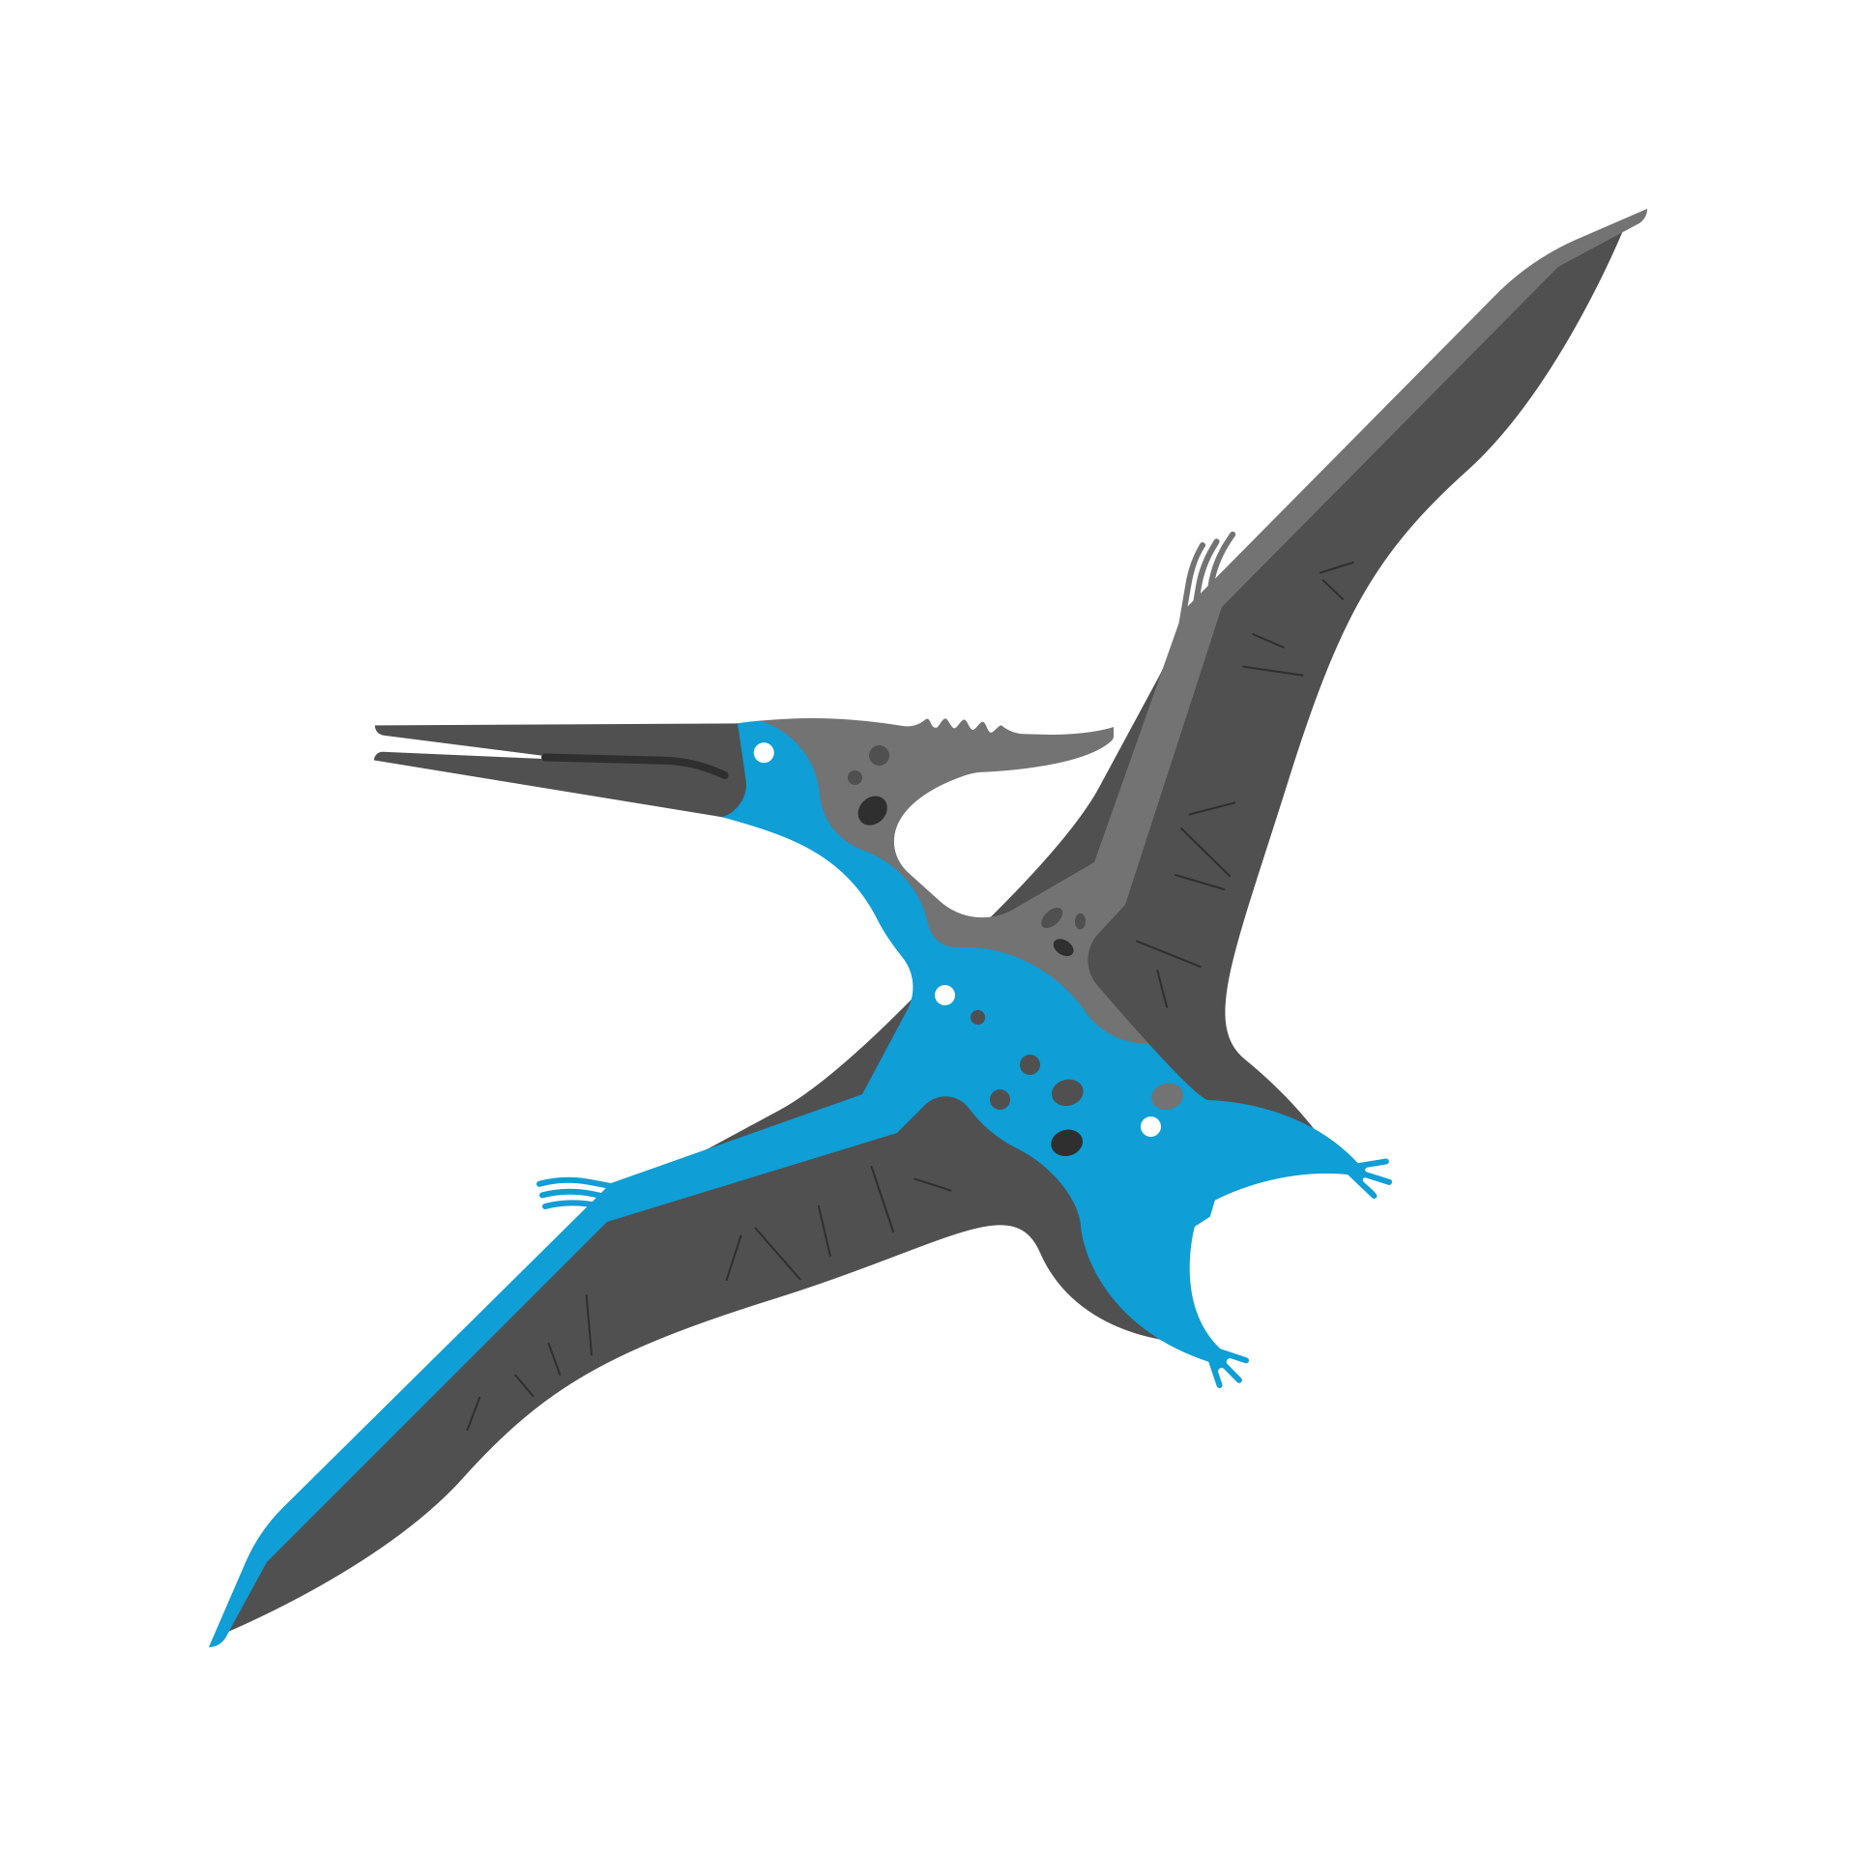  History &  Geography | Romans In Britain – children will learn about:  - Boudicca’s uprising  - why the Romans left Britian  - the Roman legacy in Britain
  Religious  Education | Incarnation (the Trinity) – children will learn:  - about the Holy Spirit  - how the concept of the Trinity impacts the way Christian’s celebrate Christmas
  Physical  Education | In addition to the daily mile, children will be doing PE on Wednesdays and Thursdays (fitness and football). Please make sure that PE kit is always in school as there may be occasions when we will use it on other days. Earring should be taken out, not taped up.
  PSHE | Valuing Differences – children will learn about:  - sharing  - sharing our world with others  - celebrating differences  - stereotypes
  Music | - Children will continue to learn the ukulele with Mr Lawrence (on Tuesdays).
  French  with  Madame Hanna | Children will:  - develop their language skills across the four attainment targets (speaking, listening, reading and writing) with a primary focus on speaking and listening  - learn vocabulary linked to colours, where they live and European countries  - learn about French traditions at Christmas time.
Enrichment Ideas | - Take your child to Lullingstone Roman Villa  - Take your child to the Ameila Museum in Tunbridge Wells to see their Evolution Collection
Suggested Reading | - Vita and the Gladiator, Ally Sherrick  - A Gladiator Stole my Lunchbox, Thiago de Moraes  - The Magnificent Book of Treasures: Ancient Rome, Eugenia Nobati & Stella Caldwell  - There was a Roman in your garden, Bettany Hughes

