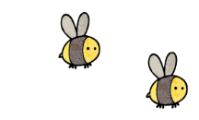
Curriculum - Term 2 November 2026
Rabbits Y3
Topic for the Term | The Stone, Bronze and Iron Ages
What we’ll be learning | What did Britain look like then?  How did people’s lives change and why?  How to use a timeline.


English
Reading | Children will:  - read fiction and non-fiction about rocks, France and Christmas  - develop their comprehension skills using VIPERS
Whole class books | A Boy named Christmas  Varjak Paw
Writing | Children will write:  - narratives  - season poems  There will be an emphasis on presentation, good letter formation and neat handwriting.
Grammar, Spelling & Punctuation | Children will:  - focus on correctly demarcating sentences  - be applying speech punctuation and prepositions  - spell words with the prefix re-, mis- and dis-  - add -ing, -er, -en or -ed to multisyllabic word  - spell challenge words from the Y3 list.
How you can help at home | - Daily reading: encourage your child to read to you for 10–15 minutes each day, discuss the story asking questions about characters, vocabulary and make predictions.  - Discuss current events. BBC Newsround is a good starting point. https://www.bbc.co.uk/newsround


Maths
Addition and Subtraction | Children will:  - use mental strategies  - add and subtract numbers with up to 3 digits  - use rounding to check answers to calculations  - be introduced to column methods without exchange  - check answers using inverse operations  - estimate, add or subtract using number lines  - solve one and two-steps problems in context.
Multiplication and Division | Children will:  - multiply equal groups  - share into equal groups or make equal groups  - use arrays  - explore multiples of 2, 3, 4, 5, 8 and 10
How you can help at home | - Practising times tables regularly (children should be fluent in 2, 3, 4, 5, 8, and 10 by the end of Year 3).  - Play games spotting multiples: eg is 32 a multiple of 5? How do you know?  - Encourage your child to explain how they worked something out, not just the answer.  - Use maths in everyday life whenever possible—shopping, cooking, telling the time, timetables and games all provide valuable practice.

  Science | Rocks and soils  Children will:  - find out how rocks are formed  - observe what soils are made of and why  - use scientific equipment such as magnifying glasses and microscopes  Forces and magnets  Children will:  - explore friction as a contact force  - explore magnetism as a non-contact force
  Art & Design Technology | Children will:  - continue sewing, using cross-stitch and applique, to create a small cushion  - explore collage  - make art inspired by the Bronze Age.
  Computing | Children will:  - revise how to stay safe on-line  - learn some basics in programming using Scratch.  - focus on motion and sound
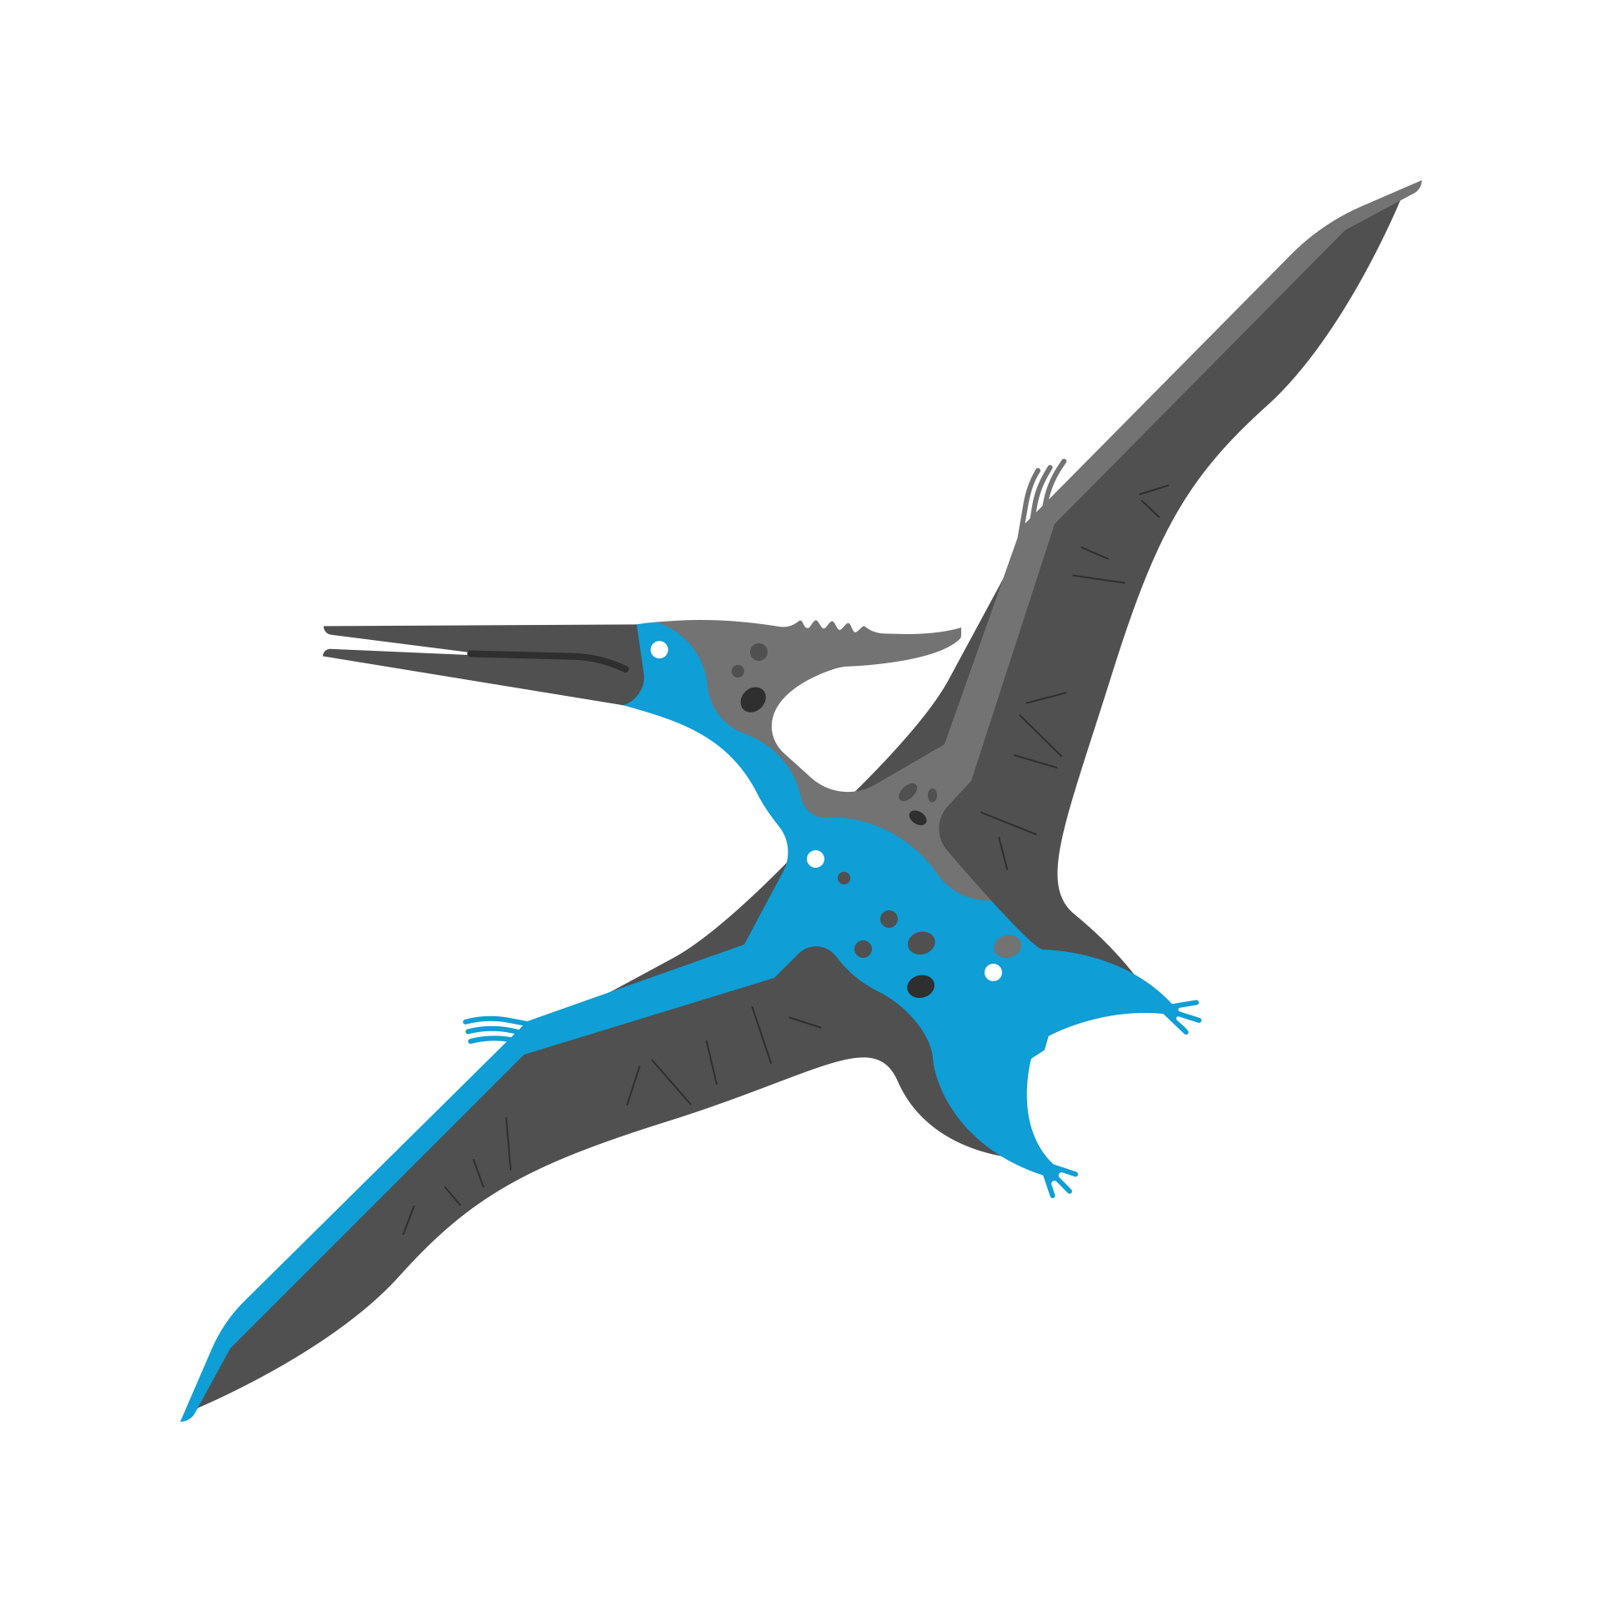  History &  Geography | History - children will:  - develop their understanding of the chronology from the Stone Age to the Iron Age in Britain  - think about what evidence archaeologists and historians use to find out about that era  - learn how the introduction of metals changed people’s lives  - discover what tools people used and why  - consider the evolution of settlements in that period, including the apparition of hillforts.
  Religious  Education | Our key question is: “What is the Trinity?” Children will:  - understand why water is an important symbol for Christians  - discover the meaning of the Trinity for Christians  - explore the symbolism in the Baptism of Christ and modern day Christenings and Baptisms.
  Physical  Education | In addition to Friday’s Forest School and the daily mile, children will take part in:  - Dance (Tuesdays)  Days for PE are scheduled as above but may vary according to the weather so please have PE kit in school at all times. Also, please check school requirements to ensure children with ears pierced can join all lessons safely – earrings need to be removed (not taped).
  RSHE | Valuing differences  As a class, children will:  - discuss the concept of respect and how it applies within the different groups they belong to such as friends, family, neighbours, school, etc…  - explore what bullying is and strategies to deal with it.
  Music | Children will:  - appreciate and understand a wide range of high-quality recorded music  - play and perform, using voices with accuracy, fluency and control.
  French | Children will:  - develop their language skills through speaking and listening, using songs and games  - explore colours, family and Christmas in France
Enrichment Ideas | - Go for a walk in Oldbury Hill – see if you can spot the remains of the Iron Age hill fort that once stood there.  - Create Bronze or Iron Age inspired artefacts – make a piece of jewellery or art inspired by the Beaker people or the Celts.  - Visit – the Wonder Lab in the Science Museum  - Go for a magnet hunt – how many can you find in and out of the house? How are they useful?  - Watch a child-friendly documentary – BBC Bitesize and Horrible Histories have engaging videos about the Bronze and Iron Ages.
Book recommendations | - The Boy with the Bronze Axe – K. Fidler  - The Playdate – C. Dackenberg & U. Brandelius  - Step into Science – Forces and Magnets  - How Winston delivered Christmas – A. T. Smith  - Leonora Bolt – G. Jose & L. Brandt

