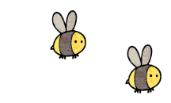
Curriculum - Term 2 November 2026
Squirrels – Year 2
Topic for the Term | Polar Regions
Topic for the Term | Where are the Polar Regions and what is it like there?  What is the same and different between the Poles?
What we’ll be learning | We will learn about the location, flora and fauna and specific geographical features and vocabulary of the Polar Regions. Where possible, we keep the polar theme woven through most subjects.


English
Reading | Children will:  - share fiction and non-fiction books looking at features and differences.  - begin to use dictionaries and thesauruses.
Whole class books | - Danny’s bear  - The Arctic Jellyfish  - The Polar Bear’s Son – an Inuit Tale  - Santa’s New Beard  - A range of non-fiction text looking at specific adaptations of polar animals and plants.
Writing | Children will:  - look at the features of non-chronological reports  - create their own reports based on our their imaginative mythical polar creature  - plan effective sentences for narratives, exploring synonyms to engage the reader.  - improve their writing and begin to re-read and edit their work  - retell parts of a story and explore creating their own alternative.  - share Christmas themed poems and look at different structures and types including acrostic, rhyming, comparative and shape poems.
Grammar, Spelling & Punctuation | Children will:  - learn about statements, commands and questions.  - use full-stops, question marks, exclamation marks, commas and apostrophes for contraction  - use verbs, adverbs, adjectives and nouns  - follow the Little Wandle Bridge to Spelling.
How you can help at home | - Listen to your child read regularly.  - Read stories that are beyond your child’s ability exploring plot and unfamiliar vocabulary.  - Share a story verbally – retell each other stories or alternate sentences with each other.  - Share a range of non-fiction books looking at features eg sub-headings, questions, captions.


Maths
Place Value | Children will:  - read, write and compare numbers to 100 and partition them.  - recognise and mark numbers on a number line and place value grid.
Addition & Subtraction | - add and subtract 1 and 10 more or less  - add two-digit and one-digit numbers together crossing the tens barrier  - subtract a one-digit number from a two-digit number crossing the tens  - use number facts to check calculations  - make number bonds to 100  - estimate and compare numbers  - begin to problem solve in both written and practical scenarios  - begin to add and subtract using a number line, part-whole models and place value chart.
Shape | - learn the properties and names of 2 and 3-dimensional shapes  - sort these and explore symmetry.
How you can help at home | - Practise forming the numerals correctly in one movement (except for 4).  - Simple board games using two dice – it is helpful if you practise adding and subtracting the dice. Encourage children to partition numbers to cross the tens barrier and feeling secure on their number bonds to 10.  - Hit the button addition and subtraction to 10, 20 and beyond on www.topmarks.co.uk is great fun and only takes a minute.

  Science | - jane
  Art & Design Technology | Children will:  - look at printing using fingerprinting, matchbox printing and introduce roller and ink  - learn how to blend two colours of ink and then create our own polyprinting blocks  - use a range of media and design skills creating Christmas craft  - look at fixed and free axels and design a Christmas inspired ferris wheel.  - study the Canadian Inuk/Inuit artist Kenojuak Ashevak and her importance in raising awareness of cultural art.
  Computing | Creating Media: Digital Photography  Children will:  - use a digital device to take a photograph  - make choices when taking a photograph  - describe what makes a good photograph  - decide how photographs can be improved  - use tools to change an image  - recognise that photos can be changed.
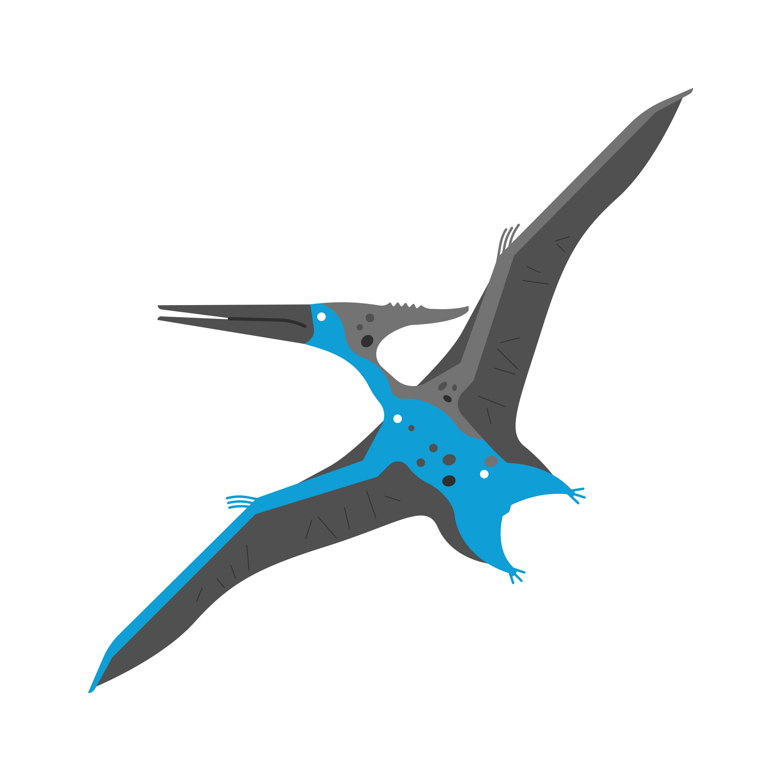  History &  Geography | In Geography, children will:  - look at where the Arctic and Antarctic are located in relation to our country and find these on maps, atlases and globes.  - look at polar weather and the extreme habitat and how this affects the people and animals living there.  - look at the effect of climate change on this area.  Historically, we will look at the Titanic and how life was different to our experiences.
  Religious  Education | Universal: How should we care for others and the world and why does it matter?  Children will learn:  - what Christians believe about caring about others  - what people of different faiths believe about caring about others
  Physical  Education | PE: Sending and Receiving  Children will:  - learn how to send and receive a ball through rolling, kicking and throwing  - practise techniques for accuracy and speed and be aware of the ready position in sending and receiving.  Dance and Drama – learning scripts, songs and dances for our Christmas Nativity.
  PSHE | VALUING DIFFERENCE  Children will:  - think about what makes us who we are  - explore people who are special to us, how we make others feel, how to recognise when others are feeling left out, how to act kindly and strategies on how to solve problems.
  Music | Children will:  - Learning Christmas songs with a focus on:  - Timbre  - pitch  - tempo
Enrichment Ideas | - Find out about polar animals and their special features that allow them to survive.  - Watch polar inspired movies.  - See how the weather and landscape changes outside.  - Make bird feeders and create cosy corners in the garden.  - Go for a walk and spot the birds’ nests and squirrels’ dreys as the trees become bare.
Suggested Reading | - The Great Explorer, Chris Judge  - Ernest Shackleton, Little People Big Dreams  - The Lights that Dance in the Night, Yuval Zommer  - The Story of Snow, Jon Nelson

