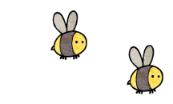
Curriculum - Term 2 - November 2026
ROBINS Y1
Topic for the Term | Childhood Then and Now  Festivals Around the World
What we’ll be learning | We will be discovering what childhood was like in the past and compare it to now, with a focus upon toys from the past. We will explore festivals and how they are celebrated.


English
Reading and Phonics | Children will:  · listen to, follow and enjoy a story with a repeating pattern.  · re-tell a familiar story using sentences.  · recognise and fluently read all phase 3, 4 and new phase 5 sounds and sight words introduced this term.  · blend to read for meaning, simple phonetically plausible words in sentences
Writing | Children will:  · understand that a sentence is a set of words that make sense.  · write sentences beginning with capital letters and end with a punctuation mark.  · write stories using a range of verbs, adjectives and ambitious vocabulary and develop narrative, recount and instruction writing skills.
Grammar, Spelling & Punctuation | - Focus on punctuation and using phonics to attempt plausible spellings.
How you can help at home | - Continue to read at home daily with a focus on understanding and inference.  - Practise all taught graphemes.  - www.phonicsplay.co.uk


Maths
Addition and Subtraction  2d and 3d shape | Children will:  - sort and count objects  - count objects from a larger group  - represent objects  - recognise numbers as words  - count 1 more and 1 less, count on from any number, count backwards within 10  - compare groups by matching  - use mathematical language: fewer, more, same, less than, greater than, equal to  - compare numbers  - order objects and numbers  - use a number line
How you can help at home | - Practise number formation  - www.ictgames.com

  Science  Everyday Materials continued | Children will:  - name a variety of everyday materials  - know that objects are made from materials  - describe and name the simple physical properties of a variety of everyday materials  - become familiar with the term absorbent/not absorbent  - become familiar with the terms waterproof/not waterproof  - revisit the key substantive knowledge from the previous four sessions  - distinguish between an object and the material from which it is made  - identify and name a variety of everyday materials, including wood, plastic, glass, metal, water and rock  - describe the simple physical properties of a variety of everyday materials.
  Art & Design Technology | Printing in Art  Moving Pictures in DT  Children will:  - develop a wide range of art and design techniques in using printing methods  - Use joining and mechanisms to create a moving picture
  Computing  Creating Media | Children will:  - learn how to paint using computers  - use shapes and lines to create media  - compare computer art and paintings.
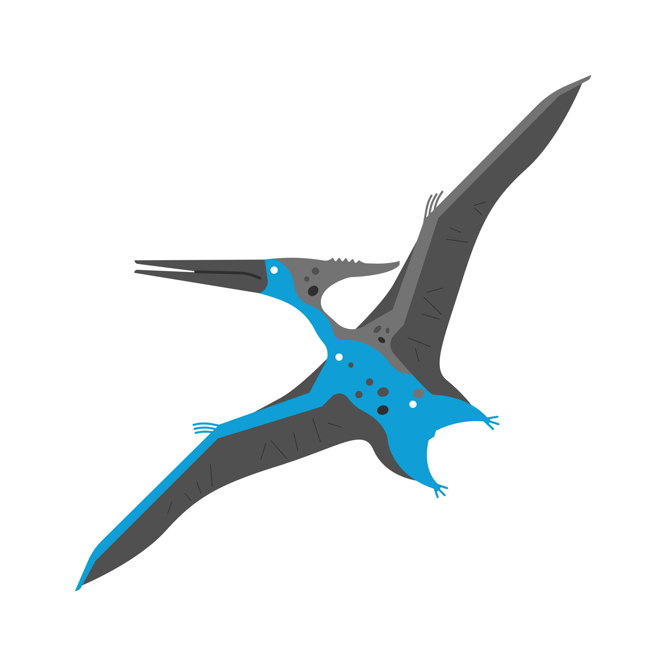  History &  Geography | Grace Darling  Children will:  - Why is Grace Darling remembered today?  - What was life like for Grace Darling, and how was it different from our lives today?  - How do we know what happened during Grace Darling’s rescue?
  Religious  Education | Incarnation: Why does Christmas Matter to Christians? Children will learn:  - hy Christmas is important to people  - why the birth of a baby is a special time to be celebrated and why the birth of Jesus is special for Christians  - the story of Jesus’ birth  - how Christians prepare for Christmas at home  - how Christians prepare for Christmas at church
  Physical  Education  Thursday and Friday | Dance  Children will:  - move in time and make my dance look interesting.  - explore pathways in dance.  - create their own dance using, actions, pathways and counts.  - explore speeds and actions in our pirate inspired dance.  - copy, remember and repeat actions that represent the theme.  - copy, repeat, create and perform actions that represent the theme.  - explore speeds and actions.  - use expression and create actions that relate to the story.  Mindful Movement - children will:  - explore movement, balance and breathing  - develop flexibility when holding balances  - develop balance whilst holding shapes.
  RSHE | Same and Different  Children will learn about:  - identify the differences and similarities between people  - empathise with those who are different from them  - explain some of their school rules and how those rules help to keep everybody safe  - identify some of the people who are special to them
  Music | Children will:  - perform an expressive poem using different vocal effects  - sing a song conveying a variety of feelings  - perform a range of songs to an audience
Suggested Reading | - The Jolly Christmas Postman – Janet and Allan Ahlberg  - The Best Diwali Ever – Sonali Shah  - Bringing in the New Year – Grace Lin
Enrichment Ideas | - Continue to read a variety of books at home  - Design a festive greetings card  - Ask a family member about a celebration and share with the class, bring in a photo

