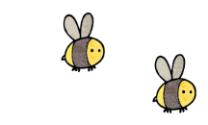 Curriculum - Term 1 September 2026
Hedgehog – Reception
Topic for the Term | Welcome to School
What we'll be learning | Settling into school life and daily routines, making friends, and beginning to explore each area of learning through play.

Communication and Language
Listening & Talking | Children will:  · listen to and appreciate others talking  · communicate with friends and adults about their needs  · talk about their play, toys or items they have brought in to show the class  · start to talk about what they did in the past, for example 'In the holidays I…'
How you can help at home | - Talk with your child about their day and encourage them to share stories and experiences  - Share books together every day and talk about what is happening in the pictures  - Play simple listening games together, such as Simon Says

 Personal, Social and Emotional Development
PSED | Children will:  · work together as a class  · share and learn what kindness looks like in practice  · learn to label their emotions
How you can help at home | - Encourage sharing and taking turns during games at home  - Talk about feelings and give your child the words to describe how they feel  - Praise kindness, good manners and cooperation

 Physical Development
PD | Children will:  · explore different mediums to pinch, squeeze and shape  · join in with dance and movement throughout the day, including catching, throwing, jumping, climbing and running
How you can help at home | - Encourage independence with coats, zips, buttons and shoes  - Provide opportunities to run, climb and be active outdoors  - Practise using scissors, pencils and cutlery

 Phonics
Little Wandle | Children will:  · follow Little Wandle Autumn 1: SATPIN sounds
How you can help at home | - Practise the sounds taught each week  - Play simple games such as I Spy, using sounds rather than letter names  - www.littlewandle.org.uk

 Mathematics
Number & Routine | Children will:  · learn about the daily routine at school and some positional language, e.g. where do things in our classroom belong?  · explore the concept of matching pairs, e.g. can you find one that looks like mine? How do you know that this is a match?
How you can help at home | - Talk about where things belong at home, using words like 'on top of', 'next to' and 'behind'  - Play simple matching games, such as matching socks or spotting pairs

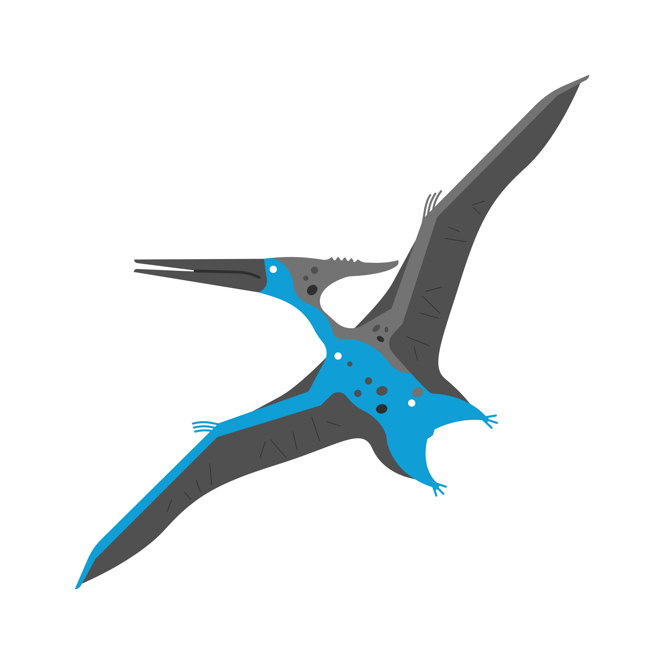 Understanding the World
UTW | Children will:  · begin to understand the changing seasons and the natural world around them  · understand the past through settings, characters and story telling
How you can help at home | - Talk about the seasons and changes you notice together on walks  - Share stories about your own childhood or family history  - Visit local outdoor spaces and talk about what you see

 Expressive Arts and Design
EAD | Children will:  · explore a range of natural objects and mediums  · give meaning to their art and marks, and explain what they have made  · listen to, make and appreciate music
How you can help at home | - Provide opportunities to draw, paint, build and make with everyday materials  - Ask your child to talk about what they have made  - Sing songs and listen to music together

 Religious Education
RE | Children will:  · explore our school values of Love, Truth and Forgiveness  · take part in class worship and prayer, talking about what we are thankful for  · learn about God and explore New Testament stories
How you can help at home | - Talk about kindness, honesty and saying sorry  - Share what your family is thankful for  - Talk about different celebrations and what they mean

Suggested Reading | - Starting School – Janet and Allan Ahlberg  - The Colour Monster – Anna Llenas  - Owl Babies – Martin Waddell

Enrichment Ideas | - Continue to read a variety of books at home every day  - Practise saying and writing your child's name  - Talk to your child about starting school and answer any questions they may have

