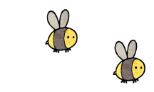
Curriculum - Term 6 June/July 2026
BADGERS Y6
Topic for the Term | Transition and Summer Production
What we’ll be learning | This term, alongside their usual curriculum, the children will work together to build sets, props and produce a show.  Alongside this, they will also research their new schools and discuss and support each other with any concerns or confusion over their next steps in education.


English
Reading | The children will spend much of their reading focus on Oracy and presentation through their production scripts and rehearsals.
Whole class book | Redwall by Brian Jacques  The Explorer by Kathrine Rundell
Writing | Writing this term will prepare the children’s books for presentation at moderation, showing off what the children can do. To best prepare them for this we will focus on:  - Non-Chronological Report  - Narrative (including dialogue)  - Persuasive letters  We will also use some of our writing time to prepare leavers’ speeches for the end of year services.
Grammar, Spelling & Punctuation | This term, these topics will be very much intwined within their writing sessions rather than as discrete learning. We will review areas of the curriculum as we go, to ensure we are able to show off these skills to the best of our ability.
How you can help at home | Please encourage your children to read a wide range of texts and practise their lines for the end of year production.


Maths
Investigations and projects | Having covered the curriculum in the lead up to SATS in Term 5, this term we will focus on real world application of Maths and revision of areas of the curriculum which will best prepare them for Year 7 maths. This will be approached by various projects that require the use of Mathematical approaches.
How you can help at home | Real world Maths, such as: handling and familiarity of money; encouraging the use of clocks and timetables for time understanding; discussion and planning of journeys to understand distance; cooking with use of measurement and weight.

  Science | CLASSIFICATION  Children will:  - explore the work of Carl Linnaeus  - develop their understanding of categorisation of creatures beyond different animal groups and plants.  - compare living things in our school environment.
  Art & Design Technology | ART  DT  We will make use of woodworking skills to create cam toys with moving parts.
  Computing | MicroBits  The children will use coding skills from previous years to complete projects using an external computer (MicroBit)
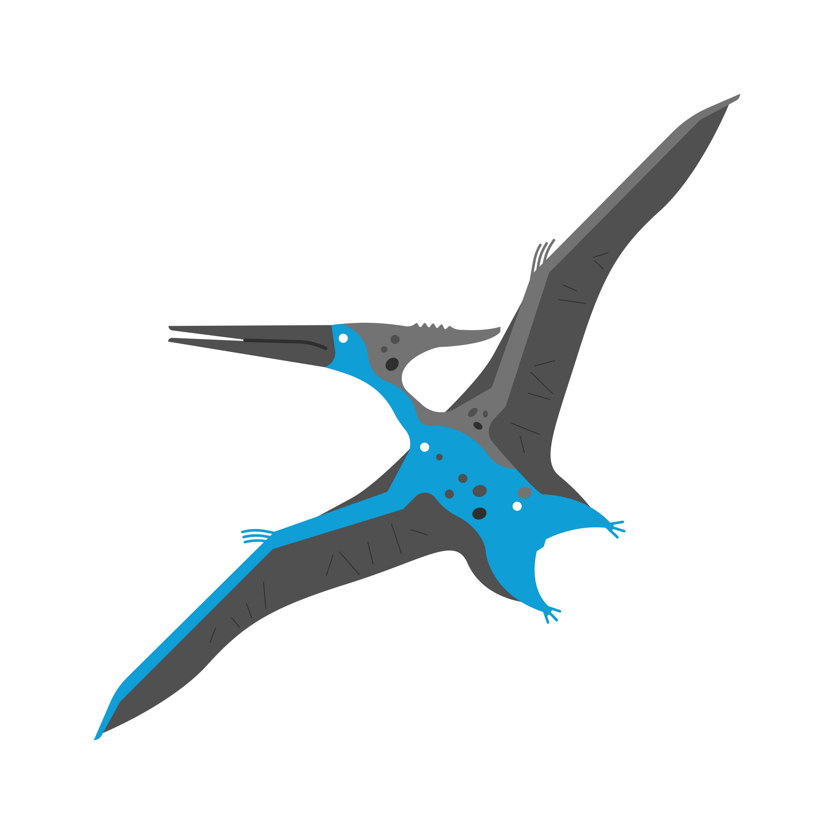  History &  Geography | GEOGRAPHY – Rainforests and South America  The children will research and compare three regions of the world (Amazon Rainforest in South America, The Black Forest in Germany, and Sherwood Forest in England)
  Religious  Education | Kingdom of God
  Physical  Education | Alongside the dances we will be practising on a Tuesday with Mrs Doll (for our summer production) we will also have PE on a MONDAY where will continue our focus of athletics and cricket.
  PSHE | My Growing Body and Transition to Secondary  - The children will have lessons around physically maturing, relationships and understanding physical relationships  - They will also make use of lessons to research their secondary schools and discuss things they are excited or nervous for.
  Music | Grimm – Once Upon a Musical  This term the children will focus on producing a summer play and musically develop the songs into a performance.

French
with
Madame Hanna

Enrichment Ideas

