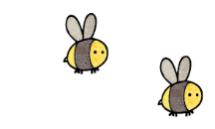
Curriculum - Term 6 June/July 2026
OTTERS Y5
Topic for the Term | Ancient Greece
What we’ll be learning | We continue our overarching theme of Ancient Greece. We will look at a variety of sources that show political, social and cultural aspects of Ancient Greek life and will consider the achievements of the Ancient Greeks their legacy.


English
Reading | Children will:  - focus on identifying how language, structure and presentation contribute to meaning  - discuss and evaluate how authors use language, including figurative language, considering the impact on the reader.
Whole class books | 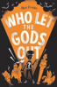  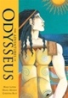  Who Let The Gods Out?  The Adventure s of Odysseus
Writing | Children will write:  - narratives  - scripts (which they will then video)  - poetry  Writing will be linked to our topic where appropriate.
Grammar, Spelling & Punctuation | Children will:  - continue working on building cohesion within a paragraph and linking ideas across paragraphs a range of devices  - learn words with hyphens, challenge words from the Y5/6 national curriculum and revise spellings learnt across the year.
How you can help at home | - Daily reading: encourage your child to read for 10–15 minutes each day and discuss the story together by asking questions about characters, vocabulary and predictions.  - Keep a holiday or weekend journal.  - Write postcards or letters.  - Create comic strips.  - Make fact files about favourite topics.  - Write instructions for a game or recipe.  - Discuss current events. BBC Newsround is a good starting point. https://www.bbc.co.uk/newsround


Maths
Decimals | Children will:  - continue to add and subtract decimals  - look at sequencing decimals  - multiply decimal numbers by 10, 100 and 1000
Negative Numbers | - investigate negative numbers, counting through 0 in 1s and multiples  - order and compare negative numbers  - find the difference between negative numbers and integers
Converting Units | - convert between metric units  - convert between metric and imperial units of measure  - convert units of time
Volume | - measure, compare and estimate volume and capacity.
How you can help at home | - Measure ingredients in g/kg and ml/l.  - Double or halve recipes using decimals.  - Compare different container capacities.  - Estimate before measuring.  - Time runs using decimal seconds.  - Compare water bottle capacities.

  Science | LIVING THINGS AND THEIR HABITATS  Children will:  - plan different types of scientific enquiries taking measurements, using a range of scientific equipment, recording data and results and report findings from enquiries  - visit Lullingstone Country Park to pond dip and investigate grassland habitats, to find out where different plants and animals live  - use a range of identification keys to recognise what they’ve found  - think about how the animals have adapted to live in their current habitat.
  Art & Design Technology | Children will:  - undergo research to compare products  - describe the process of beef production  - research a traditional recipe and make changes to it  - add nutritional value to a recipe by selecting ingredients  - prepare and cook a version of Bolognese sauce.
  Computing | Children will:  - spend some time learning how to be safe onlin  - look at video as a media format  - see examples of videos featuring production and editing techniques  - work towards creating their own videos.
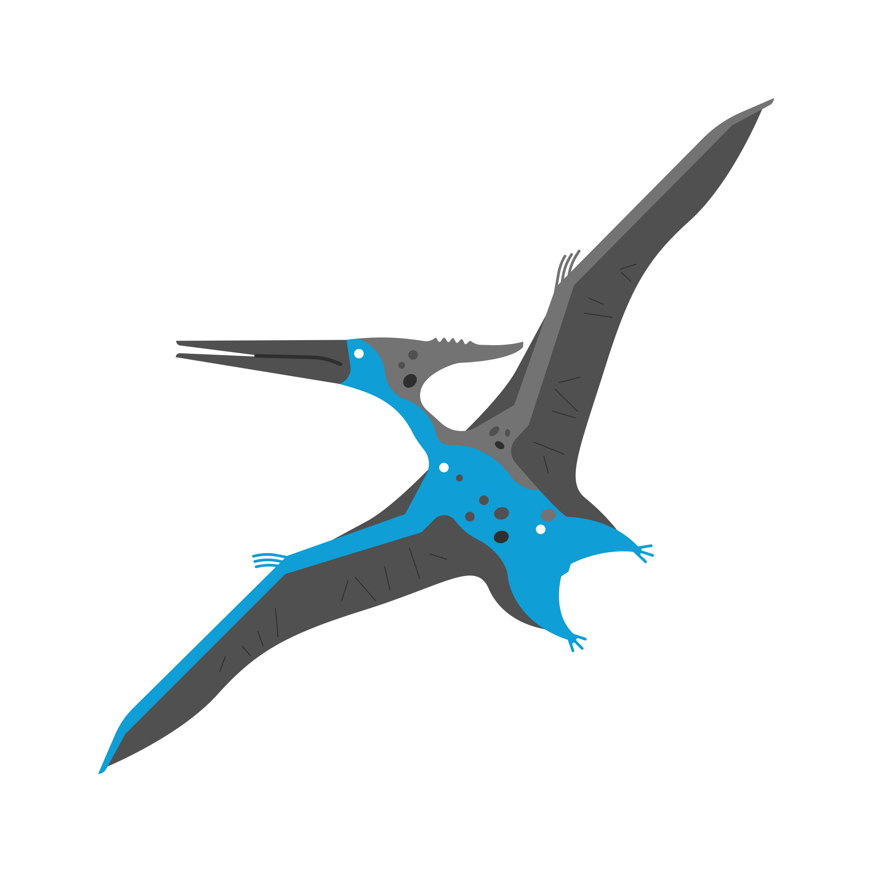  History &  Geography | History - children will:  - learn about Ancient Greek life and achievements and the influence of this period on the modern world - the legacy of Greek culture (art, architecture or literature).  Geography – children will:  - focus on map work, creating their own maps  - wayfinding using compasses and taking a baring when we visit Lullingstone Country Park.
  Religious  Education | ISLAM - What Does It Mean To Be Muslim In Britain Today?  Children will:  - look at the role of the Mosque  - learn why Muslims believe donating to charity is important  - think about why Muslims fast and go on pilgrimages.
  Physical  Education | In addition to the daily mile, children will take part in:  - Rounders  - Athletics  Days for PE may vary according to the weather so please have PE kit in school at all times.
  PSHE | BEING MY BEST  Children will look at:  - increasing independence  - the role of social media and how it can make some people feel.
  Music | In preparation for the Fête de la Musique and the end of term production, children will:  - play and perform, using voices and playing musical instruments with accuracy, fluency, control and expression  - improvise and compose music for a range of purposes  - listen with attention to detail and recall sounds.
  French  with  Madame Hanna | Children will have the opportunity to develop their language skills across the four attainment targets (Speaking, Listening, Reading and Writing) with primary focus on speaking and listening.  Communication and understanding. Children will:  - understand and tell the time on the hour, half hour and quarter/quarter past the house (analogue clock)  - understand and use vocabulary for basic food and drink items  - be able to order simple food and drink in a French café  Awareness of language patterns and understanding grammar. Children will:  - use expressions of time  Cultural understanding. Children will:  - understand something of French café culture  - understand that France uses the euro as currency and complete simple transactions
Enrichment Ideas | Create a Greek Artefact:  - design a Greek pot pattern  - create a laurel wreath  - build a Trojan Horse model  Greek Food Tasting - try foods linked to Ancient Greece:  - Olives, feta cheese, grapes and honey  - cook your own flatbreads.  Greek Architecture Hunt:  - look for columns and patterns in buildings nearby or online.  - Identify pillars, symmetry, decorative patterns  - sketch a Greek temple design.

