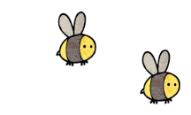
Curriculum - Term 6 June/July 2026
OWLS Y4
Topic for the Term
Topic for the Term | World War 2
What we’ll be learning | - Geographical features  - Compare and contrast 1939 to 2024  - Biggin Hill Airport


English
Reading | - In reading we will continue to improve our VIPERS skills which will be used to interrogate both fiction and non-fiction texts, many of which will be linked to our topic, during comprehension sessions.
Whole class book | 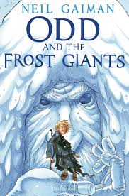  A mixture of WW2 books.
Writing | - Genres for writing – linked to our topic where appropriate - will include, narratives, explanation texts, speeches and brochures which will also form part of our speaking and listening targets.
Grammar, Spelling & Punctuation | - In grammar and punctuation, we will recap correctly demarcating sentences and focus on tenses, plurals, inverted commas and fronted adverbials. Spelling will involve looking at words with the letter patterns ‘i’ before ‘e’, sol, real, phon, sign, anti, auto and bi meaning two. Throughout these spelling sessions we will use dictionaries and thesauruses. There will continue to be an emphasis on presentation and neat handwriting.
How you can help at home


Maths
Shape | - Understand and identify angles as turns  - Compare and order angles  - Study triangles, quadrilaterals, and polygons  - Lines of symmetry within shapes
Statistics | - Interpret charts and line graphs  - Comparison, sum and difference  - Draw line graphs
Position and direction | - Describe position  - Plot coordinates  - Draw 2D shapes on a grid  - Translate the shapes
How you can help at home | Times tables recall- chanting, quizzing and TTRS ahead of MTC.

  Science | Living Things and Their Habitats  - Students will explore the characteristics that define living things, including the basic needs of plants and animals. They will learn about different habitats, such as forests, oceans, and deserts, and how organisms are adapted to survive in these environments. The unit will also cover the importance of food chains and ecosystems. Through hands-on activities and observations, students will deepen their understanding of biodiversity and the interconnectedness of life. We will also be working scientifically by using scientific vocabulary consistently with written explanations.
  Art & Design Technology | - Following on from talking about Dunkirk and the boats in our WW2 topic and our topic in Science of electricity, we will be planning, constructing and painting a lighthouse. After that we will be adding a circuit to our lighthouse using, cells, wires, bulbs and maybe even a switch!
  Computing | - We will be using the program ‘Scratch’ to create repetition of code in order for our sprite to move and complete tasks. These sequences of code will be put together to create an animation based interactive game.
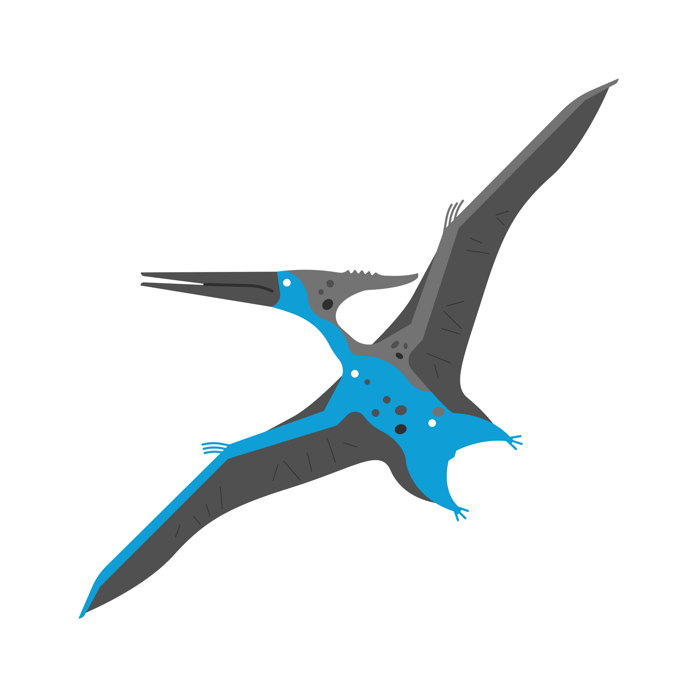  History &  Geography | - We will continue with our WW2 topic, however, we will be looking in more detail about the geographical side during these lessons. Biggin Hill played a huge role in WW2 and throughout this term we will be exploring just what the little village, so close to us did. We are very lucky to be going on a WW2 Experience Day too.
  Religious  Education | Hindu Dharma  - In term 6 we continue our study of Hindu Dharma. We ask questions like, what do Hindus believe about God? How do people that follow the Hindu religion choose to worship? How is Diwali celebrated? What is the Holi Celebration? Along with many more intriguing questions.
  Physical  Education | - Athletics – pupils will further their technique from previous years as we cycle through each athletic event, starting with long distance running, moving on to short distance running, throwing, jumping, relays and officiating an event. This will prepare us for our infamous St Katharine’s sports day.  - Cricket – pupils will learn to throw both over and under-arm, as well as learning the correct bowling, batting and wicket keeping skills. We will apply these to a game of cricket, where we will all pick up the rules of the game.
  PSHE | Growing and Change  - Moving house and change  - Secret or surprise – safety  - StK’s has decided not to teach the growing up (puberty) aspects in Year 4 as it is an optional part of the curriculum. PSHE lessons in Year 5 will cover all this information.
  Music | - We are very lucky to be the only year group in the school to be learning the ukulele. Mr Laurence’s lessons are on Tuesdays, where the children will develop their skill with the instrument and their understanding of staff and other musical notations.
  French  with  Madame Hanna | - Understand and talk about where something is  - Understand and use vocabulary for rooms and basic furniture  - Describe their house  - Begin to understand and tell the time in French (hour, quarter and half past)  - Awareness of language patterns and understanding grammar:  - Pupils can:  - Begin to understand and use prepositions  - Understand and use time expressions (including “midi” (midday) and “minuit” (midnight)
Enrichment Ideas | - Visit Biggin Hill (WW2)

