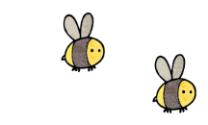
Curriculum - Term 6 June/July 2026
RABBITS Y3
Topic for the Term | Egypt including Ancient Egypt
What we’ll be learning | - We’ll continue with our Ancient Egypt topic, exploring Ancient Egyptians’ engineering achievements, mummification, papyrus, hieroglyphs and their diet. This will be covered in a range of lessons and workshops including an Ancient Egyptian Day.  - We’ll also learn about modern Egypt, using Atlases and finding out about its climate and the importance of the river Nile.


English
Whole class book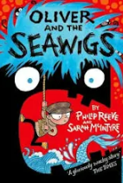 | Oliver and the Seawigs  by Philip Reeve and Sarah McIntyre
Reading and Writing | We’ll be writing using three different genres:  - A set of instructions to help us with a strong mind!  - A biography for an imaginary pharaoh  - A narrative based on the book Flood by Alvaro F. Villa. Please, do not share it with your children till we have finished the unit!
Grammar, Spelling & Punctuation | - Present Perfect  - Clauses  - Words ending in -sion  - Challenge words  - Revisions
How you can help at home | Encourage your child to complete their Spelling Shed.  Keep listening to your children read out aloud.  Ask them questions about the text such as ‘Who said that?’ and ‘What do you think will happen next?’


Maths
Time | - We’ll be using analogue clocks (including those with Roman numerals) and digital  - We’ll estimate and read time the nearest minute, using vocabulary such as o’clock, a.m./p.m., morning, afternoon, noon and midnight.  - We’ll know the number of seconds in a minute and the number of days in each month, year and leap year  - We’ll work out and compare durations of events (for example to calculate the time taken by particular events or tasks).
Shape | - Recognising shapes in different orientations and describing their properties.  - drawing 2-D shapes and making 3-D shapes using modelling materials.  - identify acute, obtuse and right angles, recognising that two right angles make a half-turn, three make three quarters of a turn and four a complete turn  - identify whether angles are greater than or less than a right angle  - identify horizontal and vertical lines and pairs of perpendicular and parallel lines.
Statistics | - interpret and present data using bar charts, pictograms and tables  - solve one-step and two-step questions (for example, ‘How many more?’ and ‘How many fewer?) using information presented in scaled bar charts, pictograms and tables.
How you can help at home | Encourage your child to complete their TT Rock Stars!  Use maths practically: use every opportunity to read the time, and work out duration, especially on analogue clocks.

  Science | PLANTS  - How are seeds dispersed?  - What are the main functions of the different parts of a flowering plant?  - Who do plants make food and how is water transported?  - What does a plant need to stay alive?  - Why does a plant need flowers?
  Art & Design Technology | DT – Nutrition - children will:  - We’re continuing with our local and seasonal food topic, which will culminate in the designing and making of a delicious (hopefully!!!) tart!  Art – Watercolours - children will:  - Learn a range of techniques  - apply them to an Egyptian landscape
  Computing | Publishing  - We’ll look at words and inserting pictures, considering layout, using templates and how to edit.
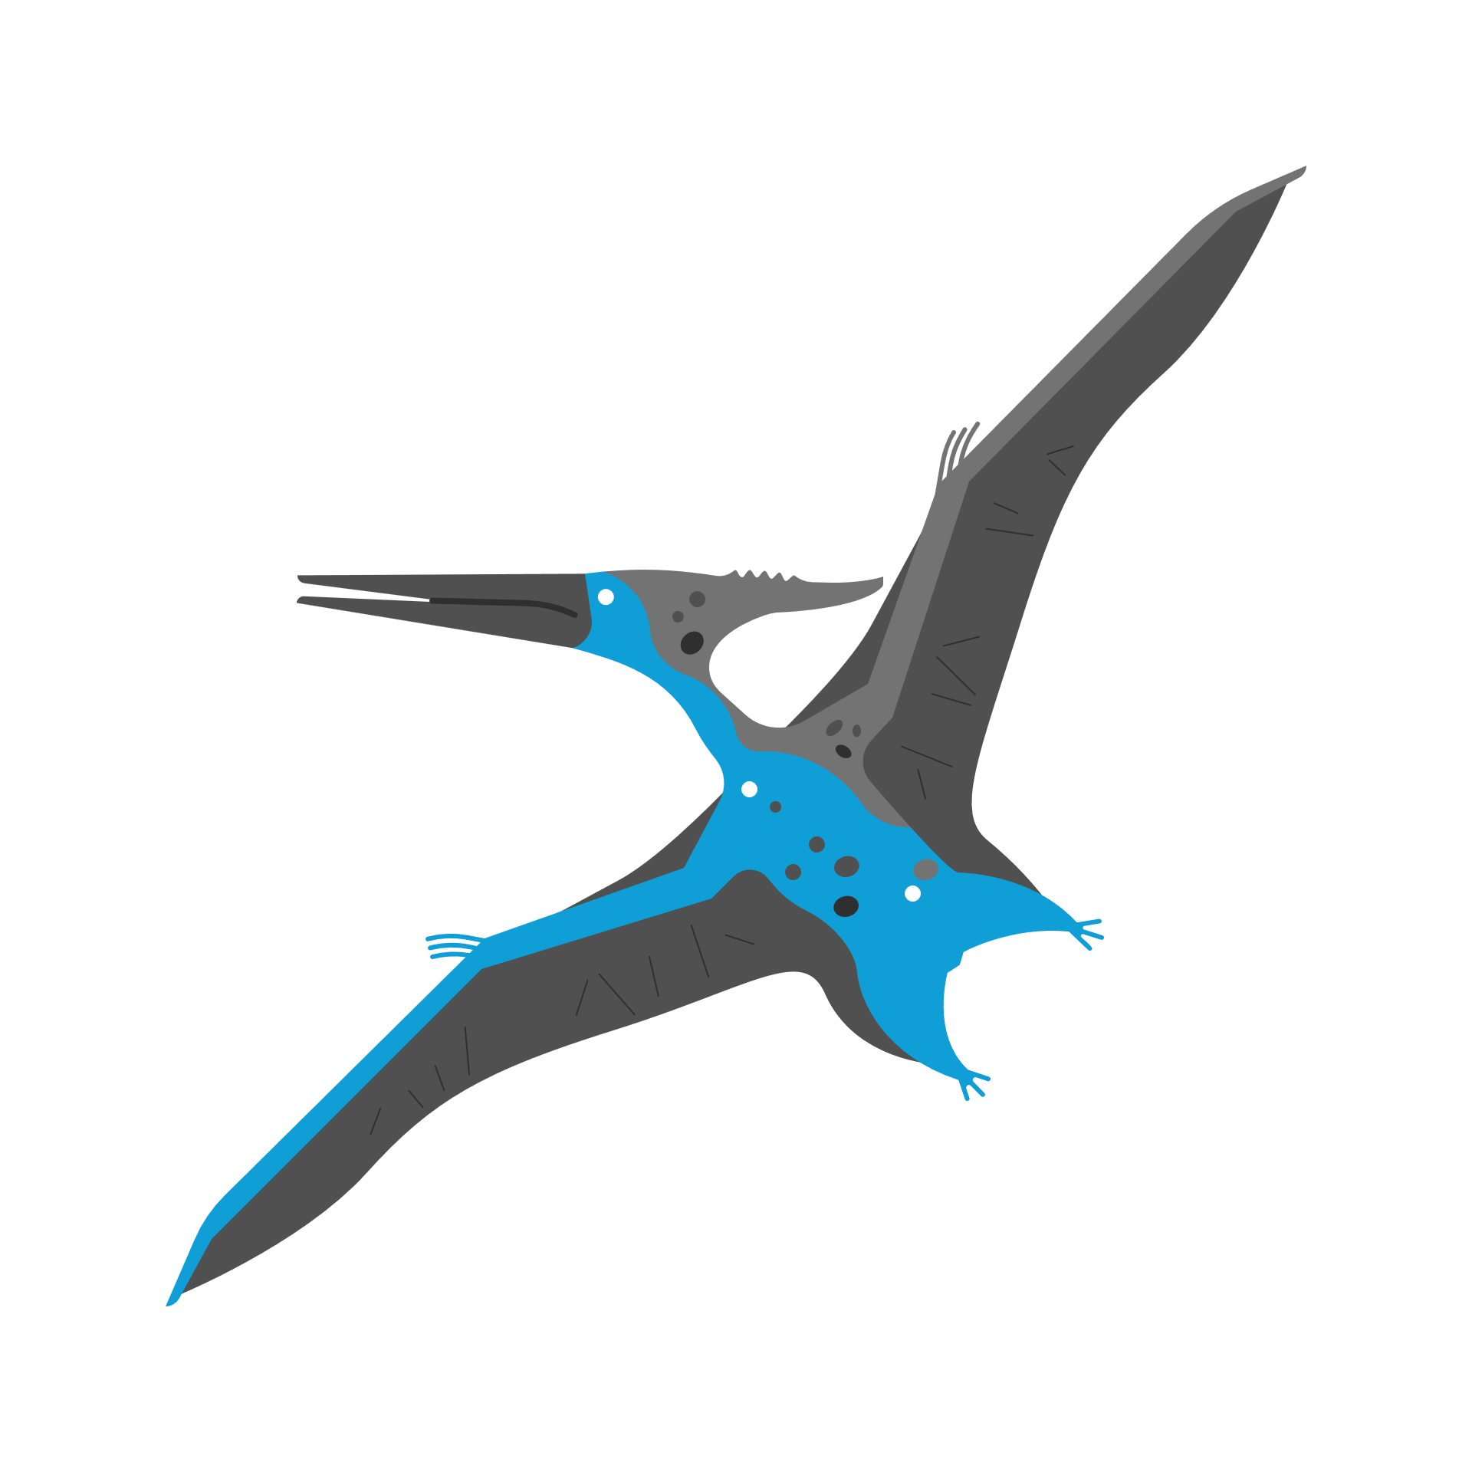  History &  Geography | - We’ll continue with our Ancient Egypt topic, exploring Ancient Egyptians’ engineering achievements, mummification, papyrus, hieroglyphs and their diet. This will be covered in a range of lessons and workshops including an Ancient Egyptian Day.  - We’ll also learn about modern Egypt, using Atlases and finding out about its climate and the importance of the river Nile.
  Religious  Education | HUMANISM  - We’ll find out what it is, what Humanists value, why happiness in important to them, how they celebrate important life events such as weddings, and what they believe about making a difference to the world around them.
  Physical  Education | - Football  - Rounders
  PSHE | GROWING AND CHANGING  This theme will explore a range of topics including our relationships tree, body space, secret or surprise, and some basic first aid.
  Music | - We’ll continue with Ocarina and will sing in French in preparation for a performance later this term.
  French | - We’ll be artistic this term, singing a lot to celebrate the Fete de la Musique, but also exploring the work of Matisse and learning French playground games.
Enrichment Ideas | - Read the time and explore Roman numerals  - Grow some fruits and vegetables and observe the full life cycle.  - Cook together focussing on seasonal and local produce, maybe even, what you’ve grown!

