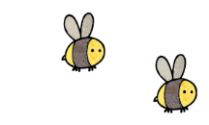
Curriculum - Term 6 June/July 2026
SQUIRRELS Y2
Topic for the Term
Topic for the Term | Sensational Safari
What we’ll be learning | - We will continue our topic from last half term going into greater depth.


English
Reading | - We will share a range of African based stories.
Whole class book
Writing | - Narrative - We will look at picture books involving Africa. We will write setting and character descriptions, re-tell narratives and write our own endings/inserts using our various Write Stuff lenses and skills.  - Postcards – We will learn the difference between formal and informal writing and send postcards from Africa using past and future tense.  - Non-fiction – we will create a travel brochure about Africa and write instructions on how to make a healthy recipe.  - Biography – We will learn more about Muta Maathai.
Grammar, Spelling & Punctuation | - We will continue to learn the rules for suffixes and prefixes including un, dis, ness, ful, ment, er, est, ing and ed. We will edit work and be confident using a range of punctuation including commas, question marks, exclamation marks and apostrophes (for both possession and contractions).
How you can help at home | Practise the suffix rules from the handout given at our recent parent meetings, focusing on short and long-vowel sounds and the rule for y changing to i.


Maths
Time | - We will recap telling o’clock and half past from year 1.  - We will learn how to tell quarter past and quarter to.  - We will then be able to tell the time in five minute intervals.
Statistics | - We will learn about tally charts, tables and block graphs.  - We will collect and interpret data depicting it in a variety of ways.  - We will be confident using scales of 2, 5 or 10.  - We will be able to answer questions about these.
Geometry – position and direction | - Describe directions and turns.  - Be able to rotate and move shapes and patterns.
How you can help at home | Encourage your child to wear a watch and get them to come and notify you when it is a set time.

  Science | PLANTS  - The children will continue to observe and explore how seeds and bulbs grow into mature plants. We will be completing a variety of investigations to find out that plants need water, light and a suitable temperature to grow and stay healthy.  - The children will be planning their own investigations and learning how to test fairly and observe changes.  - We will also have a week devoted to science around the theme of travel.
  Art & Design Technology | - We will look at African patterns and colours.  - We will learn about the artist Esther Malangu Ndbele  - We will make and decorate African inspired clay coil pots.  - We will create moving monsters.  - We will create moving African Savannah dioramas.
  Computing | Programming B - programming quizzes  - ScratchJr recap  - Outcomes  - Using a design  - Changing a design  - Designing and creating a programme  - evaluation
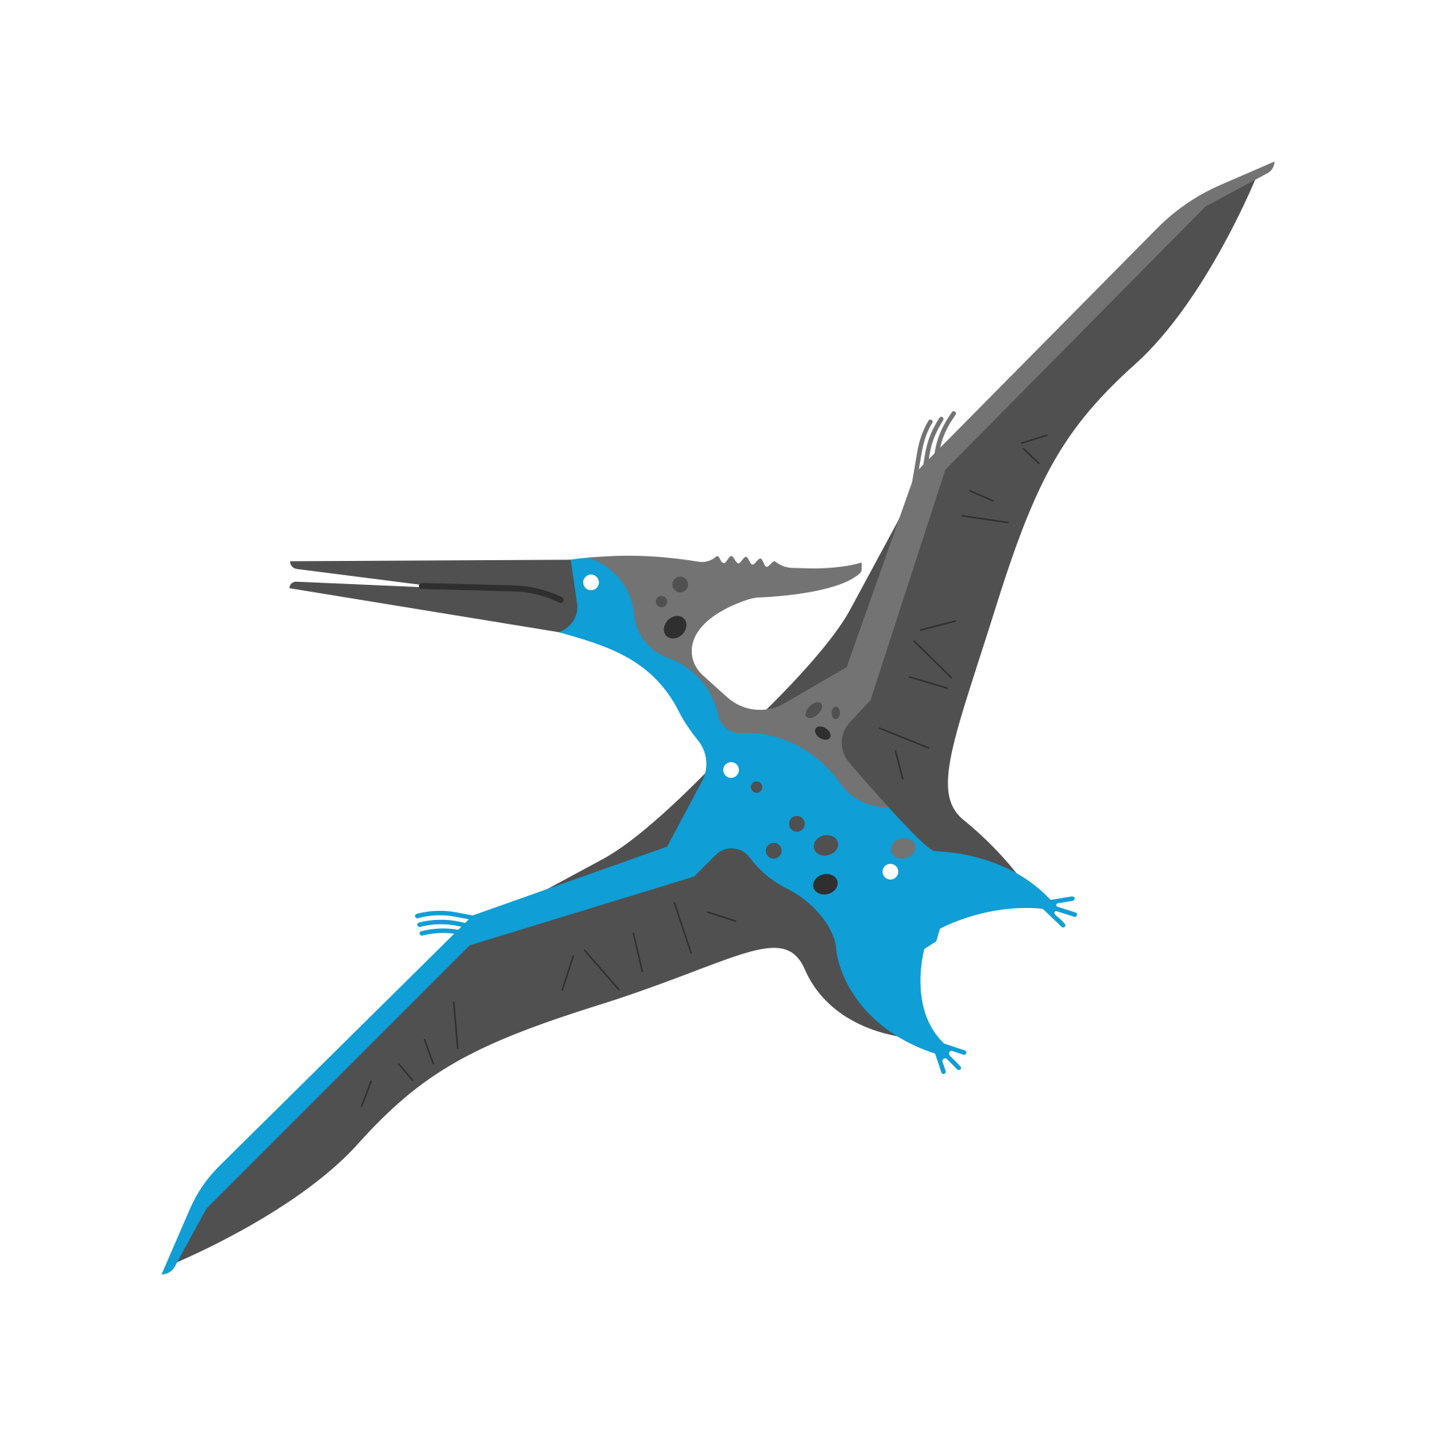  History &  Geography | - We3 will continue learning about Africa.  - We will look at the lifestyle of children living in both a city and a rural part of Africa and compare their lives to our identifying similarities and differences.  - We will learn about key features of Africa.  - We will explore the Masai Mara people.  - We will learn about maps and create one of our local area with keys, titles and symbols.
  Religious  Education | TERMLY TITLE: Islam (continued)  - Mosques near where we live: What can we find out?  - What can we learn from Muslim holy words?  - What happens at the celebration of Eid-ul-Fitr, and why?  - Who is a Muslim, and what do they believe? Final learning ideas
  Physical  Education | - We will learn about striking and fielding games improving our skills at catching, retrieving and batting.  - We will improve our athletics skills including running, jumping for height and distance and throwing for distance and accuracy.
  PSHE | Growing and Changing  - We will learn about how we grow and how to respect privacy. We will learn about safe people to talk to and how some things should never stay secret.

Music

French
with
Madame Hanna

Enrichment Ideas

