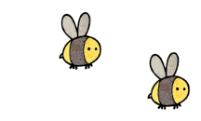
Curriculum - Term 6 June/July 2026
ROBINS Y1
Topic for the Term | Into The Woods and Beyond - continued
What we’ll be learning | We will be discovering and exploring nature from how plants grow to how our local surroundings encourage wildlife.


English
Reading | Children will:  - continue to develop comprehension and decoding during Guided Reading sessions  - read a variety of texts in class to foster the love of reading.
Phonics | Children will:  - recap all taught graphemes with a focus on decoding and blending polysyllabic words in preparation for the Phonics Check  - decode nonsense words using their phonic knowledge  - follow Little Wandle Summer 2 planning and introduce new graphemes.
Writing | Children will:  - develop sentence structure using conjunctions to link ideas  - focus on correct use of punctuation  - develop narrative, recount and instruction writing skills.
Grammar, Spelling & Punctuation | - Weekly spellings will continue to be sent home on Fridays for a test the following Thursday.
How you can help at home | Continue to read at home daily with a focus on understanding and inference.  Practise all taught graphemes.  Use Phonics Screening Check Practice Test: Free & Online - Reading Chest to practise decoding nonsense words.  Practise spellings.


Maths
Position and Direction | - Describe turns  Describe position - left and right  Ordinal numbers
Place Value | - Count from 50 to 100  Tens to 100  Partition into tens and ones  The number line to 100  Compare numbers with the same number of tens
Money and Time | - Unitising  Recognise coins and notes  Count in coins  - Recognise minutes seconds and hours  Tell the time to the hour and half past
How you can help at home | Use analogue clock and watch to recognise the hours on a clock face. Use money in real life situations.

  Science | Plants – continued topic  - Use scientific investigation to develop a deeper understanding of how plants grow and the conditions needed  - Explore the properties of trees
  Art & Design Technology | Textiles - DT  - Children will create natural weaving designs using fabrics and materials  - We will design, create and evaluate hand puppets introducing a simple stitch to join fabric together
  Computing | Programming Animations  - Children will design and create their own animation using sprites and tools.
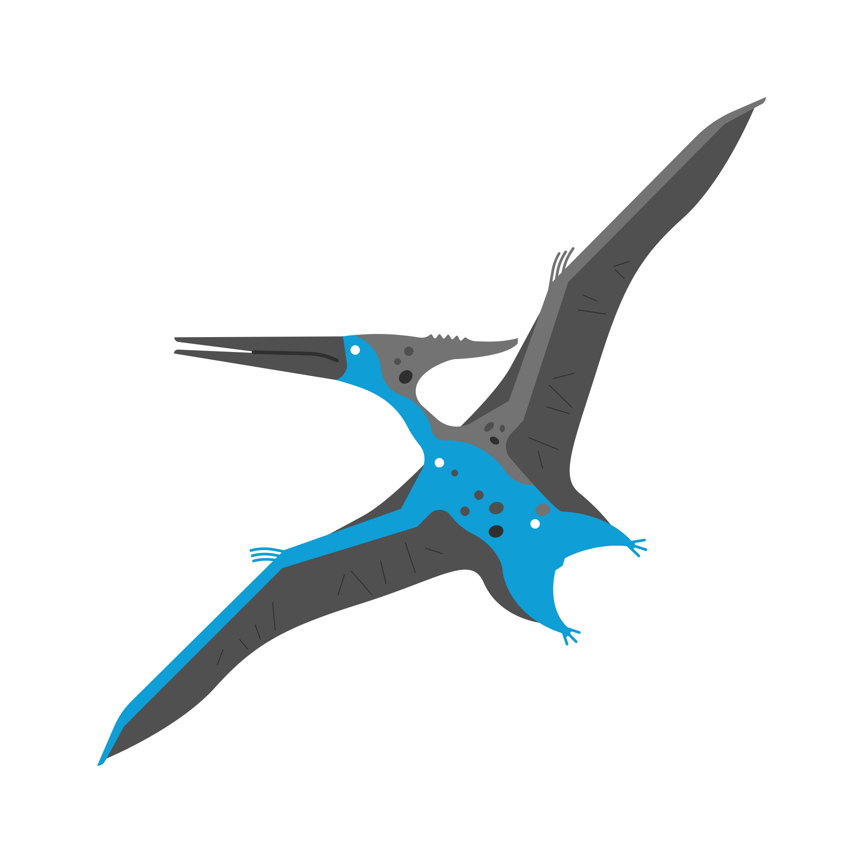  History &  Geography | Our Power, our Planet  - Geographical habitats and the plants & animals that live in them  - Learn how litter affects our local area (the plants and animals that live in it) What can we do to prevent and clear litter?  - Seasonal changes from Spring to Summer  - Climate change causing floods, droughts and wildfires and its impact on plants and animals
  Religious  Education | Judaism – continued topic  - Develop an understanding of the religious practices and beliefs of the Jewish faith
  Physical  Education | Athletics + Team building  - To work with a partner to complete challenges.  - To explore and develop working as a team.  - To develop talking, listening and sharing skills.  - To use speaking and listening skills to lead a partner.  - To plan with a partner and small group to complete challenges.  - To use talking, listening and sharing skills to complete challenges.  - Develop track and field skills  - Prepare for Sports Day events  Forest School - Friday
  PSHE | Growing and Changing  - Keeping healthy  - Taking care of babies  - Keeping privates private
  Music | - Children will listen to and perform a variety of music to develop an understanding of tempo
Enrichment Ideas | - Continue to read a variety of books at home  - Practise running skills in preparation for Sports Day  - Bring in a photo of yourself as a baby that we can compare to now during PSHE
Suggested Reading

