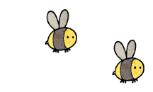
Curriculum - Term 5 April/May 2026
BADGERS Y6
Topic for the Term What we’ll be learning | Rainforests & South America
Topic for the Term What we’ll be learning | With a geography focus in Humanities, the children will develop their geographical knowledge of the world and understand the components of a rainforest as well as their impact on the world.


English
Reading | - Reading will focus on comprehension skills alongside a book study of a text chosen by the class.
Whole class book | 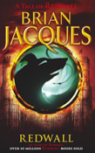  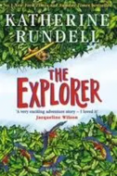  The Explorer, Katherine Rundell  Redwall, Brian Jacques
Writing | - This term will be mainly independent as the children approach a range of genres in their writing, while building up their portfolio of writing for the end of KS2 assessments.
Grammar, Spelling & Punctuation | - A lot of focus will be on reviewing prior learning and enhancing understanding of areas that children have previously found difficult.
How you can help at home | Encourage your child to read (aloud where possible) and discuss the text, ask questions and engage in a ‘book club’ type conversation of the texts. Also, encouraging them to engage with Spelling Shed (either at home or in school before the start of the day) greatly improves their chances of developing their spelling skills.


Maths
 | This term will focus on Shape to begin with but then will review arithmetic skills (addition, subtraction, multiplication and division) as well as fractions, decimals and percentages.
How you can help at home | Encourage your child to engage with homework and TTRockstars to ensure their confidence in the work being completed in school.  Also, encourage your child to engage with maths in the real world: measuring for cooking; reading an analogue/digital clock and working out timings; looking at bus schedules; or counting loose change etc.

  Science | CLASSIFICATION  Children will:  - explore the work of Carl Linnaeus  - develop their understanding of categorisation of creatures beyond different animal groups and plants.  - compare living things in our school environment.
  Art & Design Technology | - Exploring a range of paint techniques to create their very own rainforest .
  Computing | Children will:  - explore the world of Computer Aided Design (CAD)  - with the help of TinkerCad, explore the joys of 3D modelling.
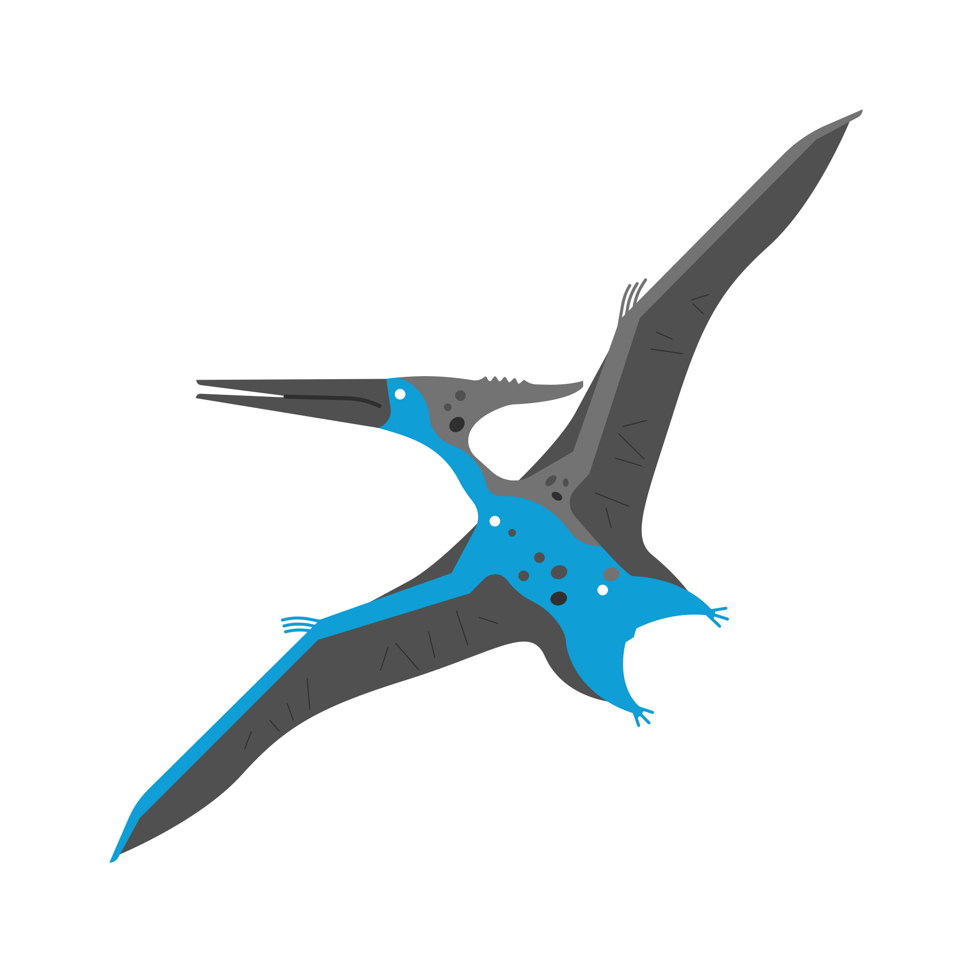  History &  Geography | With a geography focus in humanities, children will:  - develop their geographical knowledge of the world  - understand the components of a rainforest as well as their impact on the world.
  Religious  Education | Universal  What can be done to reduce racism? Can religion help?  Children will:  - learn in depth from different religious and spiritual ways of life.  - explore ideas and examples of what religions do to reduce racism, eg the work of different religious leaders in promoting respect and the teaching of different sacred texts about human unity.
  Physical  Education | Cricket and Athletics  Cricket – developing catching and throwing as well as striking skills. We will also develop our understanding of the game’s rules.  Athletics – Developing an understanding of a range of athletic activities; including setting pace for long distances, throwing athletic equipment, and generating power in jumps.  This will develop more in the build up to Sports Day.
  PSHE | Being My Best  Children will:  - look at their sense of self and explore what it means to take care of themselves and those around them including physical and mental health.
  Music | Children will:  - continue to explore the four main areas of performing, improvising, composing and reviewing music.
Enrichment Ideas | - Read books or watch documentaries about the rainforest and discuss issues such as deforestation and conservation.  - Explore resources from organisations like the WWF.  - Create a Rainforest in a Jar - make a mini terrarium using a jar or plastic bottle to learn how plants grow in warm, humid environments.  - Weather Watch - compare the weather in Kent with the weather in a rainforest location. Look at temperature and rainfall differences.
Suggested reading | To further explore our whole class books, please dip into the works of Katherine Rundell and Brian Jacques.

