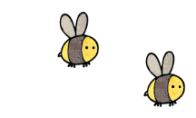
Curriculum - Term 5 April/May 2026
OTTERS Y5
Topic for the Term | Groovy Greece
Topic for the Term | Our overarching theme for terms 5 and 6 is the geography and history of Greece.
What we’ll be learning | As well as studying the geography of Greece, we will look at a variety of sources that show political, social and cultural aspects of Ancient Greek life and will consider the achievements of the Ancient Greeks and their legacy.


English
Reading | Children will:  - increase their familiarity with a wide range of books including myths, legends and traditional stories, modern fiction, fiction from our literary heritage and books from other cultures and traditions.
Whole class book | 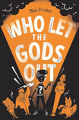  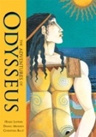  Who Let The Gods Out  The Adventure s of Odysseus
Writing | Genres for writing will include:  - narrative (a Greek myth)  - a timeline linked to Ancient Greece  - instructions
Grammar, Spelling & Punctuation | - degrees of possibility using adverbs eg perhaps, surely  - modal verbs eg might, should, will, must  - link ideas across paragraphs using adverbials of time, place and number.
How you can help at home | - Daily reading: encourage your child to read for 10–15 minutes each day and discuss the story together by asking questions about characters, vocabulary and predictions.  - Talk about books: after reading, ask children to summarise what happened, explain new words, or say what they liked about the text to build comprehension and vocabulary.  - Write for real purposes: practise writing at home by keeping a short diary, writing letters/emails to family members or creating stories linked to our topic.


Maths
Shape | Children will:  - learn how to understand and use degrees  - know how to calculate angles correctly  - know how to draw lines and angles accurately  - know how to calculate angles around a point, on a straight line and in a shape
Position and direction | - read and plot coordinates  - translate with coordinates  - identify lines of symmetry and reflection in horizontal and vertical lines
Decimals and percentages | - add and subtract decimals with different numbers of decimal places.
How you can help at home | - Practise decimals and percentages by measuring ingredients eg 0.5kg, 1.25L and sharing food – ask questions like “What is 50% of this pizza?”.  - Direction games: on walks or car journeys, ask children to describe turns using position and direction vocabulary such as quarter turn, half turn, clockwise, anticlockwise.  - Shape hunt: find 2D and 3D shapes around the house and talk about their properties (faces, edges, vertices).

  Science | Animals including humans  Children will:  - describe the changes as humans develop to old age  - create a timeline to indicate stages in the growth and development of humans  - learn about the changes experienced in puberty  - plan different types of scientific enquiries taking measurements, using a range of scientific equipment, recording data and results and report findings from enquiries.
  Art & Design Technology | Children will:  - learn about bridges and recognising that supporting shapes can help increase the strength of a bridge  - build bridges out of a variety of materials and identify areas of improvement.
  Computing | Children will:  - be introduced to video as a media format  - see examples of videos featuring production and editing techniques  - work towards creating their own videos  - analyse and compare examples of videos.
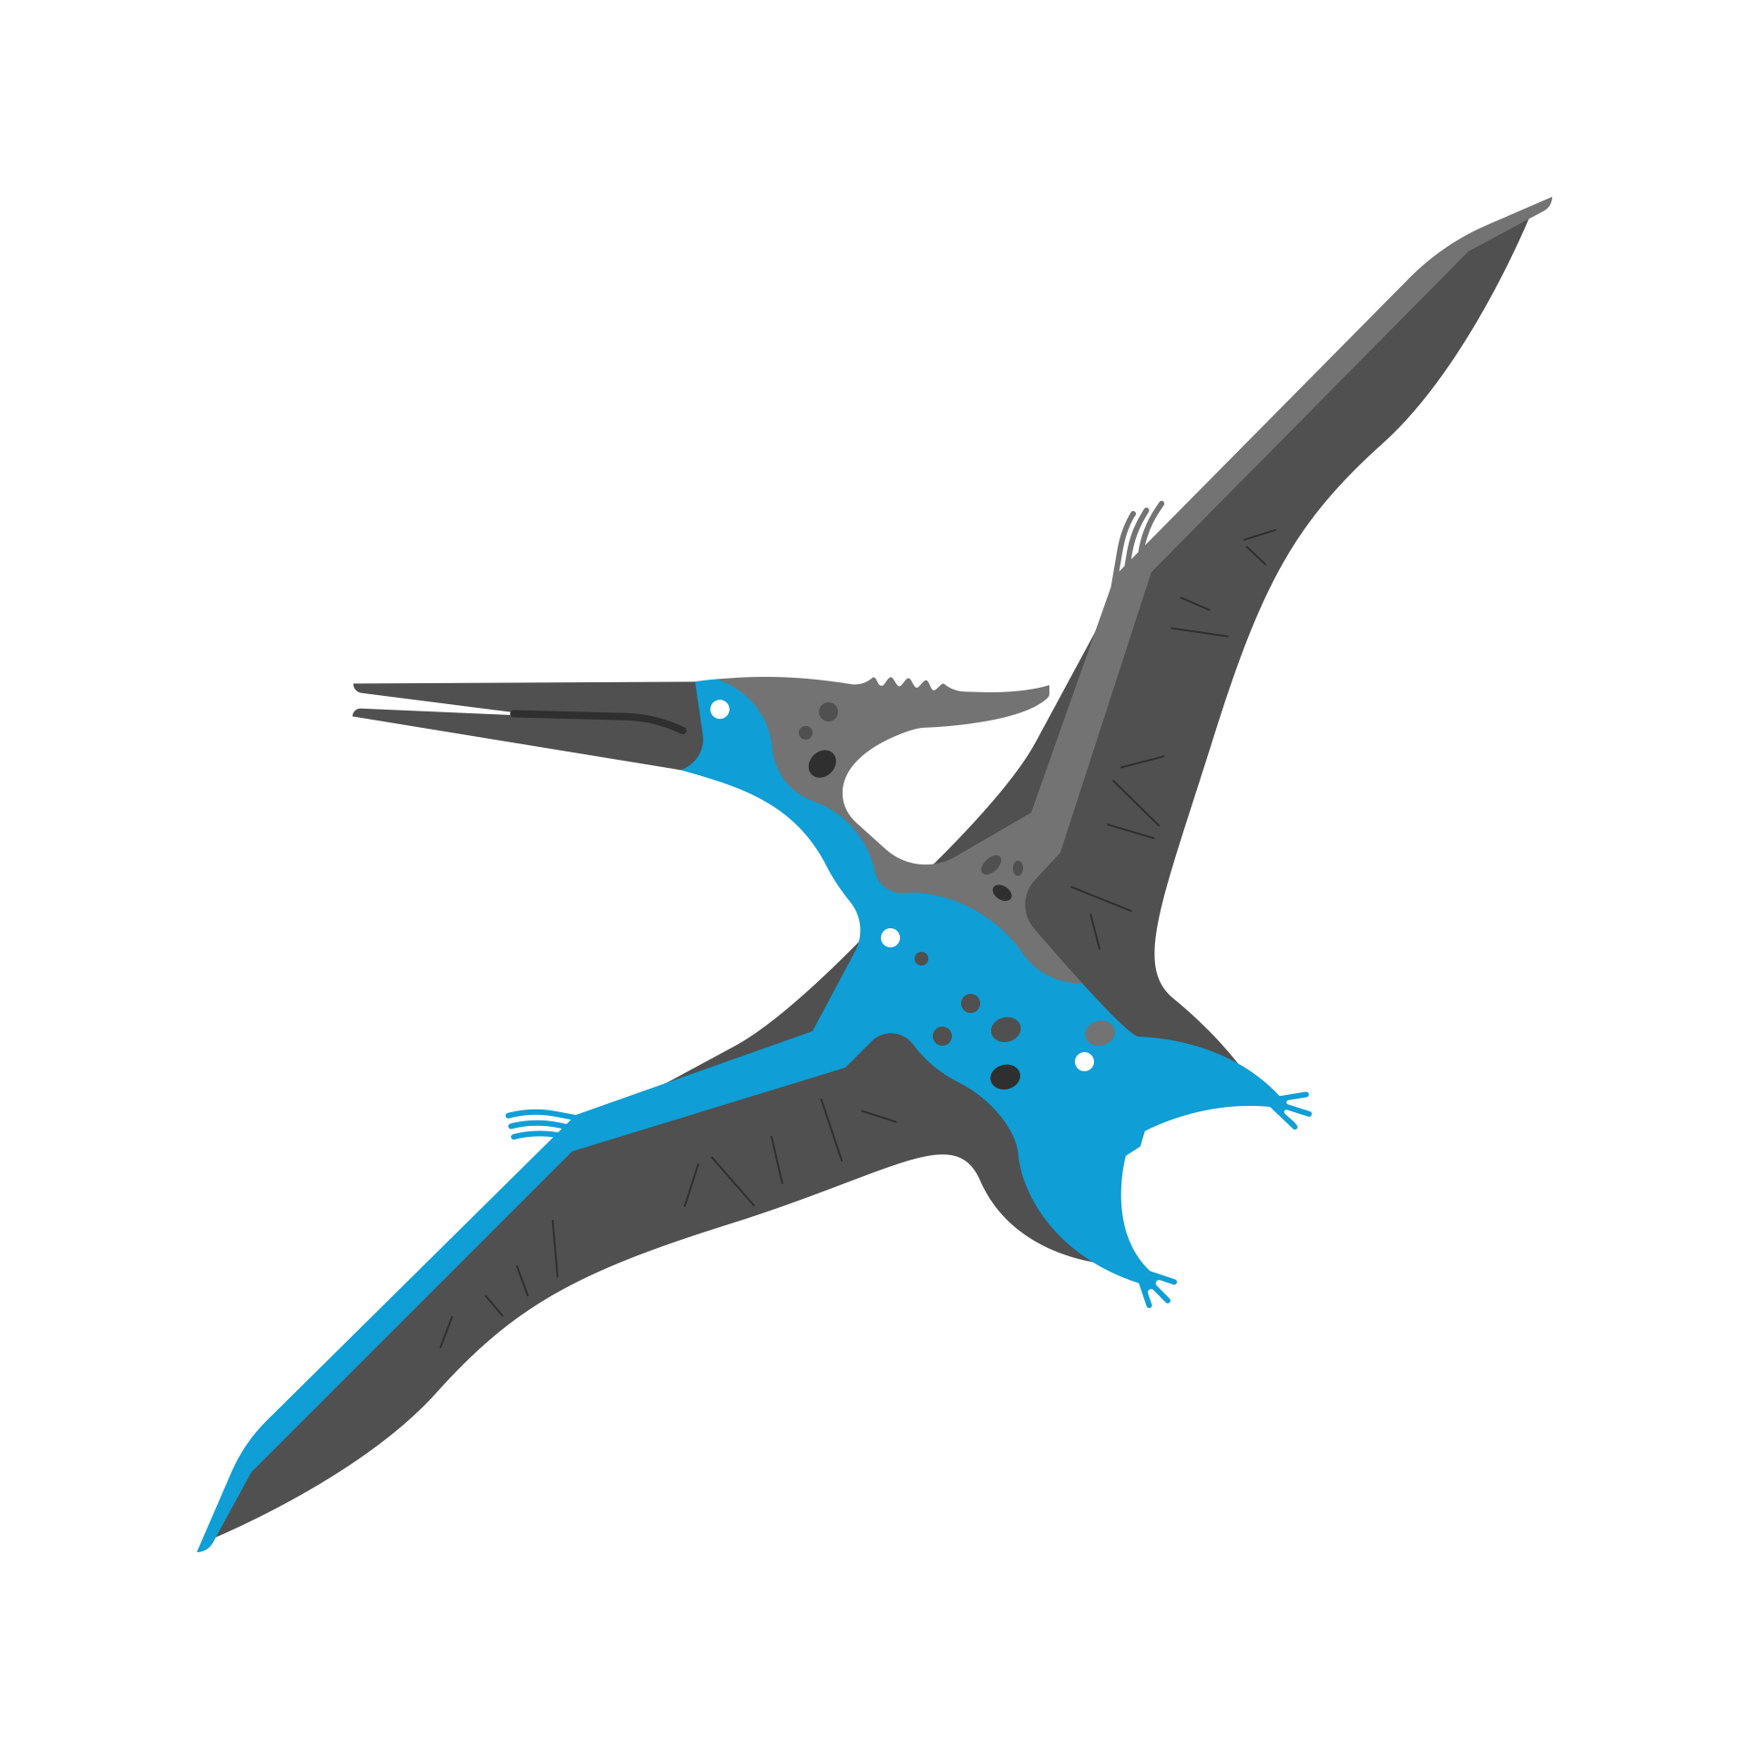  History &  Geography | Geography  Children will:  - locate Greece and comparing its climate to that of the UK  - discuss why tourism is important  - look at the country’s major exports.  There will also be a focus on fieldwork, using a compass and grid references.  History  Children will learn:  - about Ancient Greek life  - about the achievements of the Ancient Greeks  - about the influence of this period on the modern world
  Religious  Education | What does it mean to be a Muslim in Britain today?  Children will learn:  - why the five pillars of Islam are important to Muslims  - what Muslims believe about Allah  - why Shahadah and Salah and Zakah are important to Muslims  - the role of the mosque in the Muslim community.
  Physical  Education | - Rounders (Mondays)  - Athletics (Thursdays)  - Lacrosse – mouth guards needed  - Daily mile
  PSHE | Growing and changing  Children will:  - talk about why people have good and not so good feelings  - discuss how resilience can be developed  - suggest ways to cope with strong emotions in response to change  - list some of the changes that happen in puberty.
  Music | Children will:  - play and perform, using voices and playing musical instruments with accuracy, fluency, control and expression  - improvise and compose music for a range of purposes  - listen with attention to detail and recall sounds  - appreciate and understand a wide range of high-quality live and recorded music.
  French  with  Madame Hanna | Children will:  develop their language skills across the four attainment targets (speaking, listening, reading and writing) with a primary focus on speaking and listening. focus on speaking and listening.  - know the names of different buildings and amenities in a town  - understand and describe where certain places are located  - begin to be able to ask for and understand directions  - begin to understand and use prepositions  - understand and use the contractions “au” and “aux” for masculine and plural nouns  - learn about typical features of French towns
Enrichment Ideas | - Visit a museum: explore Ancient Greek artefacts at the British Museum (including the Parthenon Marbles) or the Ashmolean Museum to see Greek pottery, statues and armour.  - Create at home: make a Greek vase or pot using clay or paper and decorate it with traditional Greek patterns or myth scenes.  - Explore Greek myths: read and retell stories about figures such as Zeus, Athena or Hercules, then create a comic strip, storyboard or short play about the myth.
Suggested Reading | - Percy Jackson series by Rick Riordan  - Greek Myths by Marcia Williams (comic strip)  - Ancient Greece DK Eyewitness (non-fiction)

