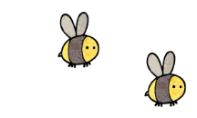
Curriculum - Term 5 April/May 2026
OWLS Y4
Topic for the Term | World War II
What we’ll be learning | - Home front  - Battle of Britain  - Evacuee


English
Reading | Children will:  improve comprehension skills in fiction and non-fiction texts  many of which will be linked to our topic; World War II.  guided reading topics will be used to develop our knowledge of different religions as well as a PSHE topic of bullying.
Whole class book | 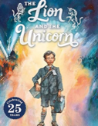  The Lion and the Unicorn by Shirley Hughes
Writing | Our writing genres this term include diary entries, instructions and reviews. These will link to our topic of World War 2 or our cookery in Design Technology. In grammar we will focus on the use of show and not tell as well as synonyms, apostrophes and commas.
Grammar, Spelling & Punctuation | Spelling will include challenge words, as well as words ending in ‘-cian’ adverbs of manner and challenge words. Throughout these spelling sessions we will use dictionaries. In addition, there will be a continued emphasis on presentation and neat handwriting.
How you can help at home | Parents can support reading by encouraging their child to read aloud regularly, discussing new vocabulary, asking questions about characters and events and exploring a range of texts (fiction, non-fiction and poetry) to build fluency, comprehension and confidence.


Maths
Decimals (Number unit) | - Making a whole with tenths and hundreds  - Partitioning and comparing decimals  - Ordering ad rounding decimals  - Halves and quarters as a decimal
Money (Measure unit) | - Write money using decimals  - Convert between pounds and pence  - Compare and estimating with money  - Solve problems with money
Time (Measure unit) | - Years, months, weeks and days  - Hours, minutes and seconds  - Convert between analogue and digital times  - Convert to the and from a 24-hour clock
How you can help at home | Multiplication Tests are coming up soon. Lots of times tables recall would really support your child ahead of this.

  Science | Electricity  This term we will continue learning about electricity. Key areas of our learning will cover: where electricity comes from, what electricity is used for, how light bulbs are used in a simple electrical circuit, how a simple switch works, what the best material is for conduction and finally what components are needed to make a working circuit. We will be working scientifically by using scientific vocabulary throughout.
  Art & Design Technology | Cookery! We will bake plain biscuits first and then we will individually adapt the recipe to create our own biscuit masterpieces!
  Computing | We will be using the program ‘Scratch’ to create repetition of code in order for our sprite to move and complete tasks. These sequences of code will be put together to create an animation based interactive game.
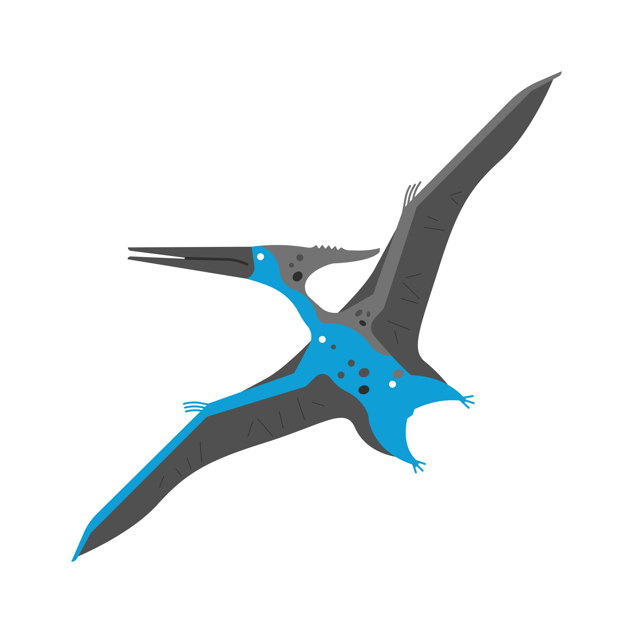  History &  Geography | Term 5’s humanities topic is World War II. We are looking forward to our trip to Kent Life in Week 5 to experience their World War II evacuee experience day. In class we will study the causes and steps that started the war. We will learn about the Battle of Britain as well as what it was like to be an evacuee. The topic of World War II will run into next term when we study the geographical topic of Biggin Hill and why it was important during WWII.
  Religious  Education | Hindu Dharma  In Term 5, we will study Hindu Dharma. We will learn what it is like to be a Hindu in Britain today. We will learn what a puja tray is and how it is used by Hindus. We will learn about the many deities within a Hindu’s beliefs and what is important to them. This topic will run through Term 5 and Term 6.
  Physical  Education | - Cricket  - Forest School
  PSHE | Being my best  - What makes me, me!  - Basic first aid  - Making choices
  Music | We are the only year group in the school to be learning the ukulele. Mr Laurence’s lessons are on Tuesdays, where the children will develop their skill with the instrument and their understanding of staff and other musical notations. In addition, we will use percussion in other areas of the curriculum to develop rhythms and incorporate songs in our learning.
  French  with  Madame Hanna | Children have opportunity to develop their language skills across the four attainment targets (Speaking, Listening, Reading and Writing) with primary focus on speaking and listening. Chilcren can:  - understand and talk about brothers and sisters  - continue to understand and talk about pets  - understand and talk about where something is  - consolidate their understanding of the adjective following the noun  - understand and use the alphabet correctly  - begin to understand and use prepositions  - learn about family life in a French town in Normandy
Enrichment Ideas | - Visit Biggin Hill to find out more about all the World War II history the town hides.  - Go to the shop and ask your child to purchase something with the correct change. You could also pay with a note and ask your child to work out how much change they should expect back. We are learning about money in maths, which is proving more and more challenging as we progress into a more and more cash-less world.
Suggested reading | - How does a lighthouse work? Roman Belyaev  - Where does lightning come from? And other questions about electricity, Anna Claybourne  - Our castle by the sea, Lucy Strange  - War dog, Carolina Rabei & Tom Palmer

