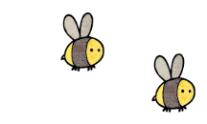
Curriculum - Term 5 April/May 2026
RABBITS Y3
Topic for the Term | Ancient Egypt!
What we’ll be learning | We will start to learn about Ancient Egyptians including the social structure of their society, famous pharaohs, deities and who built the pyramids and why.


English
Reading and Writing | Children will:  - discover skeletons and muscles and write a non-chronological report about the pangolin and other animals.  - explore the topic of Ancient Egypt by writing biographies of Hatshepsut and other pharaohs.  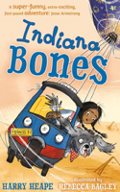
Whole class book | Indiana Bones by Harry Heap
Grammar, Spelling & Punctuation | We will continue our Y3 spellings with:  - the suffix -er  - words that end in -gue or -que  - words where ch makes /k/  - words where sc makes /s/  - challenge words
How you can help at home | Encourage your child to complete their Spelling Shed.  Keep listening to your children read out aloud.  Ask them questions about the text such as ‘Who said that?’ and ‘What do you think will happen next?’


Maths
Measurement | Children will:  - measure, compare, add and subtract: mass (kg/g) and volume/capacity (l/ml)
Fractions | - recognise, find and write fractions of a discrete set of objects: unit fractions and non-unit fractions with small denominators  - reason with fractions of an amount
Money | - recognise and using £ (pounds) and p (pence)  - find different coin combinations  - combine amounts to make a total  - solve real-life money problems, including giving change
Multiplication | - Mental recall of the times tables will continue to be a focus throughout this term.
How you can help at home | Encourage your child to complete their TT Rock Stars!  Use maths practically: handle real money - measuring and using fractions in cooking and in the garden.

  Science | Animals including humans  Children will observe and learn about:  - the role of skeletons and muscles  - the importance of nutrition
  Art & Design Technology | DT – Nutrition - children will:  - understand where our food comes from.  - understand what eating local and seasonal food means  Art – Pastels - children will:  - understand warm versus cool colours  - apply them to an Egyptian sunset.
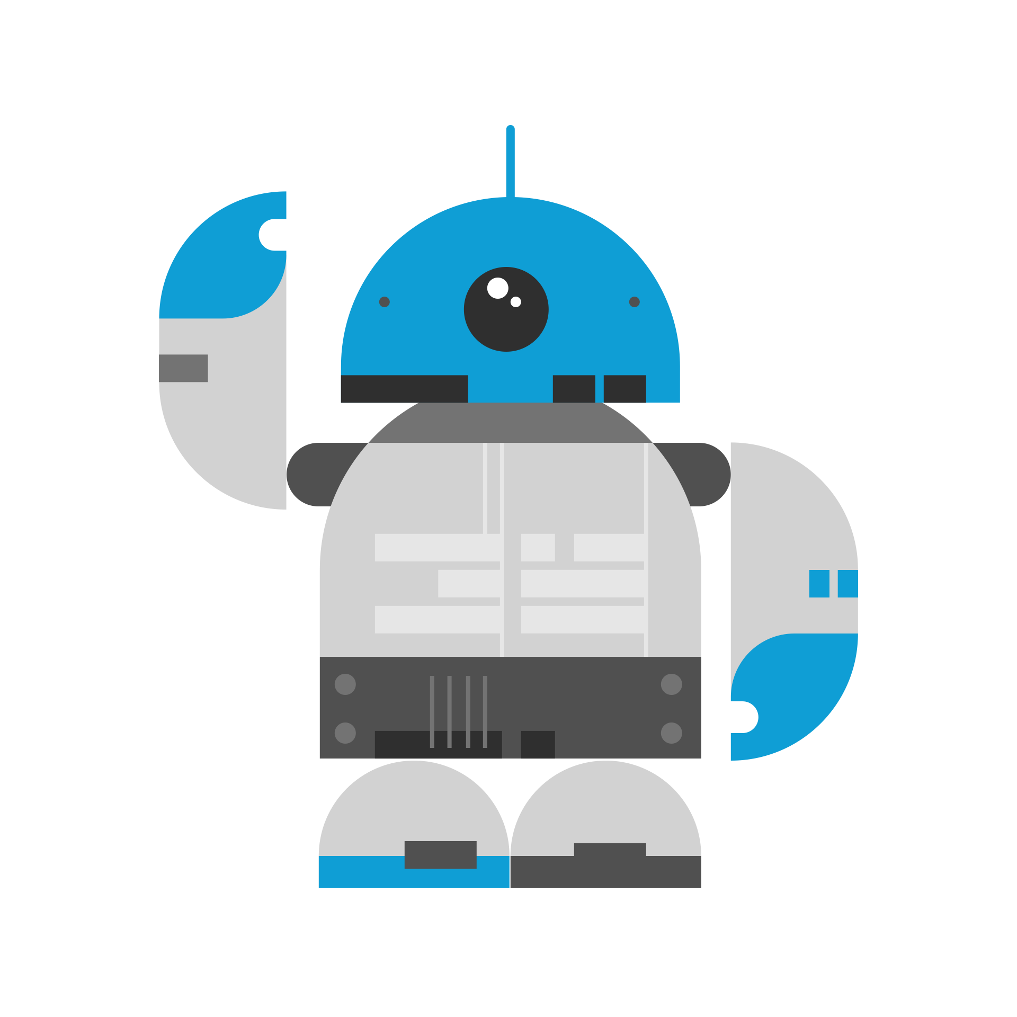  Computing | Children will:  understand, design and create their very own stop motion movies!
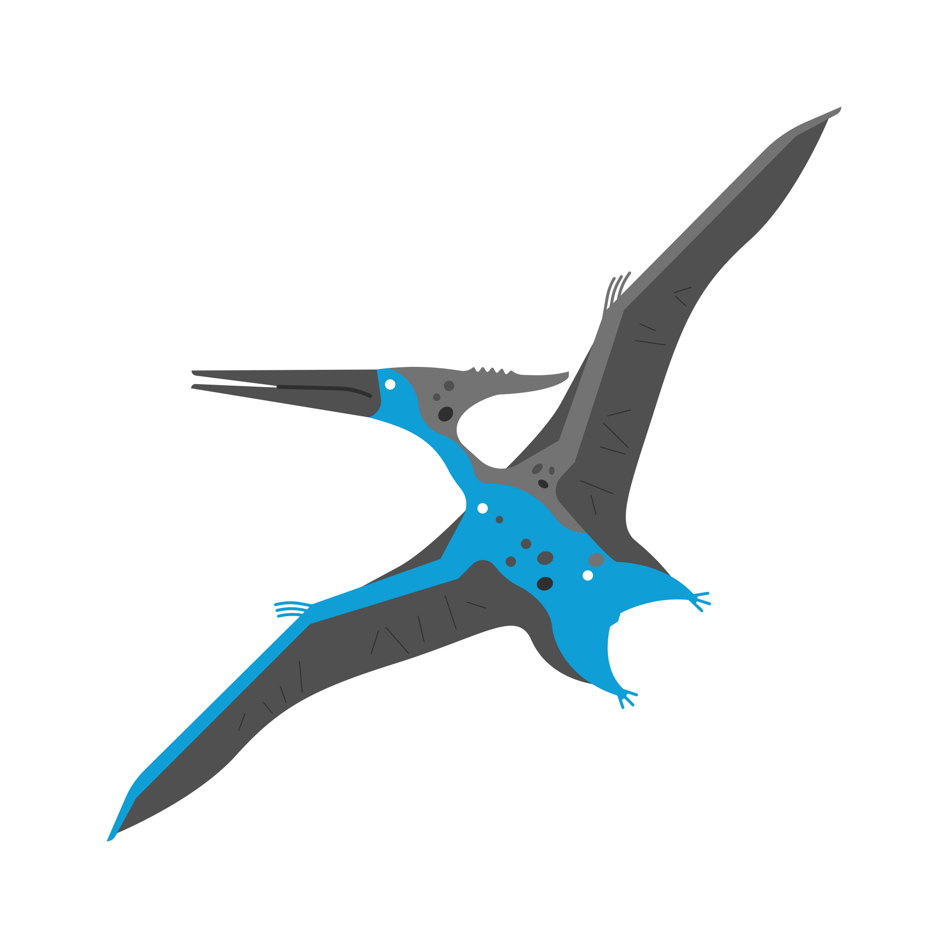  History | Children will learn about Ancient Egyptians including:  - the social structure of their society  - famous pharaohs  - deities  - who built the pyramids and why
  Religious  Education | Pentecost – children will:  - learn what happened after Easter  - understand the symbolism associated with Pentecost  - understand the impact of Pentecost on the disciples and the world.
  Physical  Education | - Athletics  - Football
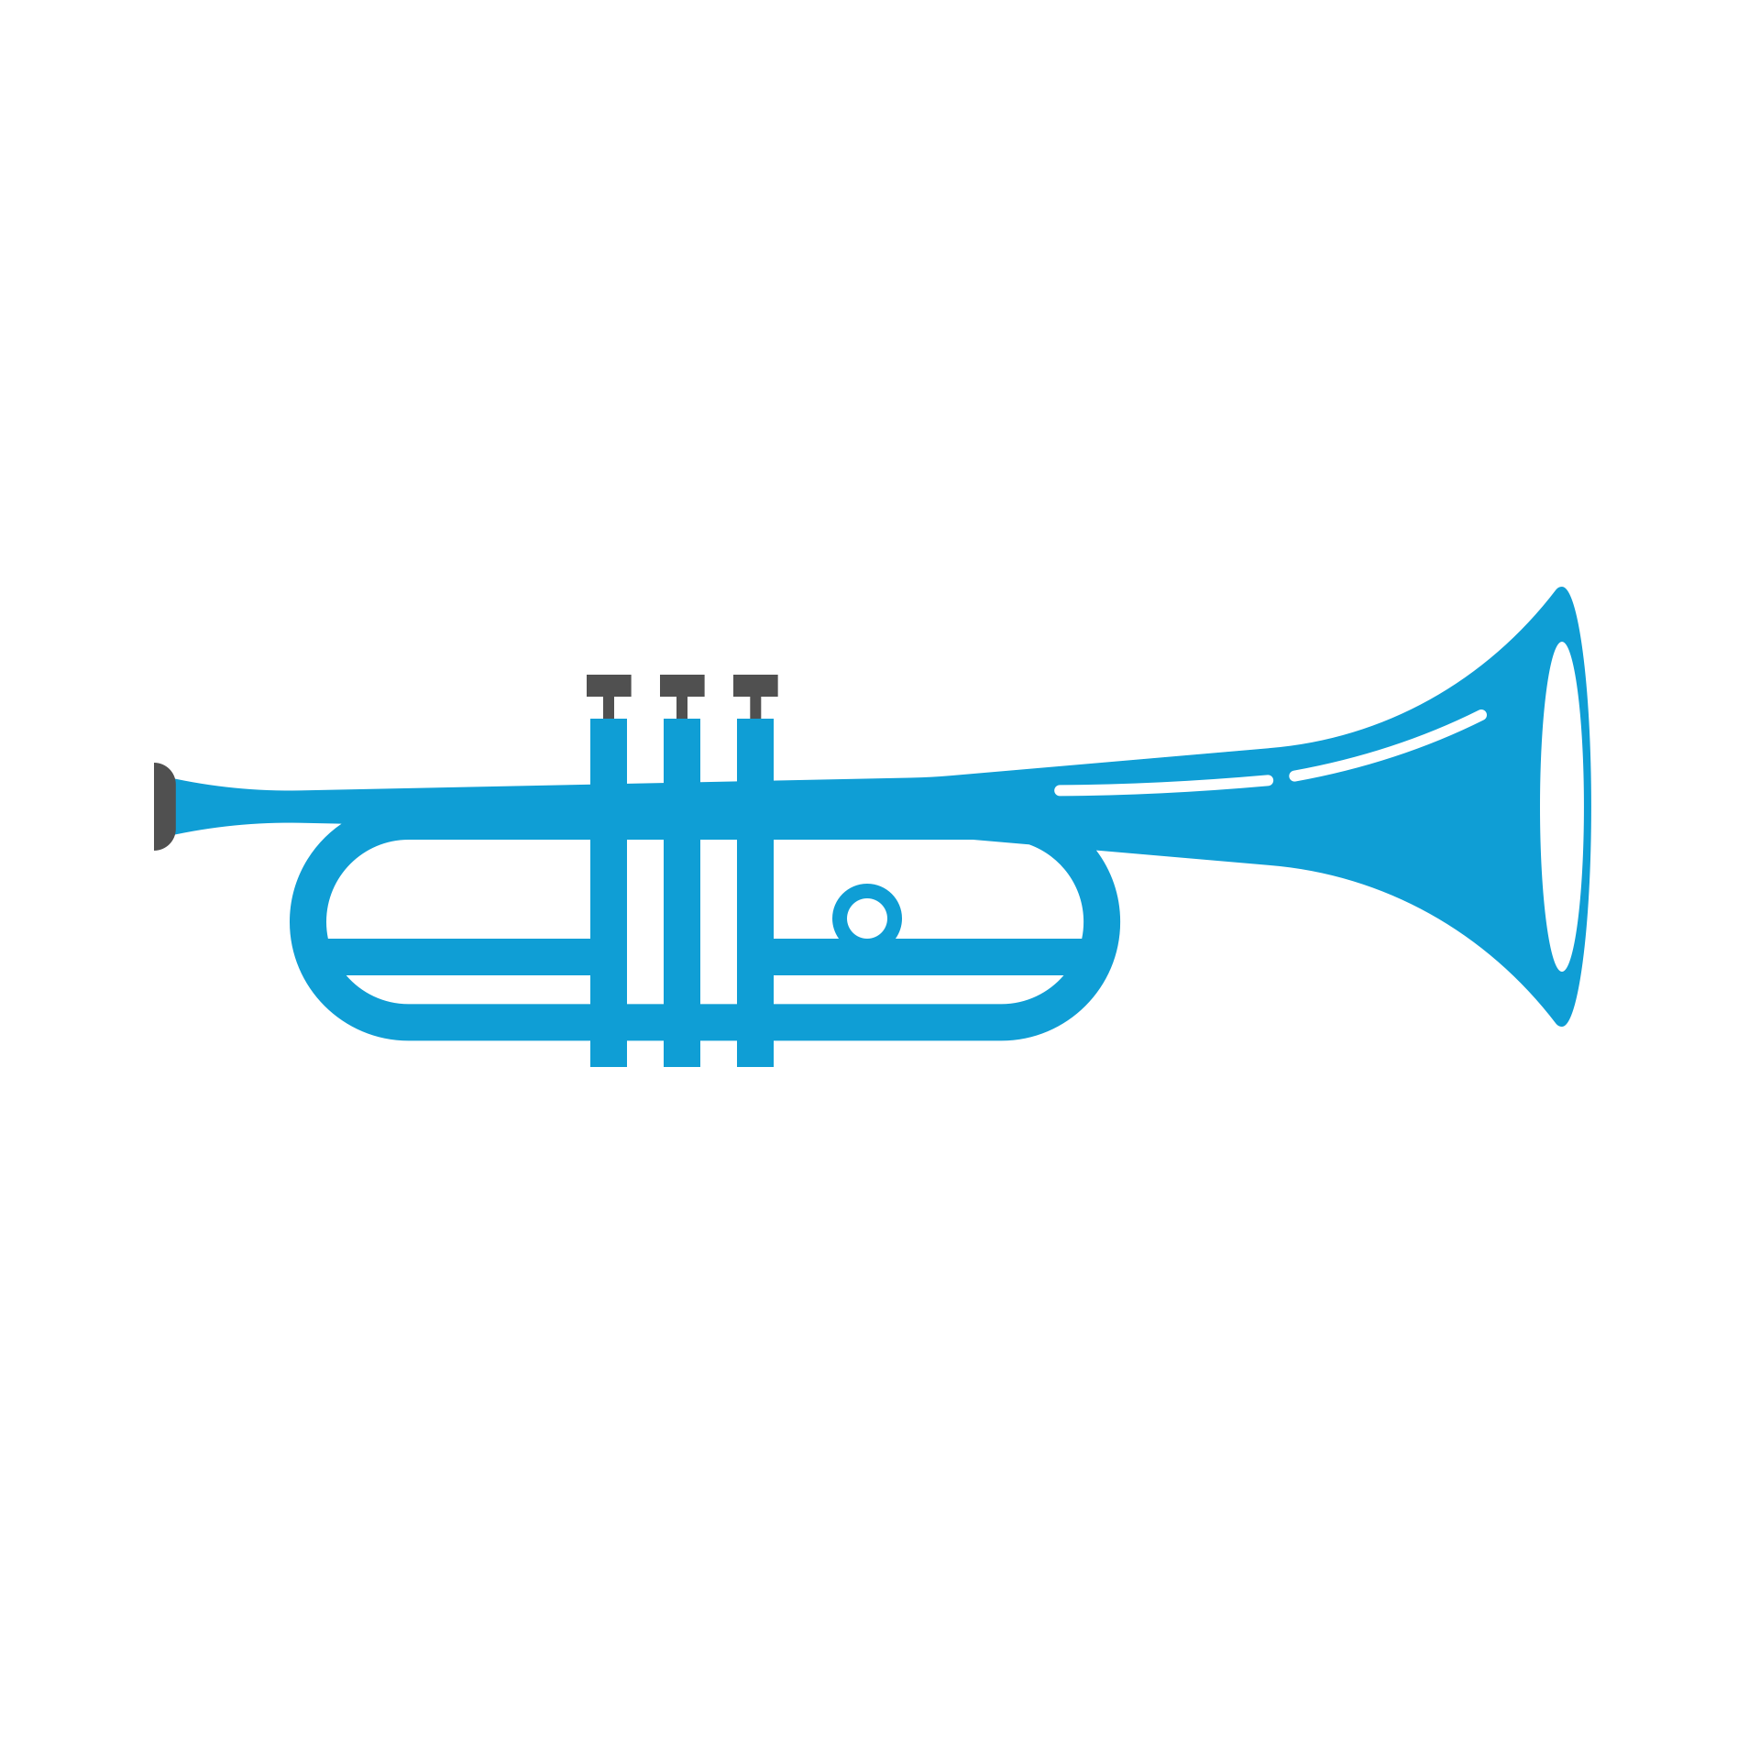    PSHE | Being my Best  - Healthy eating, hygiene and links to disease  - Our major organs and how the food, water and air we absorb reach them  - Debating, listening and empathising skills  - Identifying personal achievements and areas of development.
Music  With Mrs Bennett | - Ocarina and percussions
  French | Children will learn:  - months, numbers and birthdays  - body parts  - songs and games!
Enrichment Ideas | - Take a trip to the British Museum to explore Ancient Egypt  - Visit food markets using cash to pay (if sellers will have it!)  - Cook together focussing on seasonal and local produce, weighing and measuring ingredients
Suggested reading | - Flat Stanley: the great Egyptian grave robbery (S. Pennypacker)  - Tales of Ancient Egypt (H Cook & S Avedikian)  - Marcy and the Riddle of the Sphinx (J. Todd-Stanton)  - The Ancient Egypt sleepover (S Davies)

