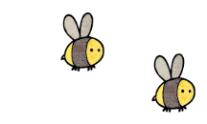
Curriculum - Term 5 April/May 2026
SQUIRRELS Y2
Topic for the Term | Sensational Safari


English
Daily phonics and spellings | Children will:  - continue weekly spellings  - practise alternative sounds
Writing | Children will:  - Narrative - finish their unit on the Day the Crayons Quit writing a letter of apology.  - Stories from other cultures – look at Tinga Tinga traditional African tales and use these short stories to support our grammar and punctuation development.  - Recount - create recounts on flying to Africa and the things they did there. Write about gorilla trekking.  - Postcards - write postcards.
Grammar, Spelling & Punctuation | Children will:  - consolidate prior learning including: noun & adverbial phrases, homophones, adjectives using -ful and -ness, changing adjectives to verbs using suffixes, questions, commands and statements  - continue structuring effective sentences  - become familiar with editing work and spotting errors and omissions.  - become text detectives, developing comprehension skills in spotting and underlining answers and grammatical features of a text.
How you can help at home | - Read together daily and discuss the story.  - Practise weekly spellings.


Maths
Fractions | Children will:  - find lines of symmetry.  - find fractions of amounts, shapes and objects.  - sort and order fractions including whole and parts.  - spend Fridays problem solving, applying strategies they have learnt to answer questions in different ways and to build confidence in number.
Geometry | - position and direction  - right angles  - quarter and half turns.
Time | - tell the time to the hour, half hour, quarter and five-minute intervals.
How you can help at home | - Practise finding parts of the whole, cutting cakes, sandwiches or anything you can find.  - Make mocktails using ¼, ½ or ¾ of different juices.  - Ask your child to come and tell you when it is a certain time – focus on o’clock and half-past to start.  - Time them doing something for 1 minute, 5 minutes or 10 so they understand how long something takes.  - Keep practising mental maths with your child eg  simple word sentences: 6 x 5, 44 – 21  problem solving questions: what different combination of coins make 26p? If apples are in bags of 8, how many bags are needed for 26 children?

  Science | Plants  Children will:  - observe and explore how seeds and bulbs grow into mature plants  - complete a variety of investigations to find out that plants need water, light and a suitable temperature to grow and stay healthy  - observe the life cycle of a butterfly (we will have our own caterpillars growing in the classroom, linking back to last term’s science learning).
  Art & Design Technology | Collage and Sculpture  Children will:  - look at frottage  - investigate how fabrics take up colour  - investigate texture and form  - box loom weaving  - develop clay techniques and skills.  - create many African-inspired artworks  - research the artist Esther Mahlangu  - look at African patterns and colours  - create necklaces and bracelets  - make animals out of junk.
  Computing | Creating media - digital music - Children will:  - explore how music makes us feel  - Rhythms and patterns  - How music can be used  - Notes and tempo  - Creative digital music  - Review and editing music
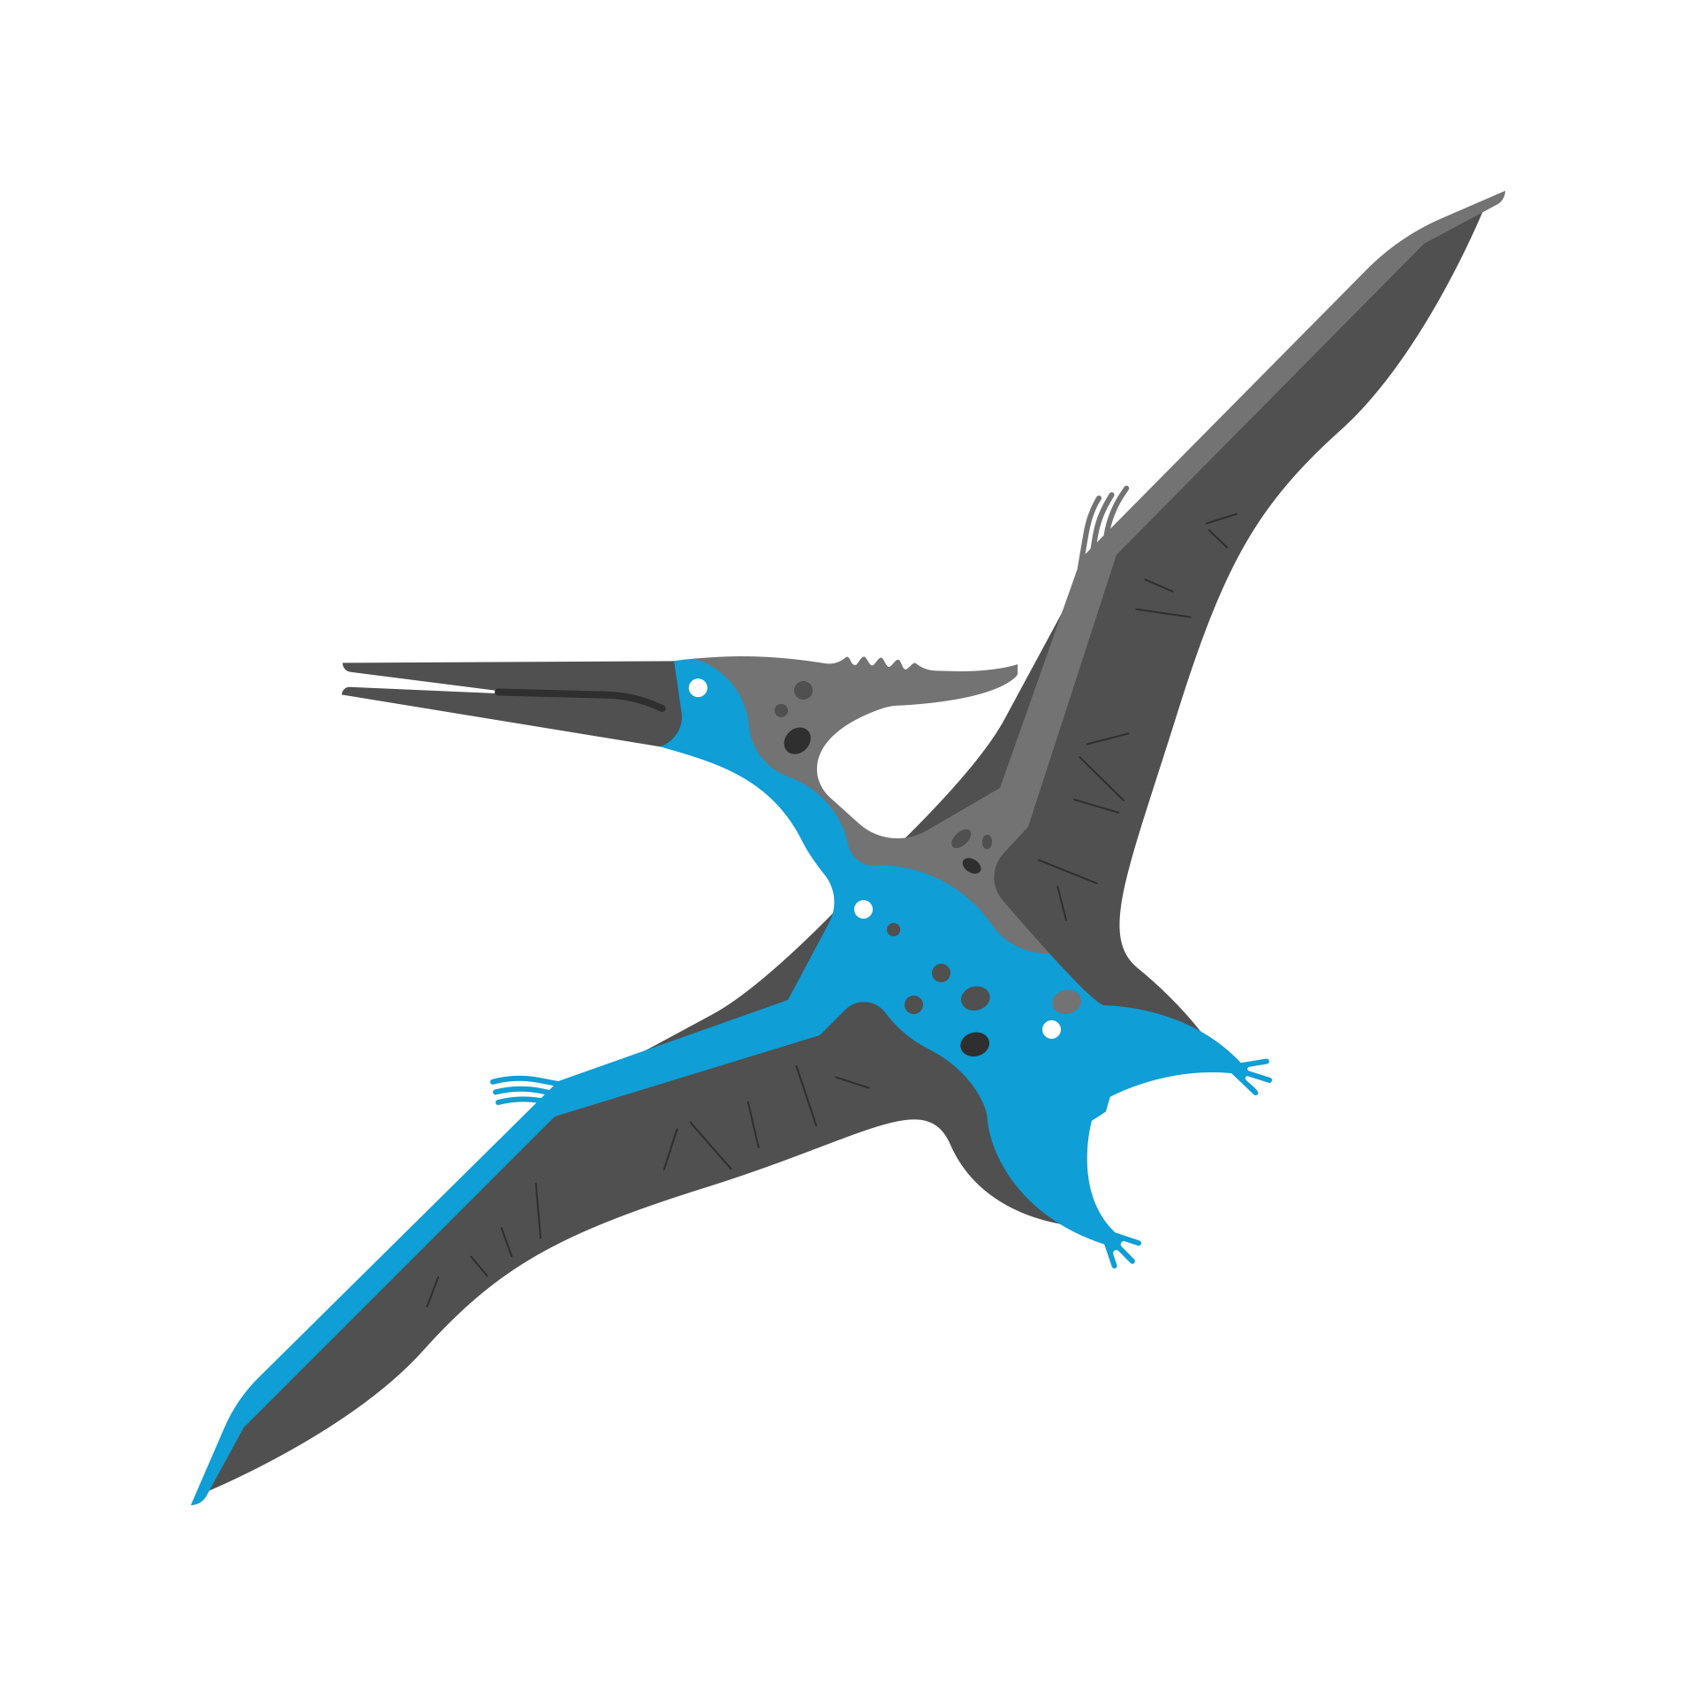  History &  Geography | Geography - children will:  - focus on directional language including compass points  - look at features on maps  - plan and follow simple routes  - use simple fieldwork techniques and observational skills to study the geography of our school and grounds and the key human and physical features of the surrounding environment  - compare these to a contrasting country in Africa  - study the different biomes within Africa as a continent  History - children will:  - learn about the life of Wangari Muta Maathai and the founding of the Kenyan Greenbelt Movement  - look at key historical figures  - create their own projects based on key historical figures.
  Religious  Education | Islam - children will learn:  - who is Muslim  - what Muslims believe about God  - who the Prophet Muhammad was and why is he important to Muslims  - stories of the prophet Muslims loved to tell  - what makes a place or object special to them and to Muslims  - what a mosque is and what happens in a mosque
  Physical  Education | Dance (Tuesdays) Our theme will be the African watering hole. Children will:  - explore movements linked to animals  - create their own short dances.  Net and Wall Games (Fridays):  Children will learn:  - how to defend a space  - how to use a racket and ball  - how to return to a partner  Please ensure correct PE kit is in school and plimsolls/trainers still fit.
  PSHE | Being My Best This unit:  - encourages children to learn how to be healthy and happy  - looks at hygiene and what our body needs.
  Music | - This term we will be working on drumming, rhythms and African percussion with Mrs Bennett
Enrichment Ideas | - Plant bulbs and seeds to find out what a plant needs to stay healthy. Measure the growth of beans.  - Go on a nature walk and spot the signs of spring with bulbs, buds and growth.  - Practise doing exercises that cross the mid-line ie the movement of a racket across the body. Try both hands to help build balace and co-ordination.
Suggested reading | - Lilah and the secret of rain, David Conway & Jude Daly  - Mama Miti: Wangari Maathai and the Trees of Kenya, Donna Jo Napoli & Kadir Nelson  - The big green: everyone can make a difference, Ken Wilson-Max

