Communication and Language  Children learn to listen and appreciate others in class talking and expressing their own opinions.  Children are using their vocabulary to express their emotions and the emotions of others and story characters (links to PSED and English).  Children are taking turns to talk. | Personal, Social and  Emotional Development  Learning to name and identify our emotions. Learning how to self-regulate.  Children think about how we can help others,  Learning about what being kind and helpful looks like. | Physical Development  Children explore different mediums to pinch, squeeze, and shape.  Children join in with dance and movement throughout the day including: catching and throwing, jumping, climbing and running, for example. | Phonics  Following Little Wandle Spring 1  Vowel Diagraphs  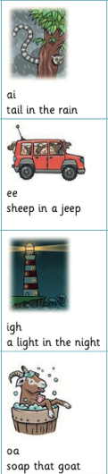  ai – tail in the rain  ee – sheep in a jeep  igh – a light in the night  oa – soap that goat
Term 3 Hedgehog Class
People Who Help Us
Mathematics  Children are learning about the concepts of one more and one less up to 10. E.G. What is one less than 5? What is one more than 5? Can you show me?  Children are learning to recognise and form zero.  Children are learning about measurements and capacity. E.G. with water and sand. |  |  | Religious Education  Exploring our school values of Love, Truth and Forgiveness.  Children begin to listen to Bible stories and discuss why they have a good teaching to them (Links to Communication and Language)  English  Children are using their phonics knowledge to spell words of their choice. Children are learning to spell tricky words by memory.  Children are writing their names.
 | Understanding the World  We are learning about people that help us in our society. We are learning about their job roles, what makes them helpful and what to do in an emergency.  Children will learn to identify people in our emergency services. | Expressive Arts and Design  Providing a range of natural objects and mediums for children to explore.  We are exploring rhythm and keeping to a beat.  We are learning different songs and rhymes off by heart.

