Chapter 3 The Den
- P 22 She thinks —
What is this punctuation called? What is its purpose? (2)
…………………………………………………………………………………………………………………………..

- P18 There was a host of dragonflies.

Host is a collective noun. It is singular even though there are lots of dragonflies.
Find and write down 5 more collective nouns. (5)

- A school of fish

- ………………………………………………

- …………………………………………………..

- …………………………………………………

- ……………………………………………

- ………………………………………………….

- P19 Why did Fred say to Max that he should not have been drinking the water? (2)

………………………………………………………………………………………………………………………………………………

………………………………………………………………………………………………………………….
- Spelling practise
Aeroplane
Flight
Shriek
Singed
Vicious
Probably
Deserted

- What do these words mean? (1)

P29 Botanist ………………………

P30 Grudgingly -------------------- Name ……………………… Marks out of 10
Chapter 3 The Den ANSWERS
- P 22 She thinks —
What is this punctuation called? What is its purpose? (2)
This is a dash (it is longer than a hyphen). It joins two clauses together.
- P18 There was a host of dragonflies. Host is a collective noun. It is singular even though there are lots of dragonflies.
Find and write down 5 more collective nouns. (5)

A school of fish
There are many possible answers such as
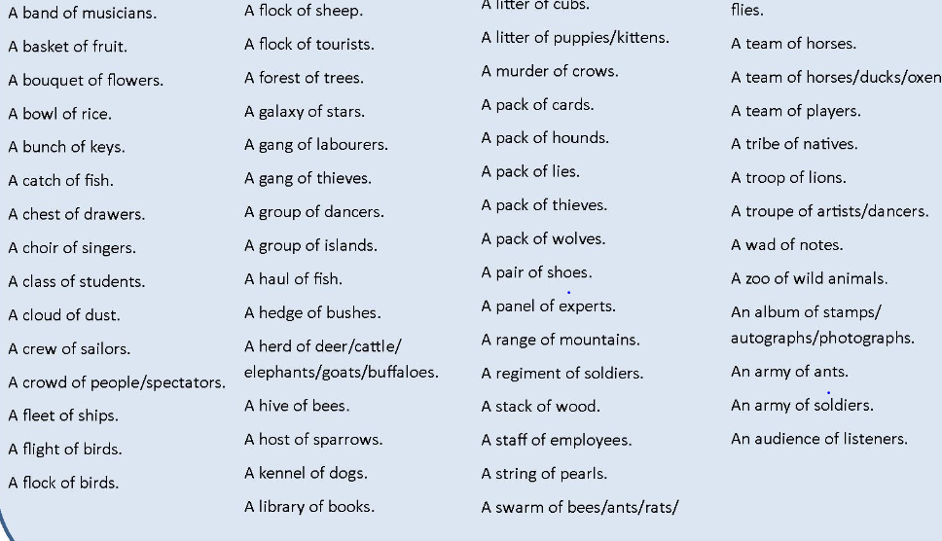
- P19 Why did Fred say to Max that he should not have been drinking the water? (2)
Fred wanted Max to stop and not drink the water again because it was vile-smelling and he though it would be harmful/dangerous/unsafe for Max to drink.

- Spelling practise
Aeroplane
Flight
Shriek
Singed
Vicious
Probably
Deserted

- What do these words mean? (1)

P29 Botanist Noun - A person who studies plants
P30 Grudgingly Adverb Doing something unwillingly

