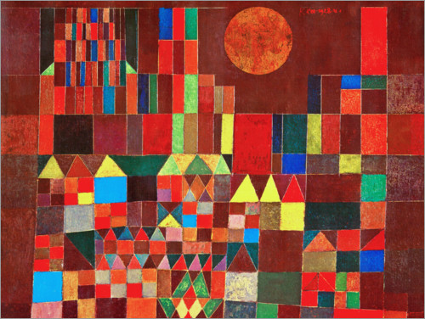
Use the viewing box. Put it over part of the picture.
Count how many of each shapes can you find:

Circles | Squares | Triangles | Rectangles

A triangle has …………………………. sides and ……………………………….. corners.

A square has …………………………….. sides and ……………………………….. corners.

A circle has …………………………… sides and …………………………….. corners.

A rectangle has …………………………. sides and ……………………………. corners.

What is the difference between a square and a rectangle?

………………………………………………………………………………………………………………………………………

…………………………………………………………………………………………………………………………………….
Art - Paul Klee – Castle and Sun

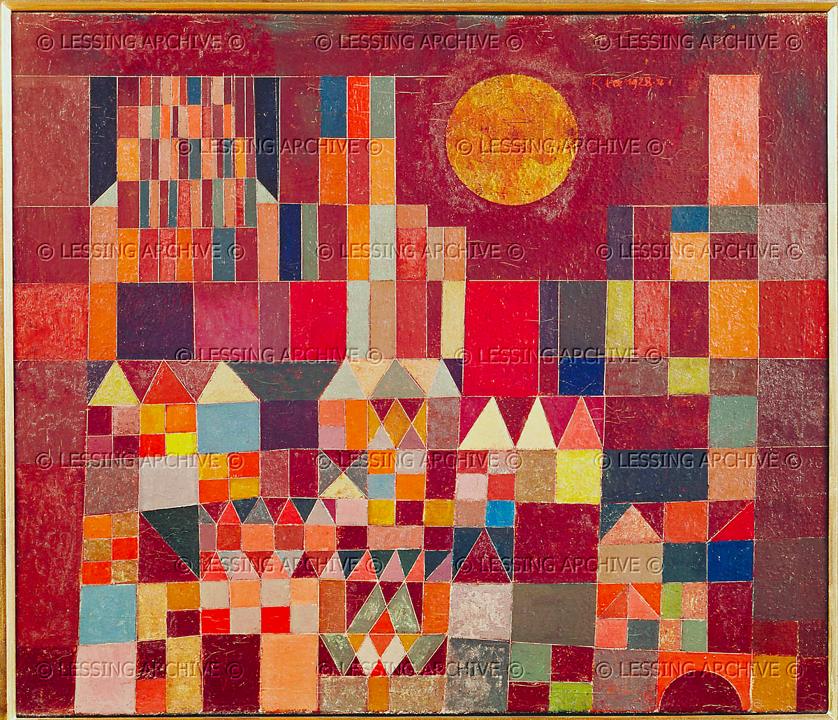

Introduction:

Talk about what we already know about Paul Klee.

What techniques did he use?
Would you prefer to use his line techniques or his fish techniques? Why?
Is Klee’s work good, bad, interesting – why?

Explain that today we are going to learn about another technique of Klee’s. We are going to look at his painting: ‘Castle and Sun,’

Share the picture.

Can you tell what the painting is? What might it look like to you?
What shapes can you see in the painting?
How might Klee create art like this?

Activities:

Explain that Klee used shapes to create the image of the castle and the sun. He also used colour – is that the colour of a real castle? Why would he use colours that aren’t real?

