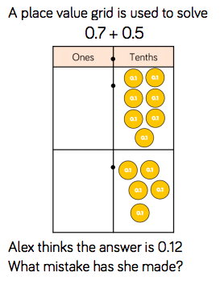

CHALLENGE
Create a poster to show how to add decimals.

Answers

Ten lots of one tenth is one whole. There are 12 tenths so Alex needs to make an exchange. She should exchange 10 tenths for 1 one. The correct answer is 1.2

