Notes

WAGOLL (What A Good One Looks Like) This gives children examples of the genre of writing.

Poetic devices
Metaphor – a figure of speech to link two things eg the classroom was a zoo.
Onomatopoeia – a word that resembles the sound it describes eg splash, miaow.
Simile – a figure of speech comparing two things using as __ as or like ______ eg as brave as a lion.
Personification – human characteristics to something non-human eg lightning danced across the sky.
Alliteration – repetition of the same initial sound or letter eg short, sharp, shock.

LO: to plan a poem.
There are some examples in each box to get you started…

Senses | Adjectives | Nouns | Verbs (-ing)
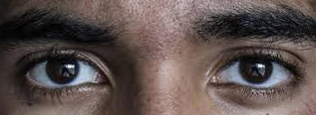 | golden | flowers | spreading
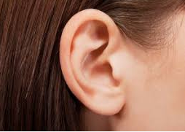 | dappled | frogs | croaking
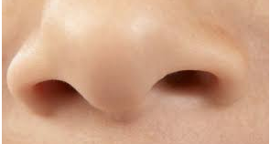 | fresh | grass | waving
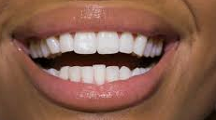 | toasted | hot-cross buns | dripping with butter
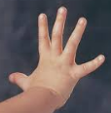 | warm | sun | glowing
Template, I recommend writing your own so that you have space to edit and adapt as you go.

LO: to write a poem.

I can see  I can see | __________________________________________________________  __________________________________________________________  __________________________________________________________  __________________________________________________________
I can hear  I can hear | __________________________________________________________  __________________________________________________________  __________________________________________________________  __________________________________________________________
I can smell  I can smell | __________________________________________________________  __________________________________________________________  __________________________________________________________  __________________________________________________________
I can touch  I can touch | __________________________________________________________  __________________________________________________________  __________________________________________________________  __________________________________________________________

Year 5 and 6
Spring Senses Poem
I have included expanded noun phrases.
I have included powerful verbs.
I have described using all my senses.
I have included a simile (as __ as, like ...)
I have included a metaphor eg the clouds were sheep in the sky.
I have used other poetic devices eg alliteration, personification
I have edited to remove unnecessary words eg determiners, I can hear, I can see etc
I have edited to make sure I have spelt correctly and used adventurous vocabulary.
What could I do to improve my spring poem next time?

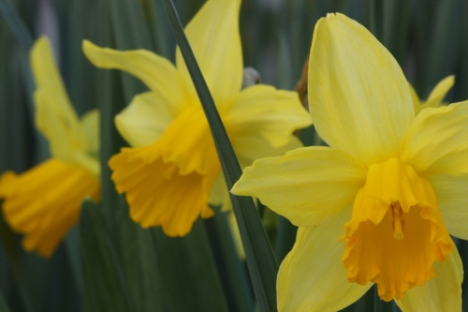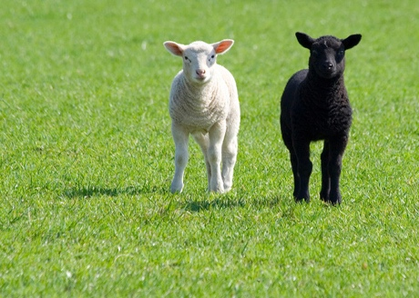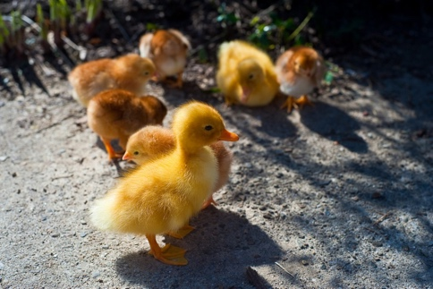

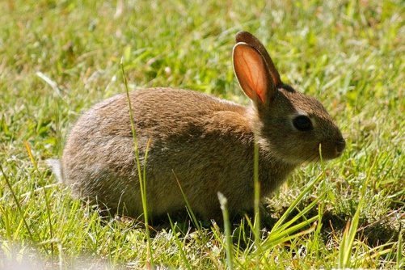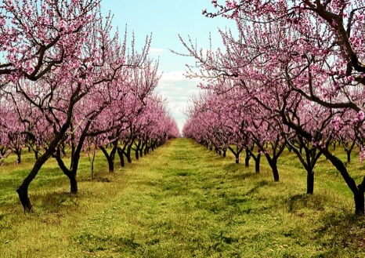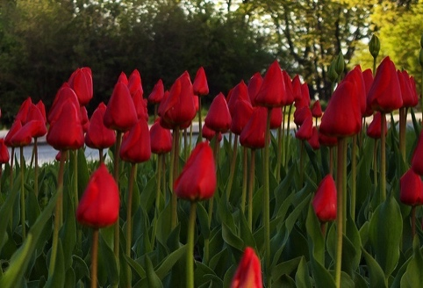

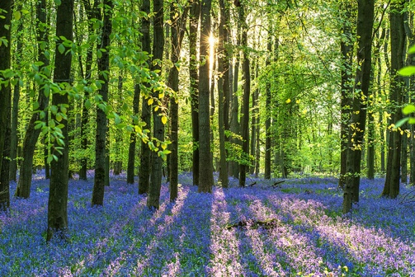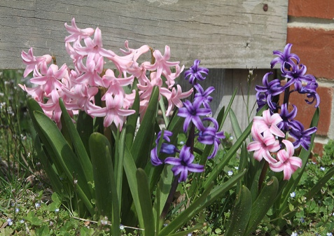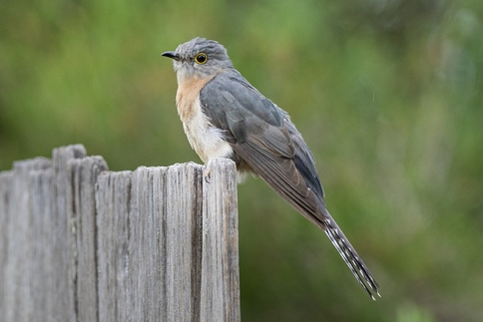

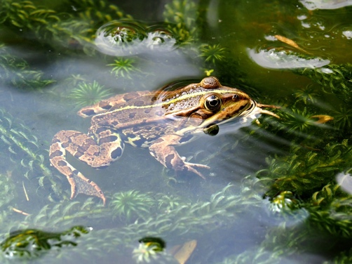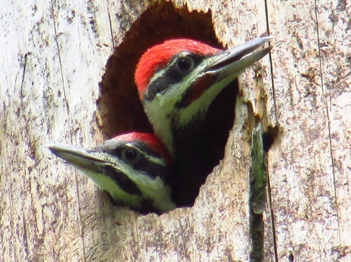

WAGOLLs
Years 3 and 4
Read through some of these poems with an adult and think about the language the poet uses. Choose your favourite words (and maybe magpie some!).

Years 5 and 6
Spring has inspired many poets. Before you write your own poem, cut these up into individual poems. Read them and look at how the poet uses language for effect and think about the poetic devices they use (similes, alliteration etc). Highlight particular words or phrases you think are effective.

Very Early Spring Katherine Mansfield (1912)
The fields are snowbound no longer;
There are little blue lakes and flags of tenderest green.
The snow has been caught up into the sky-- So many white clouds--and the blue of the sky is cold.
Now the sun walks in the forest,
He touches the bows and stems with his
golden fingers;
They shiver, and wake from slumber.
Over the barren branches he shakes his yellow curls. Yet is the forest full of the sound of tears....
A wind dances over the fields.
Shrill and clear the sound of her waking laughter, Yet the little blue lakes tremble
And the flags of tenderest green bend and quiver.

Spring Song
Robert Louis Stevenson (1887)
The air was full of sun and birds,
The fresh air sparkled clearly.
Remembrance wakened in my heart
And I knew I loved her dearly.
The fallows and the leafless trees
And all my spirit tingled.
My earliest thought of love, and Spring's
First puff of perfume mingled.
In my still heart the thoughts awoke,
Came lone by lone together -
Say, birds and Sun and Spring, is Love A mere affair of weather?

Spring Pools Robert Frost (1922)
These pools that, though in forests, still reflect
The total sky almost without defect,
And like the flowers beside them, chill and shiver,
Will like the flowers beside them soon be gone,
And yet not out by any brook or river,
But up by roots to bring dark foliage on.
The trees that have it in their pent-up buds
To darken nature and be summer woods --
Let them think twice before they use their powers
To blot out and drink up and sweep away
These flowery waters and these watery flowers
From snow that melted only yesterday.

Spring William Blake (1789)
Sound the Flute! Now it's mute.
Birds delight
Day and Night
Nightingale
In the dale
Lark in Sky
Merrily
Merrily Merrily to welcome in the Year

Little Boy
Full of joy,
Little Girl
Sweet and small,
Cock does crow
So do you.
Merry voice
Infant noise
Merrily Merrily to welcome in the Year

From You Have I Been Absent in the Spring (Sonnet 98) William Shakespeare (1599)
From you have I been absent in the spring,
When proud-pied April, dressed in all his trim,
Hath put a spirit of youth in everything,
That heavy Saturn laughed and leaped with him,
Yet nor the lays of birds, nor the sweet smell
Of different flowers in odor and in hue,
Could make me any summer's story tell,
Or from their proud lap pluck them where they grew.
Nor did I wonder at the lily's white,
Nor praise the deep vermilion in the rose;
They were but sweet, but figures of delight,
Drawn after you, you pattern of all those.
Yet seemed it winter still, and, you away,
As with your shadow I with these did play.
Lines Written in Early Spring (1798)
William Wordsworth
I heard a thousand blended notes,
While in a grove I sate reclined,
In that sweet mood when pleasant thoughts
Bring sad thoughts to the mind.
To her fair works did Nature link
The human soul that through me ran;
And much it grieved my heart to think
What man has made of man.
Through primrose tufts, in that green bower,
The periwinkle trailed its wreaths;
And ’tis my faith that every flower
Enjoys the air it breathes.
The birds around me hopped and played,
Their thoughts I cannot measure:—
But the least motion which they made
It seemed a thrill of pleasure.
The budding twigs spread out their fan,
To catch the breezy air;
And I must think, do all I can,
That there was pleasure there.
If this belief from heaven be sent,
If such be Nature’s holy plan,
Have I not reason to lament
What man has made of man?

From, “A Shropshire Lad” (1896) A E Housman
Loveliest of trees, the cherry now
Is hung with bloom along the bough,
And stands about the woodland ride
Wearing white for Eastertide.

The Trees (1974) Philip Larkin
The trees are coming into leaf
Like something almost being said;
The recent buds relax and spread,
Their greenness is a kind of grief.
Is it that they are born again
And we grow old? No, they die too,
Their yearly trick of looking new
Is written down in rings of grain.
Yet still the unresting castles thresh
In fullgrown thickness every May.
Last year is dead, they seem to say,
Begin afresh, afresh, afresh.

Spring (circa 1864) Gerard Manley Hopkins
Nothing is so beautiful as Spring –
When weeds, in wheels, shoot long and lovely and lush;
Thrush’s eggs look little low heavens, and thrush
Through the echoing timber does so rinse and wring
The ear, it strikes like lightnings to hear him sing;
The glassy peartree leaves and blooms, they brush
The descending blue; that blue is all in a rush
With richness; the racing lambs too have fair their fling.
What is all this juice and all this joy?
A strain of the earth’s sweet being in the beginning
In Eden garden. – Have, get, before it cloy,
Before it cloud, Christ, lord, and sour with sinning,
Innocent mind and Mayday in girl and boy,
Most, O maid’s child, thy choice and worthy the winning.

I Wandered Lonely as a Cloud, Wordsworth
I wandered lonely as a cloud
That floats on high o'er vales and hills,
When all at once I saw a crowd,
A host, of golden daffodils;
Beside the lake, beneath the trees,
Fluttering and dancing in the breeze.

Continuous as the stars that shine
And twinkle on the milky way,
They stretched in never-ending line
Along the margin of a bay:
Ten thousand saw I at a glance,
Tossing their heads in sprightly dance.

The waves beside them danced; but they
Out-did the sparkling waves in glee:
A poet could not but be gay,
In such a jocund company:
I gazed—and gazed—but little thought
What wealth the show to me had brought:

For oft, when on my couch I lie
In vacant or in pensive mood,
They flash upon that inward eye
Which is the bliss of solitude;
And then my heart with pleasure fills,
And dances with the daffodils.

