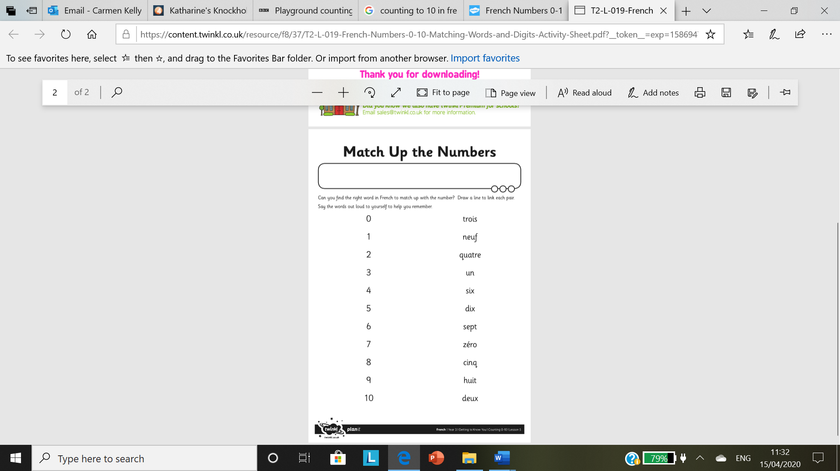

**I can read number words to 10 in French**

**I can write number words to 10**