|  |
| --- |
|  |

|  |  |
| --- | --- |
| Thea ‘s Acrostc poem about PLANTS | **Simile poem**  Sparkly eyes like diamonds.  Shiny nose like a shimmering pool.  Small like a bee.  Happy just like me. |
| Lily has been writing about her friends | Comparing illustrations can you see that Lily has a particular drawing style! |

|  |  |
| --- | --- |
|  | What a marvellous map!  Guess who lives here?    She is a big fan of pigs!  Perfect, precious pig.  I really want a pot pig.  Gorgeous, wonderful and brilliant pigs.  Spectacular, terrific, lovely pigs. |
| Jacob’s poem | Thomas has been busy growing cress in a specially designed pot.  Look out for his mug  back and front design. |

|  |  |
| --- | --- |
| Written by Charlie Assender | Dexter’s poem |
| Brilliant Bunting that I  missed last week! | Healthy exercise! |

|  |  |
| --- | --- |
|  |  |
| Looking forward to shouting this Thomas!    Healthy exercise followed by health lunch! |  |
| What a super sister baking such a creative cake! | **Hope Jeremy and Jacob have such cakes next week.**  **Happy Birthday Jeremy !**  **Joyeux Anniversaire Jacob !** |
| <https://www.youtube.com/watch?v=cgWxC3B4eso>  Joyeux Anniversaire | Chanson pour les petit + Karaoke  **TEACHER ALERT** | See the source image |

|  |  |  |  |  |  |  |  |  |  |  |  |  |  |  |  |  |  |  |  |  |  |  |  |  |  |  |  |  |  |
| --- | --- | --- | --- | --- | --- | --- | --- | --- | --- | --- | --- | --- | --- | --- | --- | --- | --- | --- | --- | --- | --- | --- | --- | --- | --- | --- | --- | --- | --- |
| Who said Home School wasn’t fun? | Impressive ICT skills Katherine!    Answers to Sugary Challenge   |  |  | | --- | --- | | clue | answer | | Laughing pins | skittles | | Breaks under your feet | Crunchie/breakaway | | People from Malta | malteasers | | A meal outside | picnic | | Toothless drink | wine gums | | Edible fasteners | chocolate buttons | | Double x bar | twix | | Talks quietly | wispa | | 9s come next | after eights | | A planet with a bar | mars | | A System of billions of stars | galaxy | | galaxy that contains the Solar system | milky way | | A kitten goes with a cat | kit kat | |

|  |  |
| --- | --- |
|  |  |
| Written by Thomas | Lily found this other poem by Michael Rosen. |

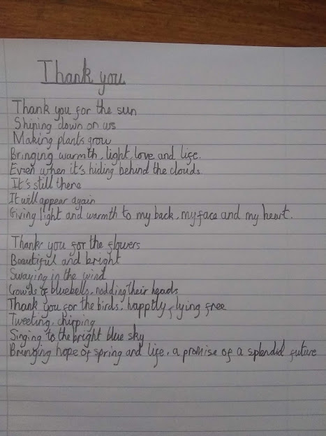

Written by Owen.