<https://central.espresso.co.uk/espresso/modules/t2_egyptians/people/video_people1_inv.html>

Espresso Keystage 2 History Egyptians People

**Watch video part 1 then write the answers to these questions**

Who discovered Tutankhamun’s tomb?

When did they discover his tomb?

Where was the tomb?

They found it by accident?

How long had this tomb been there full of amazing objects?

**Watch video part 2**

Answer these questions on same page as part 1 answers

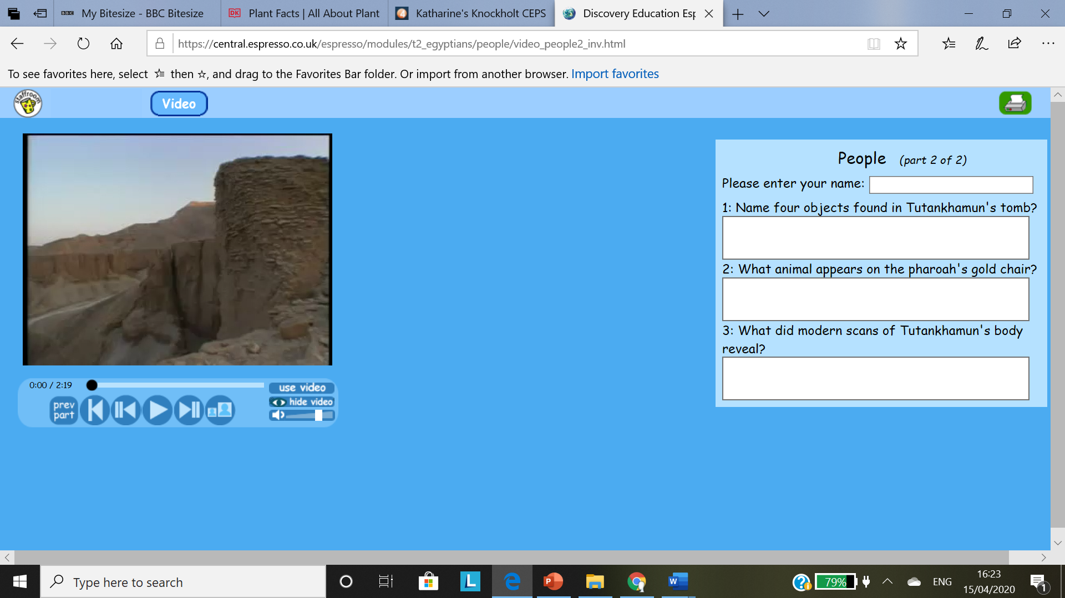

**Now can you explain why Tutankhamun’s tomb is so important to Egyptologists?**

useful sites

<https://www.dkfindout.com/uk/history/ancient-egypt/tutankhamun/>