Science Term 5- Plants Week 4
Topic information for parents:
Key vocabulary:
Trees- deciduous, evergreen, apple, ash, birch, beech, cherry, elder, fir, hawthorn, holly, horse chestnut, sweet chestnut, lime, oak, pine, rowan, sycamore, willow, yew etc
Wild flowering plants- bluebell, buttercup, cleavers, coltsfoot, daisy, dandelion, garlic mustard, mallow, mugwort, plantain, primrose, red clover, selfheal, shepherd’s purse, sorrel, spear thistle, white campion, white deadnettle, stringing nettle, yarrow
Garden/house plant names- whatever you have in yours. (Weeds are just plants growing in a place you don’t want them to!)
Plant structure: roots, stem, stalk, twig, branch, trunk, leaf, flower, blossom, petal, pollen, seed-box, fruit, seed, bulb.
In most plants the part above the ground is the shoot system and the part below is called the root system. Roots anchor the plant to whatever material it is growing on or in. They also absorb water and minerals that the plant needs in order to live healthily and grow normally & store nutrients in the roots for later. The stem (stalk/trunk/branch) supports the leaves and is also part of the plant’s transport system for taking water & food to all parts of the plant. The leaf makes food for the plant in the green part of the leaf, using water and air and energy from sunlight. Buds are undeveloped shoots. Some buds develop into leaves and some develop into flowers. The flower attracts pollenating insects to it with coloured petals, fragrance & sweet tasting nectar. When insects visit flowers, they rub the pollen onto a special part of the flower so that the plant can make seeds. As the flower dies, a seed box develops which will ripen & contain seeds. Some plants develop fruit, which is a type of seed box that animals like to eat it (some of these are poisonous to humans).
Health & safety- Please remind your child that some plants can be poisonous- berries, fruits and seeds growing in the wild or in the garden may not be safe to eat. Some plants have thorns & a few can cause allergic reactions e.g. stinging nettles- help your child to recognise these. Always wash hands after the end of an activity outside.
Resources to help with plant identification:
- Great Plant Hunt identikit (free) at www.greatplanthunt.org/teachers
- ID Guides- Tree ID Poster, Tree Guide & Common Urban Wall Ferns (free) at https://www.opalexplorenature.org/
- Wild flower identification printables for kids- downloadable (free) ID sheets for ‘In the Wood’, ‘Walk in the Country’ & ‘Around Town’ from https://www.plantlife.org.uk/wildflowerhunt/select-hunt-pack/
- Common flowers found in lawns (downloadable free) at https://www.plantlife.org.uk/everyflowercounts/wp-content/uploads/2019/05/EFC-ID-sheet.pdf
- Also see the following apps available to download for identification of flowers you find. https://www.simplemost.com/these-7-apps-will-help-you-identify-unknown-plants-and-flowers/
- Gatekeeper identification charts

Ideas for the week beginning 18th May
Learning expectations: To identify, describe and compare trunks. To be able to use simple features of a plant to sort & group them.
Resources: Paper, wax crayons for bark rubbing, plasticine, string, simple digital camera.
Introduction: How can we identify trees?
Remind your child that last week they identified plants by looking at their flowers. Ask them how they think they could identify trees in the garden & local area.
Trees do have flowers which we call blossom, but it doesn’t last very long & the recent strong winds may have blown it away. They may have noticed the differences in the leaves of trees & suggest this. (Identifying trees from their leaves is the next week’s plan). Ask them how scientists might identify trees in Winter & early Spring when deciduous trees drop their leaves. (We talked about ‘deciduous’ & ‘evergreen’ trees back in the Autumn term but they may need reminding of these words.)
Even without leaves, scientists can still identify trees by looking closely at their bark, twigs & buds.
Observe: How are trunks of trees similar & different from each other?
Explore tree trunks in your garden or local area. Take a close look:
- Colour. Is it brown, grey, green white or red?
- Appearance. Is it shiny or dull?,
- Texture. Is it smooth or rough? Does it have peeling strips, flakes or is it scaly?
- Markings. Does it have a pattern of cracks, grooves or ridges & are they vertical, horizontal or both?
Record: Document observations
Make bark rubbings by attaching a sheet of paper with masking tape to a tree. Rub over with the crayon laid lengthways on the paper against the bark. Encourage children to describe the texture of the bark (& the colour if this is distinctive as with birch.) Ask your child to
Or make plasticene moulds of bark of different trees by rolling it flat & then pressing into some bark.
And/or take photographs of bark & buds to identify later at home.
Research: Using secondary sources
Using the bark rubbing, plasticene mould & photographs try to identify the name of the trees using the following website.
Use the bark & tree identification guide below to help identify some of the our most common native trees.

Using secondary sources: How old are trees?
Look at the video clip to see how scientists can tell the age of trees.
https://www.youtube.com/watch?v=MwNJC-IRgPE

Investigation: Be a tree scientist.
Investigation question- Do the tallest trees have the biggest trunks?
Think like a scientist: Ask children if they have any ideas how they might try to do this.
Help them with the investigation as suggested below.
Prepare a simple table for them to record the information found. E.g.
Name of tree | Height of tree | Circumference of trunk

Measuring & recording:
To estimate the height of a tree, walk a distance away from the tree that you think is the same as it’s height. Turn your back to the tree, stand with your legs wise apart & then look through your legs. Adjust how far you \are away from the tree until you can just see the top through your legs. The distance from you to the tree will roughly be its height (ignore the funny looks from passers-by). The children can measure this distance in numbers of steps. Write it down
Alternatively: Find a stick the length of your arm. Hold your arm out straight with the stick pointing straight up (90-degree angle to your outstretched arm). Walk backwards until you see the tip of the stick line up with the top of the tree. Your feet are now at approximately the same distance from the tree as it is high (provided the tree is significantly taller than you are, and the ground is relatively level). Measure this distance in numbers of steps
How far is it around the trunk?
Explain that the ‘circumference’ of something is how far it is around.
Use a length of string to measure how far it is around the circumference of a tree. Mark where the ends join. Place the marked string on the floor & count the number of steps it takes to walk that the same length.
Discussing the findings. Is the tallest tree the one with the biggest circumference in you investigation?

More learning: What’s so important about trees?
https://www.youtube.com/watch?v=5I7u5FMQxHA

Sycamore
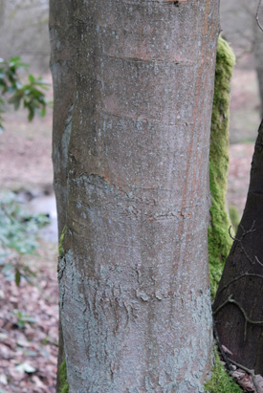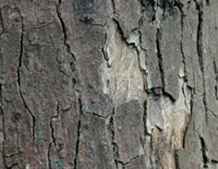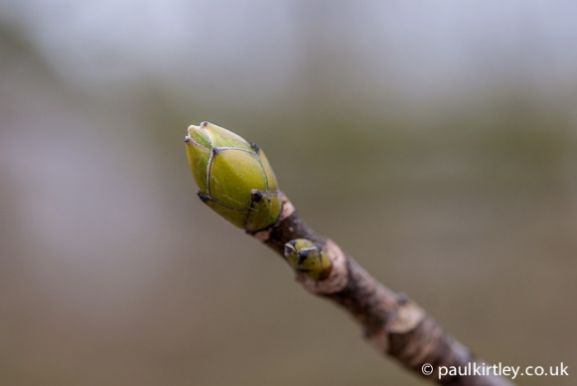
The bark of young Sycamore trees is usually smooth and silvery-grey but sometimes brown. As the tree ages, the bark develops cracks, later having large peeling scales of between 10-20cm by 5-10cm.
Sycamore’s buds are arranged in opposite pairs. They are ‘egg-shaped’ with a pointed end, green in colour and the tips of the bud scales are brown.

Ash
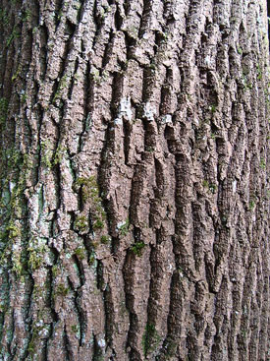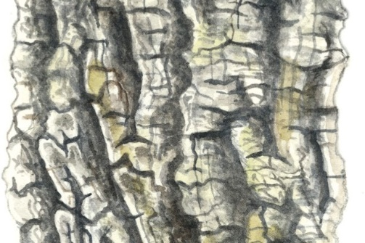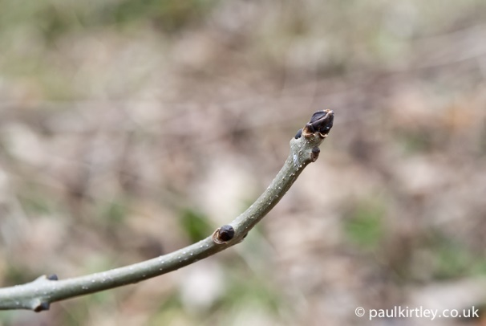
Ash bark is smooth grey or a pale grey-brown in young trees. In older trees the bark very rough with deep grooves and ridges and can look similar to the bark of Oak (see other page).
The buds of Ash are arranged in opposite pairs, rounded except for the buds at the end of shoots and branches which are more cone shaped. The key identifying feature of the buds of is that they are black or very dark, looking sooty. Also note how the ends of shoots curve upwards.

Alder
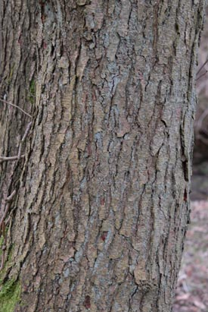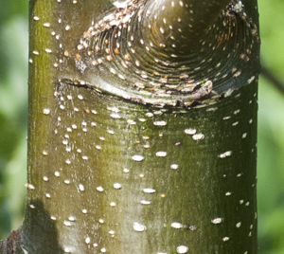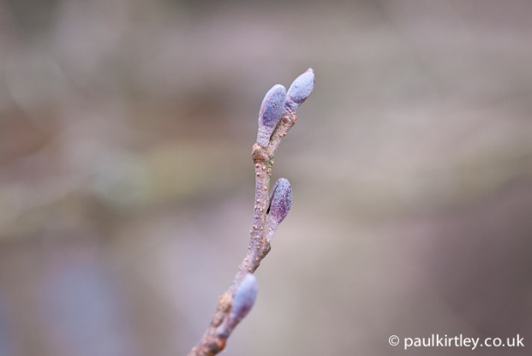
The bark of Alder is purplish brown in young trees, darkening with age to grey-brown. In older trees the bark becomes cracked, creating small vertical scales in old trees.
Alder buds are often mauvy/purple in colour and oval shaped on a short grey, scaly stalk.

Silver Birch
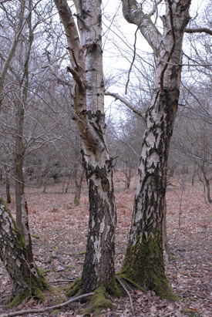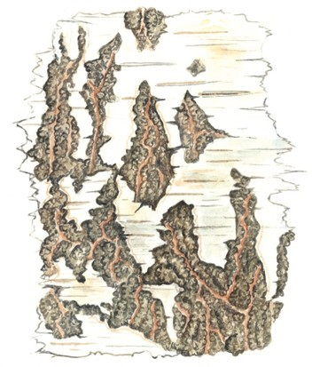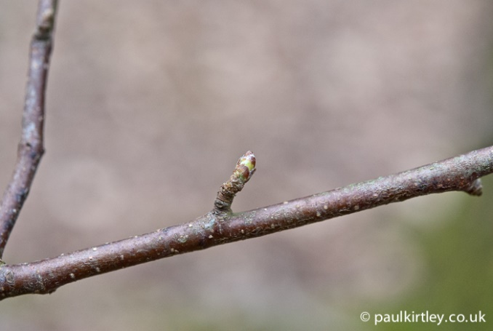
The bark of the Silver Birch is a distinctive silvery white colour. In older trees the bark remains very silvery white in the upper section of the tree, but lower down develops black diamond shapes. Eventually, the lower trunk develops thick cracks with dark grey-brown to black large knobby scales and ridges. In young trees and, shoots of more mature trees, the bark is a shiny red-brown at first. In other types of birch tree, the top layer of bark can peel away from the tree like sheets of old paper.
The buds of Silver Birch are small and egg-shaped. But the bark of the Silver Birch is so easily recognisable that you hardly need look at the buds.

Hazel or Cobnut
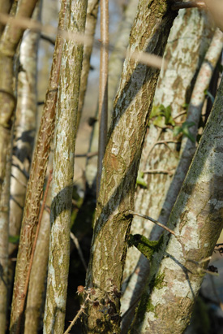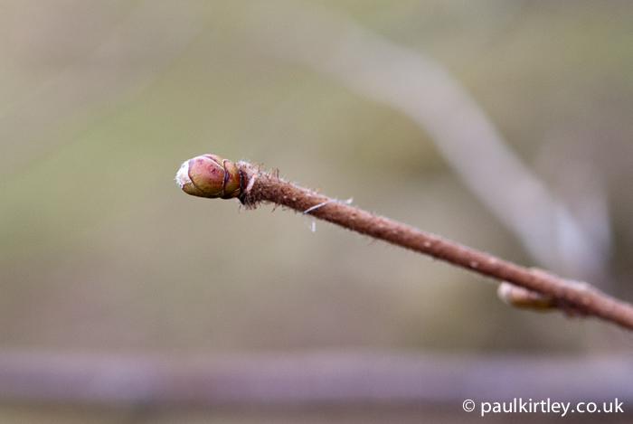
Hazel is often found in hedges and under larger trees in woodland. It grows as a small tree or a large bush. It is a useful tree because the wood can be cut down near the ground and used to make things but this doesn’t kill the tree. Lots of new stems will grow back from where it was cut and over many years, these stems grow thicker and can be cut again. This cutting is called ‘coppicing’ & has been done for many hundreds of years.
Hazel bark starts a light grey-brown, often with a bit of a sheen to it. The bark can be peeling in younger shoots but the peelings are quite fragile compared to the peelings of birch. Cracks can appear in medium sized growths but larger ‘trunks’ tend to have smooth grey-brown bark.
Hazel buds are short, blunt with green-red scales. The shoots are roughly hairy.
Goat Willow also called Pussy Willow

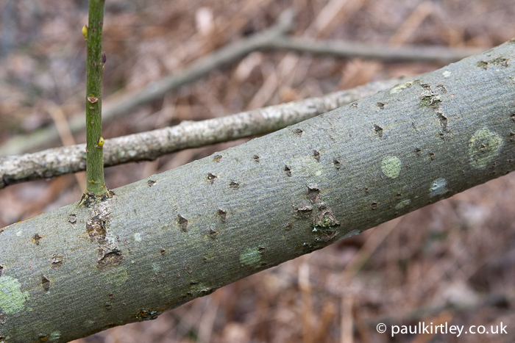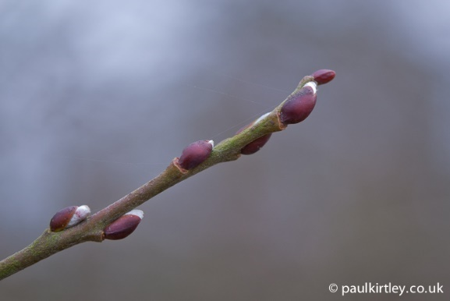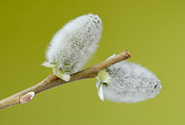
There are many different types of Willow that can be found in the wild in this country. The Goat Willow or Puss Willow is one of the easiest to recognise. It often grows near to water.
The bark of Goat Willow is pale grey. When young the bark is marked with small diamond-shaped pits. Later the bark develops shallow, criss-cross ridges and can later develop orange cracks.
The buds are rounded and quite a shiny red or chestnut brown. They have only one scale covering the bud. Look out for the furry ‘catkins’ which are seen before the flower fully opens in early Spring.

Beech

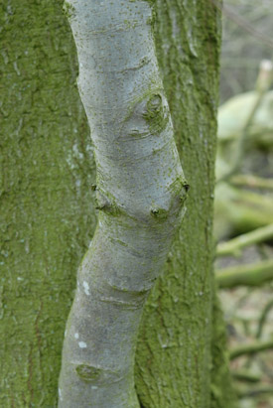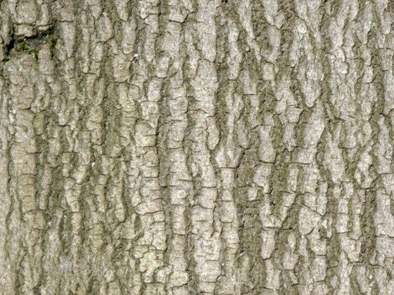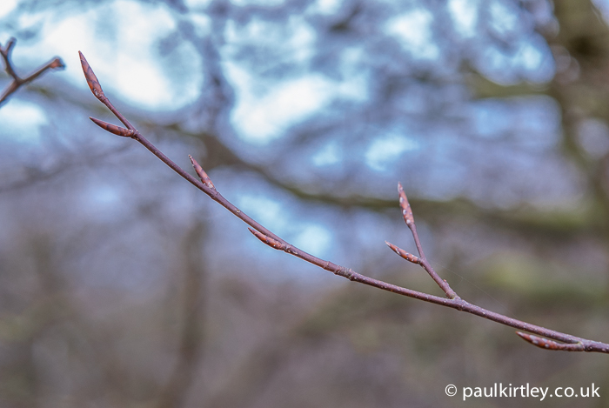
(Younger beech in the front and older beech behind in 1st image)
The bark of Beech starts smooth and silvery grey. It becomes a bit rougher in old trees and can become a little scaly in very old trees but not as textured as mature Sycamore, Ash or Oak.
Beech buds are a long, thin and sharply pointed like needles. They are a coppery-brown colour, like Hornbeam bud (see below) but Beech buds are often on short stems.
Often on younger trees and the smaller branches of larger trees, you see dead brown leaves attached all winter.

Hornbeam
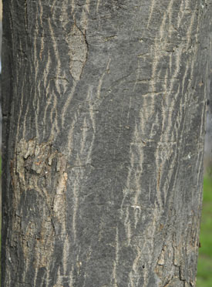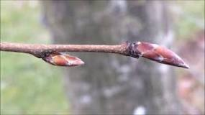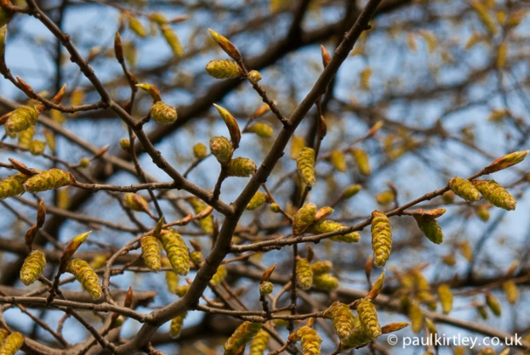
The bark and buds of Hornbeam are similar to those of beech (see above) but Hornbeam doesn’t tend to grow into as large a tree as beech.
The bark of Hornbeam is a silver to dark grey and generally smooth like beech. Some people say it reminds them of the skin of elephants.
Hornbeam’s buds are long & sharply pointed like the shape of beech buds. But they are attached close to them stem. Hornbeam produces catkins in early Spring (see photograph), Beech doesn’t.

English Oak
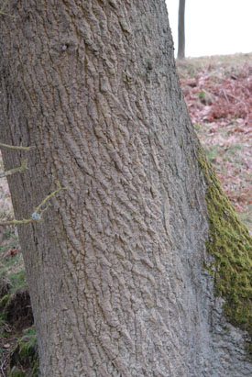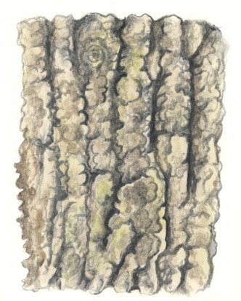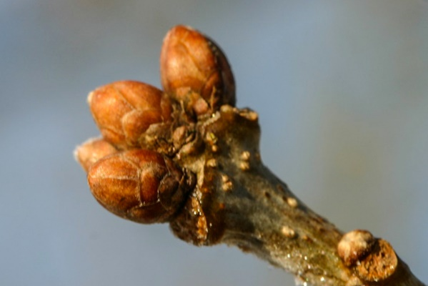
The bark of young Oak trees is smooth and grey-green. As the tree ages its bark develops more and more ridges and furrows, often crossed with cracks making rectangular and hexagonal shapes.
The buds of English Oak range from egg-shaped with a blunt tip, to egg-shaped with a more cone-shaped tip. The bud tips tend to be rounded. At the tips of the shoots the buds tend to be clustered together in a group. The buds are usually orangey-brown.

Wild Cherry
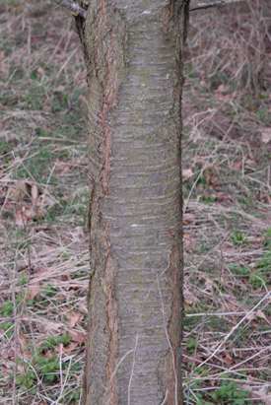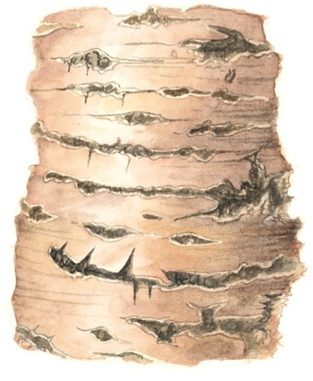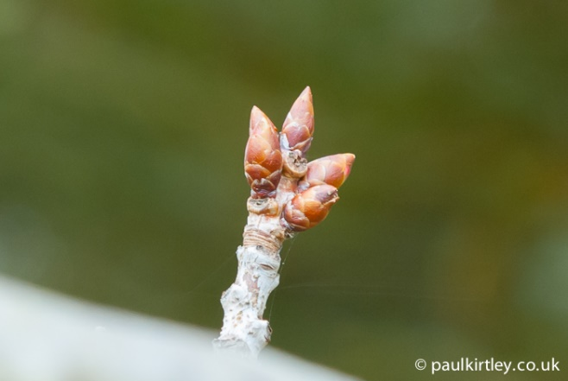
In young or small Wild Cherry trees the bark ranges from greyish-pink to purplish-red and is usually shiny. In older trees the bark is purplish grey with horizontal light-brown bands around the trunk. The bark can in peel off in horizontal strips of bark (a bit like birch trees).
The buds are a bit like the English Oak. They are egg-shaped and dark orangey-brown but more pointed. Only the flower buds are clustered and these are not always at the end of shoots or branches.

Elder
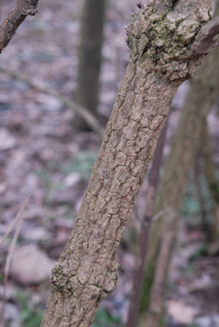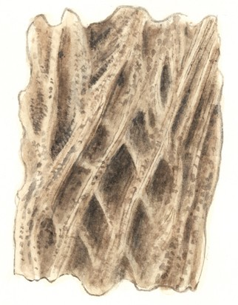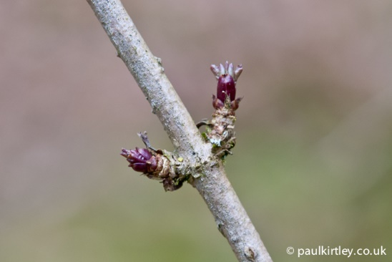
The bark of Elder is a beige-grey. The young shoots often have small raised ‘lumps’ while the older growth develops rugged, ridges and furrows.
The buds on Elder are quite fun– they look like miniature pineapples. They have spiky scales and are purple in colour. They are arranged in opposite pairs.

Rowan or Mountain Ash
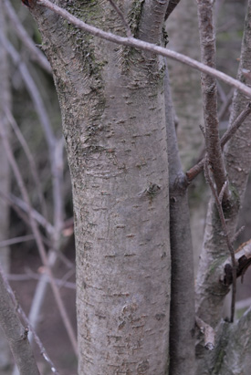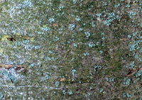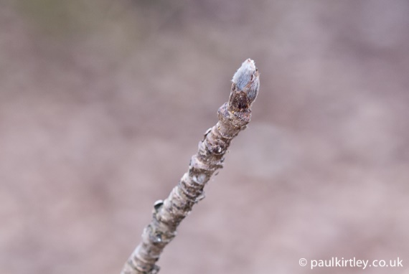
Rowan’s bark is grey or silvery grey. It is often very smooth and can be shiny. On old trees the bark is duller, grey-brown can develop scaly ridges.
The buds of Rowan are egg shaped with a bit of a cone-shaped tip. They tend to be grey with a hint of purple, with thick white hairs which are often brown at the tip.

