The Moons of Vuvv
The planet of Vuvv has 7 moons which lie spread out on one plane in a great disc around it. These Vuvvian moons all have long and confusing names so scientists usually call them by their initials: A, B, C, D, E, F and G (what a lucky coincidence) starting with the nearest one to the planet.
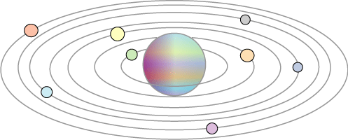
When two of these moons line up with the planet it is called a 'lunar eclipse'. When three line up with the planet it is called a 'double eclipse', when four do it is a 'triple eclipse' and so on. Once in a while all seven moons line up with the planet and this is called a 'super-eclipse'.
Moon A completes a cycle round the planet in one Vuvvian year, moon B takes two years, moon C takes three years, moon D takes four years and so on.
How long is it between each 'super-eclipse' on the planet of Vuvv?

Getting Started:

You could look at just two moons and work out how many years it takes for them to coincide.
Which moons might it be good to look at first?
It might help to use a calculator and to jot your ideas on paper.

Use reasoning skills as well as number skills.

