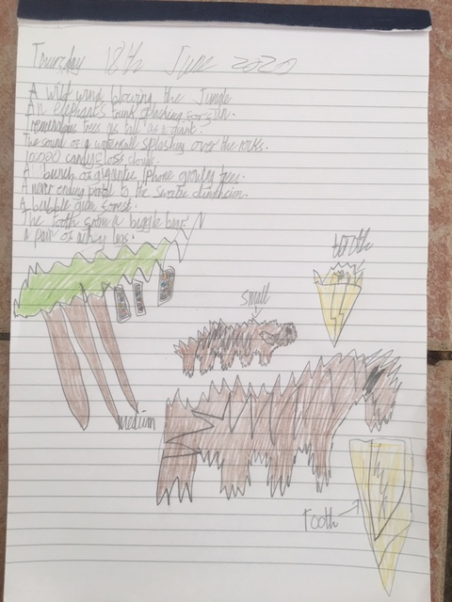  Thomas | 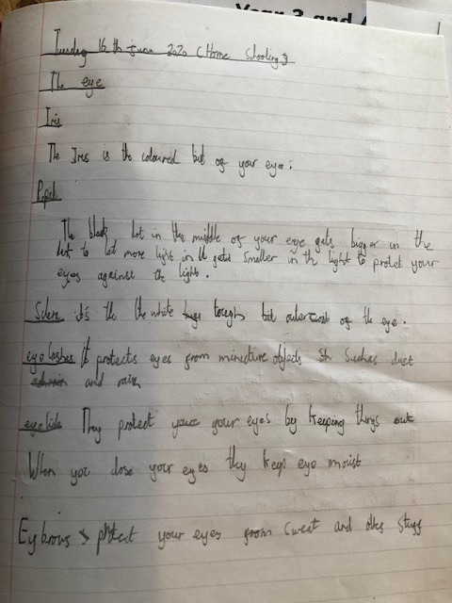
10 things in an explorer's rucksack  A Delightful Doggie joining me on my lovely adventures,  Yummy clouds made of cotton candy,  The sound of happy horse hooves trotting through the fields,  A glittering rainbow with piles of gold at each end,  1 billion million trillion pounds,  The smell of Yorkshire puddings,  A pair of flying flamingos to take me anywhere,  Gloves made of fluffy fur balls,  A pretty pony to be my best friend,  All the lovely creatures I have met on my travels.  By Heidi Coole and Mungo Coole | Read Jacob’s eye facts with detailed drawing to help you.

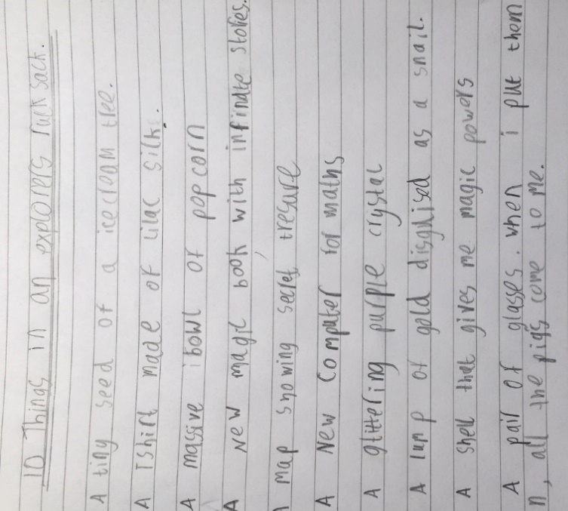  Emma’s poem  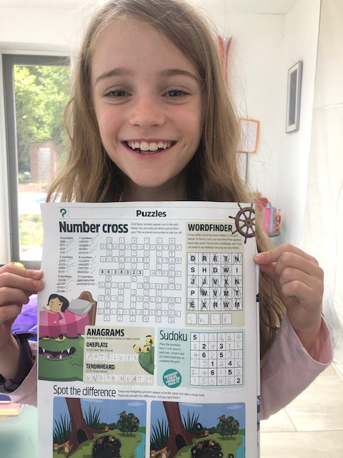  Lily has been busy trying Sudoko  on her puzzle page | 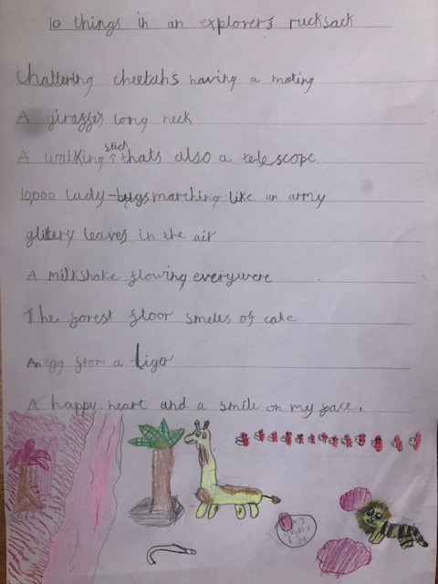  Thea’s list poem.  Can you spot the alliteration?  ANSWER TO OWEN’S PUZZLE  A=4 or A=5  B=2 B=1  C=3 C=3  D=1 D=2  E=5 E=4

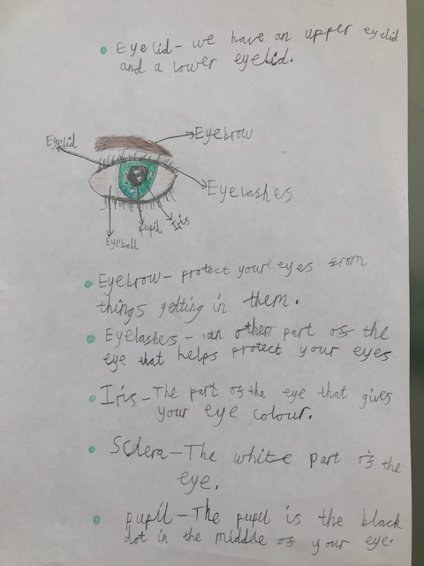  Lily’s eye facts | 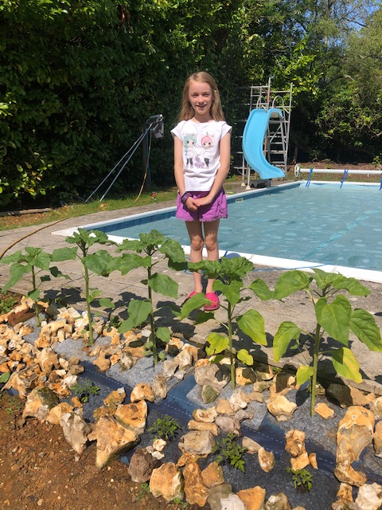  Sunflowers are thriving.

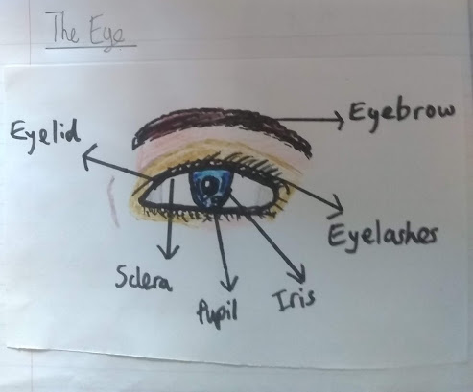Owen
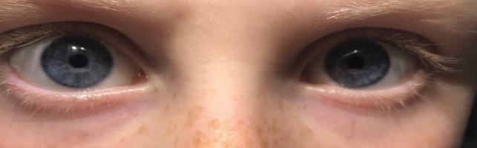  Someone else has created a magnificent labelled illustration  of the eye! | What is happening in this photo?  Did you do this test?  If you did, were you surprised by how strong the sun’s rays are? The sections under the black shapes were protected so would not have faded.
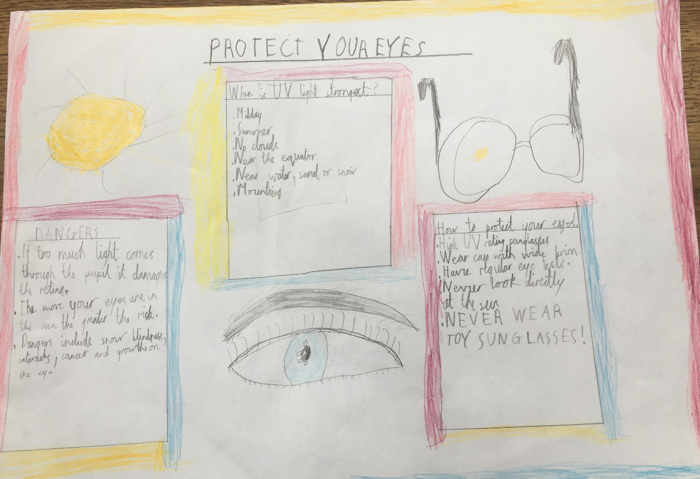
Dexter’s informative poster.

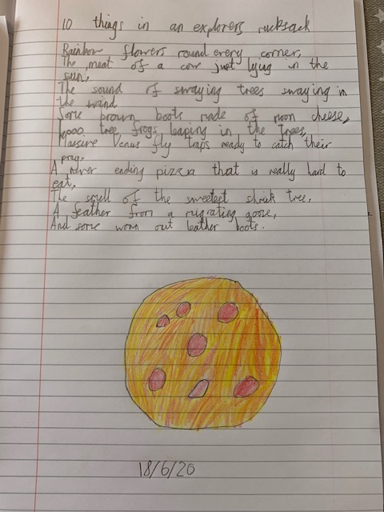  Mattie A | 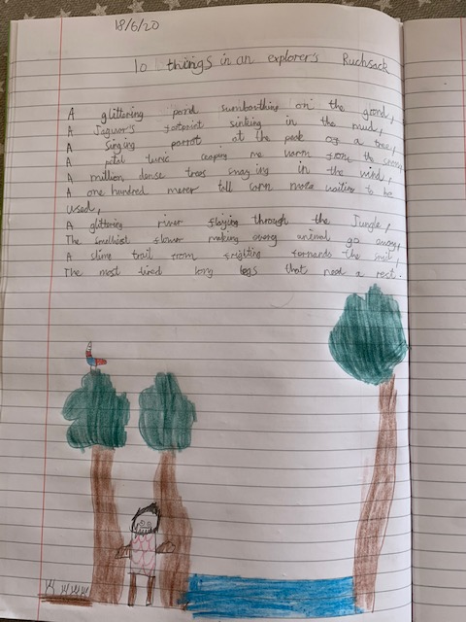  Charlie A  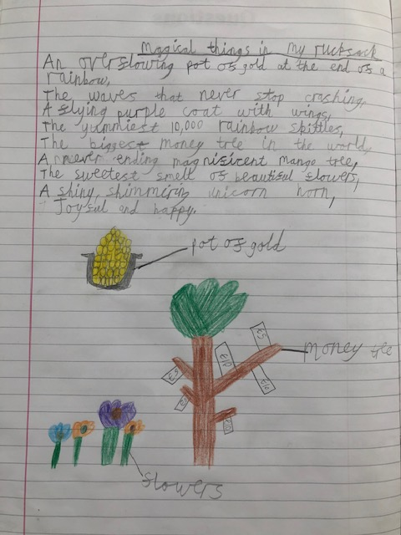  Lily

A note from the editor
I hope you have enjoyed reading this week’s edition. I know lots of you are doing brilliant work at home, if you want me to publish it on RABBIT TIMES please send me some photos. It doesn’t have to be work I have set you.
I hope you have started planning your project on kent. Now we are allowed to go out more you might visit somewhere and take some photos or find some leaflets.Here are some websites you could use to help you choose.
https://kentattractions.co.uk/outing-ideas/kids-attractions-2/

https://thehopfarm.co.uk/ Hop Farm in Paddock Wood.

https://kids.kiddle.co/Eurostar Find out about the Eurostar that runs through Kent.

