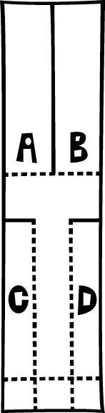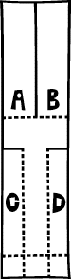

Cut along the solid lines then fold the dotted lines.
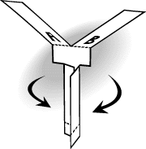 Add a paperclip (or similar) to the bottom of the spinner to add weight.

