PURPLE MASH update
Click on this box to find books to read
Click on this to check what tasks I have set for you!

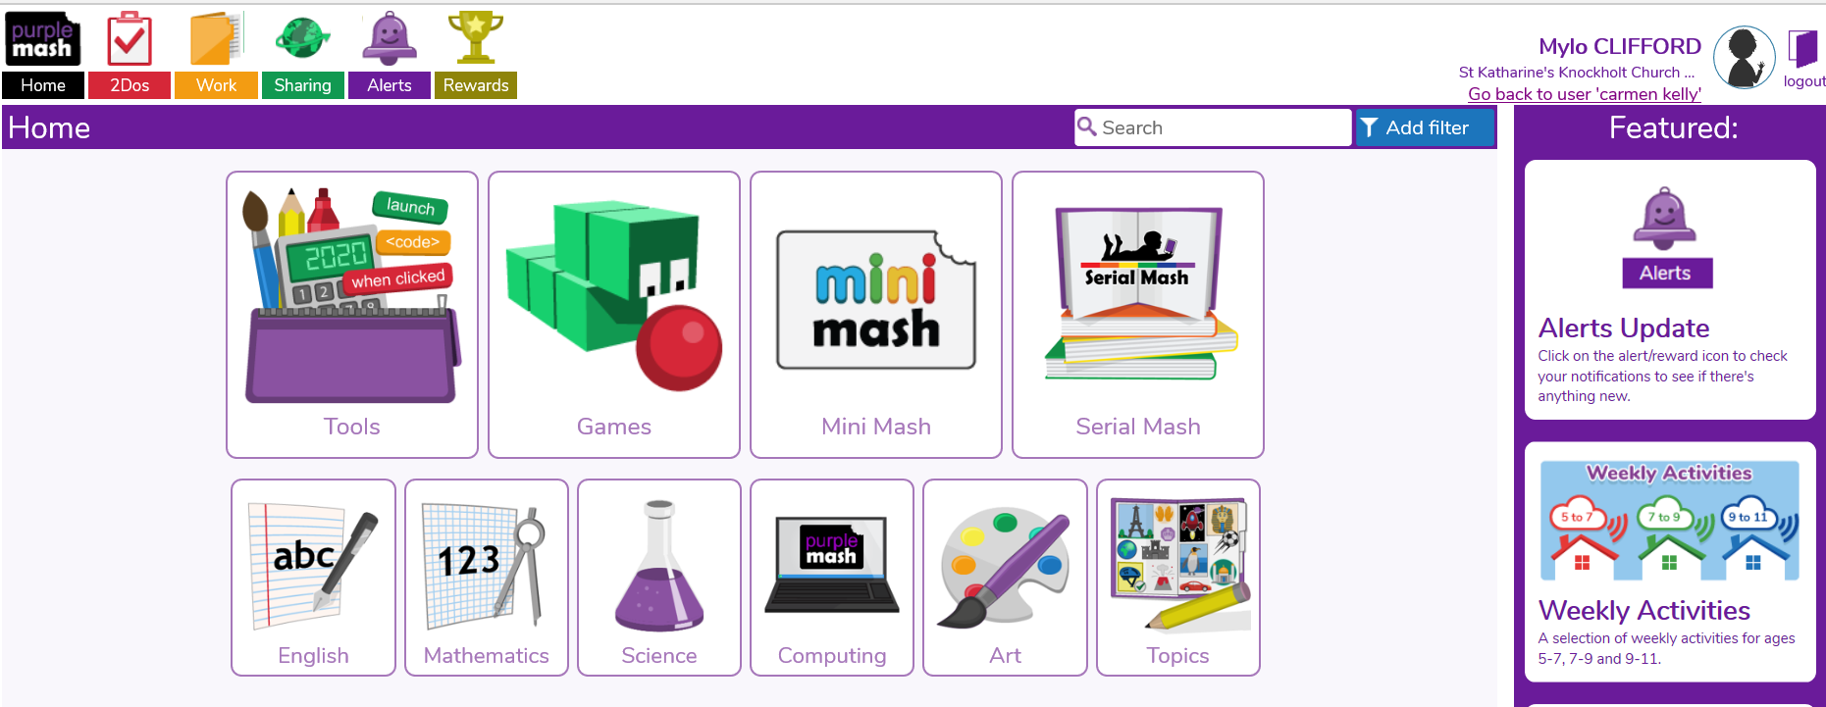
Click on this box to find some interesting tasks too.

The books in Serial Mash are differentiated so click on the right one for you. I will be setting tasks here for some children who have not been completing Treasure House reading tasks.

