Task 1 I can locate my county on a map
I can name nearby counties

Berkshire doesn’t have any beaches because it does not have a coastline.
Cumbria is located in the North West of England. Part of it touches the sea, so it has a coastline.

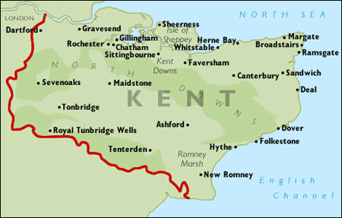

Cut out the map and stick in your book. Answer the questions in sentences. Remember all place names begin with a capital letter.

Kent is the county we live in.

- Which part of England is Kent located?

- Name the counties that border (touch) Kent.

- Kent has lots of beaches. Explain how you know this by looking at the map

- Name three seaside resorts in Kent

- Name some of the bigger towns in Kent.

- If I wanted to travel to France from Kent what would be the easiest way?

- Name two Airports near Kent.

