RABBIT CLASS CHALLENGE Remember what an autobiography is.
Design a book cover for your autobiography. Draw some things that are clues about you and write a few captions but DO NOT write your name. After Easter we can put them on the website and you can all try and identify which book cover belongs to who. Some of you might draw a pony, a football, a Harry Potter book or felt tips……………. Can’t wait to see what you draw! I’ll design a cover too!

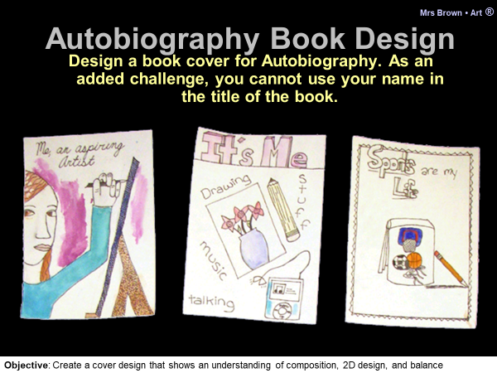
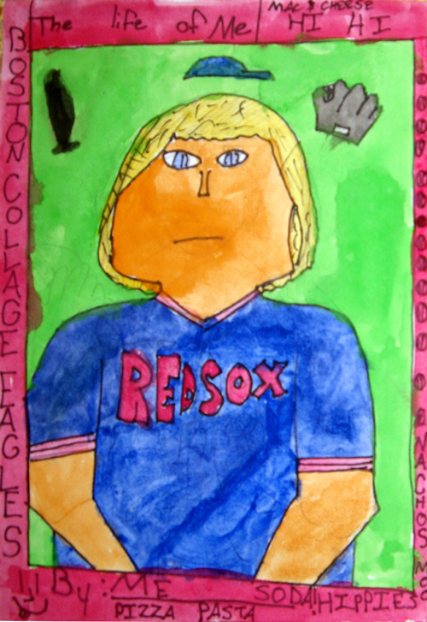

Another Fun task, you could draw 2 different Easter egg patterns as an accordion drawing
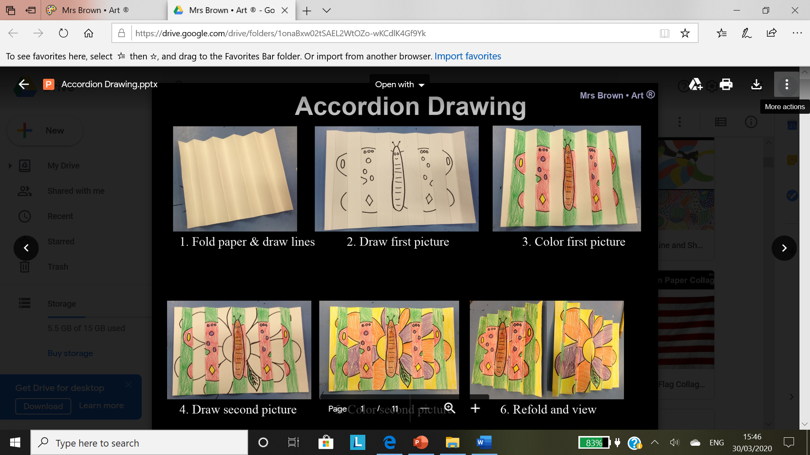

https://www.youtube.com/watch?v=atNZ4O5iuho Easy Pop Up Chick Card - 3D Easter Card DIY - Cute & Easy
